2015-16

Georgia Breast and cervical cancer program
Screening Site Performance Evaluation Plan
PREPARED BY
Nicolle Dally, MPH, Program Evaluator, Chronic Disease Prevention Section

Monique Martin, MPH, CHES, Manager, Georgia Breast Cancer Genomics Project

Cathy Broom, Program Manager, Georgia Breast and Cervical Cancer Program
Evaluation of the Georgia Breast and Cervical Cancer Program Screening Site Performance

- Plan Overview

The Georgia Breast and Cervical Cancer Program (GBCCP) has designed a comprehensive evaluation strategy focused on quality assurance/quality improvement for the 2015 - 2016 project period. The purpose of this evaluation is to determine the effectiveness and efficiency of provider screening sites and to identify areas to build, strengthen and enhance performance. The evaluation design features a mixed methods approach, incorporating both quantitative and qualitative methodologies.
The overarching questions for this evaluation are:
- What are the facilitating factors and barriers to screening site performance?
  - How will barriers be reduced?
- To what extent are women screened at each site retained through the completion of their plan of care?

- Intended Use and Users of Evaluation Results

Evaluation plays a central role in organizational learning, program planning, decision-making and measurement of program initiatives. The purpose of this evaluation is to determine the effectiveness and efficiency of provider screening sites and to identify areas to build, strengthen and enhance performance.

Primary users of evaluation findings include GBCCP program staff, public health district coordinators, local provider screening sites and the CDC [Table 1]. Evaluation progress and findings will be reported to intended users through monthly evaluation briefs.

The GBCCP evaluator will work collaboratively with the Principal Investigator, Program Manager, and other GBCCP staff to ensure the use of evaluation findings for programmatic improvements. The CDC Project Officer and Evaluation Technical Advisor will have access to evaluation findings and participate in consensus building exercises and planning discussions if major programmatic changes are recommended.

Table 1. Stakeholder Assessment and Engagement Plan
Stakeholder Name | Interest or Perspective | Role in the Evaluation
CDC | Monitors Program deliverables, requirements and performance measures | Provide technical assistance
Georgia Breast and Cervical Cancer Program (GBCCP) staff | Ensure program success through monitoring of Program goals, objectives, funding, reports and data | Guide evaluation design and utilize evaluation findings to inform Program activities
Georgia Department of Public Health (DPH) Health Departments | Deliver GBCCP services, collaborate with local partners and enrollment of eligible women into state’s Women’s Health Medicaid | Provide data through qualitative and quantitative collection methods.
DPH Evaluation Team | Collection, analytics and reporting of program specific data | Develop, execute and disseminate evaluation plan. Create recommendations from findings.
Related Chronic Disease Programs | Strategic partnerships, coordination, and collaboration. Progress toward Departmental goals | Provide input on evaluation questions and use findings for successful achievement of respective program goals
American Cancer Society (ACS) Client Navigation Program (CNP) | Provide patient navigation, outreach and education | Provide screening data and previous CNP evaluation data.
Participating Primary Care Providers | Perform screening, education, follow-up diagnostic evaluation, and case management | Provide screening data and information on current policies and activities.
Policymakers & Other Government Agencies | Enhanced capacity to service constituents | Define priorities for evaluation focus
Women receiving services through GBCCP | Receipt of GBCCP services | Provide data.

- Program Description

Breast cancer is the most common cancer diagnosed and the second leading cause of cancer death among women in Georgia. Each year from 2005-2009, an average of 5,800 new cases of female breast cancer were reported to the Georgia Comprehensive Cancer Registry. Non-Hispanic white women were more likely to be diagnosed with the disease than were non-Hispanic black or Hispanic women.

Each year from 2006-2010, about 390 cases of cervical cancer were reported to the Georgia
Comprehensive Cancer Registry. Hispanic women were more likely than non-Hispanic black or non-Hispanic white women to be diagnosed with the disease. Overall, Georgia’s cervical cancer incidence and mortality rates were similar to the US average.

The Georgia Breast and Cervical Cancer Program (GBCCP) was established in 1992 in response to the Breast and Cervical Cancer Prevention and Treatment Act. GBCCP is funded jointly through state and federal funding, and implemented statewide through contract agreements with public health districts and other participating primary care providers, as well as agreements with participating mammography facilities and cytology laboratories. The American Cancer Society (ACS) Client Navigation Program (CNP) works in tandem with the GBCCP to provide population based community education on breast and cervical cancer and assists eligible women to access screening and diagnostic services offered through the GBCCP. ACS Client Navigators are based in 9 health districts in Georgia and serve counties based on population needs, Georgia cancer registry data, and screening capacity.

The primary purpose of the GBCCP is to provide screening and follow-up services to low income, uninsured and/or underinsured women between 21 and 64 years old, whose household income falls below 200% of the Federal Poverty Level throughout the state of Georgia. Services provided by GBCCP include:

- Clinical breast examinations
- Pelvic examinations
- Pap tests
- Mammograms (if 40-64 years old)
- Diagnostic evaluation, if screening results are abnormal
- Referrals to treatment through the Women’s Health Medicaid Program and Cancer State Aid.

The GBCCP logic model provides a high-level visual representation of the program work plan. It demonstrates what the program plans to accomplish, and how program activities relate to short-term, intermediate, and long-term outcomes. Elements of the logic model include inputs, strategies/activities and outcomes (Figure 1).
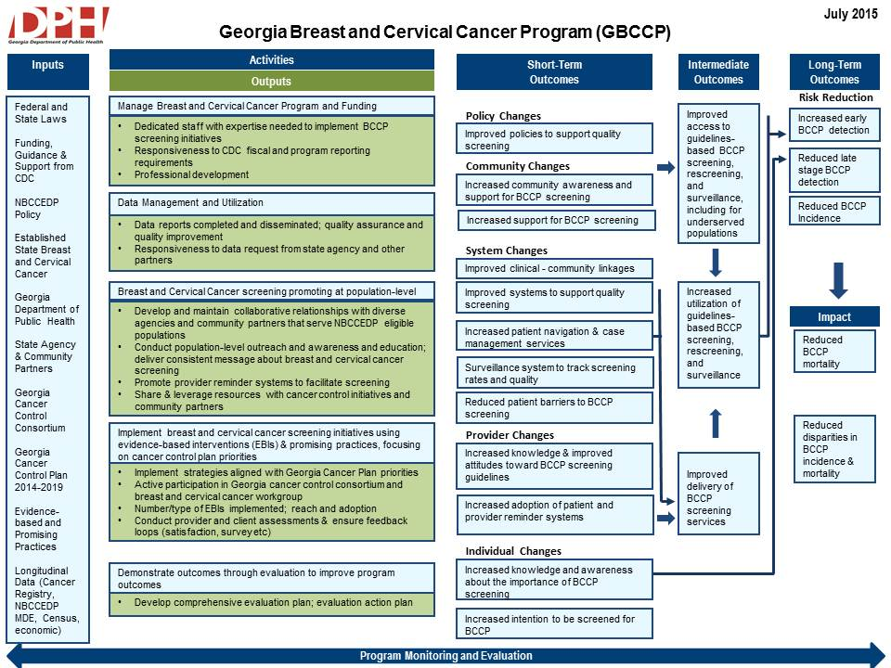
- Evaluation Focus

The overarching questions for this evaluation are:
- What are the facilitating factors and barriers to successful performance of BCCP screenings sites?
  - How will barriers be reduced?
- To what extent are women screened at each site retained through the completion of their plan of care?

The evaluation questions were primarily determined by programmatic need. GBCCP monitors the trends in screening site perform to ensure adequate screening provision statewide. This evaluation will identify the facilitators and barriers present at provider screening site and the extent to which women screened at each site were retained through the completion of their plan of care. The results of the evaluation will inform the program on how to build, strengthen, and enhance provider performance.

The evaluation will use a mixed methods approach drawing on methods such as archival data, surveys (patient/provider experience), semi-structured interviews, screening data, and site observation. A baseline for each screening site will be determined using archival data. Data about the effectiveness and efficiency of screening site performance will be captured via patient and provider experience surveys, site observation (process flow), screening data, and semi-structured interviews with site staff and clients.

- Data Collection
Evaluation Question | Indicators | Performance Measure | Data Collection Sources | Data Collection Frequency
What are the facilitating factors and barriers to screening site performance?  How will barriers be reduced? | Mammograms Provided to Women 50 Years of Age and Pap Smears Provided to Women 21-64 Years of Age | Percentage of NBCCEDP funded mammograms provided to women 50 years of age and older and pap smears provided to women 21-64 years of age (goal: >= 75%) | Screening Data  Patient/Provider Experience  Semi Structured Interviews, Site Observation | Monthly, Quarterly, Annually
To what extent are women screened at each site retained through the completion of their plan of care? | Abnormal Screening Results with Complete Follow-Up | Percentage of abnormal Pap tests with complete follow-up (goal: >=  90%) | Screening Data,  Site Observation | Monthly, Quarterly, Annually
 | Abnormal Screening Results; Time from Screening to Diagnosis > 90 Days | Percentage of abnormal breast screenings with complete follow-up  (goal: >= 90%) | Screening Data | Monthly, Quarterly, Annually
 | Abnormal Screening Results with Complete Follow-Up | Percentage of abnormal breast screenings where the time between the screening/referral and final diagnosis was > 60 days (goal: <= 25%) | Site Observation | Monthly, Quarterly, Annually
 | Abnormal Screening Results; Time from Screening to Diagnosis > 60 Days | Percentage of final diagnosis of breast cancer where the time between the date of final diagnosis and the date of treatment initiation is > 60 days (goal: <= 20%) | Screening Data | Monthly, Quarterly, Annually

- Data Analysis and Interpretation

Data Analysis
The GBCCP evaluator is responsible for compiling, cleaning, coding, and interpreting initial data from surveys, interviews, MDE reports, etc. Thematic analysis, descriptive statistics, and regression analysis with a limited selection of predictor variables will be used to analyze information collected via the instruments used in this evaluation.

Thematic analysis is qualitative analytic method for identifying, analyzing and reporting patterns within data. This method facilitates identification of common themes that can inform program improvements.

Survey responses will be tabulated and analyzed using basic quantitative methods. Univariate statistics will be computed to look for missing data, check for data entry errors, and ensure the data fall within specified ranges. Descriptive statistics, such as frequencies and percentages, will be used to analyze data from participant surveys. Surveys will be labeled with numeric identification codes to allow linkage between pre-tests and post-test for while maintaining confidentiality.

Data Interpretation
Upon completion of initial data analysis, the evaluator will present the initial findings to the Principal Investigator, Program Manager, and other GBCCP staff for programmatic interpretation. The evaluator will work collaboratively with the program to develop an action plan based on evaluation findings. The action plan will identify targeted recommendations and action steps necessary to implement the recommendations.

The CDC Project Officer and Evaluation Technical Advisor will have access to evaluation findings and participate in consensus building exercises and planning discussion if major programmatic changes are recommended.

- Dissemination and Use of Findings

Evaluation findings will be disseminated through a variety of methods to include professional conferences and meetings, formal and informal evaluation reports, webinars, scholarly journal publications, and other publications (i.e. evaluation briefs, DPH public health weekly newsletter). A presentation of evaluation results to other state breast and cervical cancer programs, as well as other state, federal, and national level stakeholders interested in the Georgia Breast and Cervical Cancer Program will be facilitated via a webinar that will also be made available on the Georgia DPH website.

- Evaluation Timeline

The timeline below outlines the major evaluation activities that will be conducted over the next year.

Timeframe | Task
1st Quarter  July 2015-September 2015 | - Finalize evaluation design  - Adapt/develop data collection instruments (patient/provider experience survey)  - Adapt/develop semi structured interview guide  - Adapt/develop site visit protocol  - Development and disseminate monthly evaluation brief
2nd Quarter  October 2015-December 2015 | - Field and analyze data from provider/provider experience surveys  - Develop and disseminate quarterly evaluation progress report  - Development and disseminate monthly evaluation brief
3rd Quarter  January 2016-March 2016 | - Conduct site observations and semi structured interviews  - Development and disseminate monthly evaluation brief
4th Quarter  April 2016-June 2016 | - Analyze data from site observations and semi structured interviews  - Analyze screening data  - Development and disseminate monthly evaluation brief
1st Quarter  July 2016-September 2016 | - Complete final evaluation report  - Disseminate final evaluation report to stakeholders

