American Cancer Society
Client Navigation Program Impact Assessment
Reporting Period: 7/1/2011 - 6/30/2016

Authors
Janet Y. Jeon, MPH, Cancer Program Evaluator, Georgia Department of Public Health
Phanesha Jones, MPH, Community Outreach Data/Evaluation Manager, American Cancer Society
Olga Lucia Jimenez, BS, Senior Manager Community Outreach, American Cancer Society

Acknowledgements
The Client Navigation Program is made possible through funding and a joint partnership with the American Cancer Society, the United Way, and the Georgia Department of Public Health’s Breast and Cervical Cancer Program (State Funding).

Suggested citation: Jeon JY, Jones P, & Jimenez OL. (2017). American Cancer Society Client Navigation Program Impact Assessment, American Cancer Society, United Way, and Georgia Department of Public Health, Atlanta, Georgia.

Acronyms

ACS – American Cancer Society
BCCP – Breast and Cervical Cancer Program
CDC – Centers for Disease Control and Prevention
CN – Client Navigator
CNP – Client Navigation Program
DPH – Department of Public Health
EBI – Evidence-Based Intervention
FY – Fiscal Year
HIPAA – Health Insurance Portability and Accountability Act
NBCCEDP – National Breast and Cervical Cancer Early Detection Program
WHMP – Women’s Health Medicaid Program

Executive Summary

The American Cancer Society (ACS) Client Navigation Program (CNP) provides population-based community education on breast, cervical and colorectal cancer and facilitates access to receive screening and diagnostic services for low-income, uninsured and underinsured women in Georgia (ACS, 2014). The Client Navigators (CNs) implement evidence-based intervention strategies, including group education, one-on-one education, client reminders, reduction of barriers to care, and case management.

The objective of this report is to evaluate the CNP’s effectiveness in providing education and promoting breast and cervical cancer screening between FY2012 and FY2016.

Between FY2012 and FY2016, the CNP collected data in the CN Activities Database, Client Intake Database and Client Satisfaction Survey. Starting in FY2015, the CNs submitted success stories about clients who completed a plan of cancer care. Databases were stored in Microsoft Access and were exported into Microsoft Excel and SPSS to conduct the statistical data analysis. Breast and cervical cancer screening and incidence rates were calculated.

Key Findings
- The number of women who participated in the community education increased progressively from FY2012 to FY2016.
- Client intake, retention and new recruitment increased between FY2012-FY2016.
- The program exceeded the goal of enrolling at least 20% of rarely or never screened women during FY2012-FY2016. The percentage of rarely or never screened clients was approximately 50% in FY2016.
- The mammogram appointment rates and the breast cancer screening rates increased progressively from FY2013 to FY2016. The breast cancer screening rate was 94.8% in FY2016. Moreover, the breast cancer incidence rate decreased considerably from FY2012 to FY2016, showing that this program has contributed to reducing breast cancer morbidity.
- The Pap appointment rates and the cervical cancer screening rates increased from FY2013 to FY2016. Cervical cancer incidence rates fluctuated with time.
- The percentage of participants who completed the plan of breast and cervical cancer care progressively increased from FY2013 to FY2016. In FY2016, the program screened 95.7% of the clients to complete the diagnosis. The percentages of missed appointments and loss of communication progressively decreased from FY2013 to FY2016.

The findings clearly demonstrate the effectiveness of the Client Navigation Program in providing education and facilitating access to breast and cervical cancer screening during FY2012-FY2016.

Table of Contents

Program Background 1
Program Activities 1
Program Eligibility 2
Geographic Location 2
Program Evaluation 5
Data Accuracy 5
Data Completeness 5
Objectives 6
Program Goals 6
Data Accuracy and Completeness Goals 6
Methods: Data Collection and Analysis 7
Data Overview 7
Data Sources and Data Collection 7
Data Analysis 8
Results 9
Success Stories 24
Dougherty County 24
Fulton County 24
Gwinnett County 25
Clarke County 25
Walton County 25
Peach County 26
Cobb County 26
Discussion 27
Conclusion 29
References 30

Program Background

The Georgia Department of Public Health’s (DPH) Breast and Cervical Cancer Program (BCCP) is part of the Centers for Disease Control and Prevention’s (CDC) National Breast and Cervical Cancer Early Detection Program (NBCCEDP), which provides breast and cervical screening and diagnostic services to low-income, uninsured and underinsured women (CDC, 2012). Since 2011, the BCCP established a formal partnership with American Cancer Society (ACS) and contracted out the community education and partnership components, including the Client Navigation Program (CNP) (ACS, 2014; ACS, 2016a). The program is funded by the BCCP, the United Way Atlanta Affiliate and the ACS. Further details of the program background are described in the ACS CNP Baseline Impact Assessment (ACS, 2014) and the ACS CNP Evaluation Plan (ACS, 2016a).

Program Activities
The CNP provides population-based community education on breast, cervical and colorectal cancer and facilitates access and navigation to receive screening, diagnosis and follow-up services at health department clinics and other BCCP providers (ACS, 2014). The Client Navigators (CNs) implement evidence-based intervention (EBI) strategies, including small media, group education, one-on-one education, client reminders, reduction of structural barriers to care, and case management (Figure 1). Figure 1 summarizes the program process and activities.

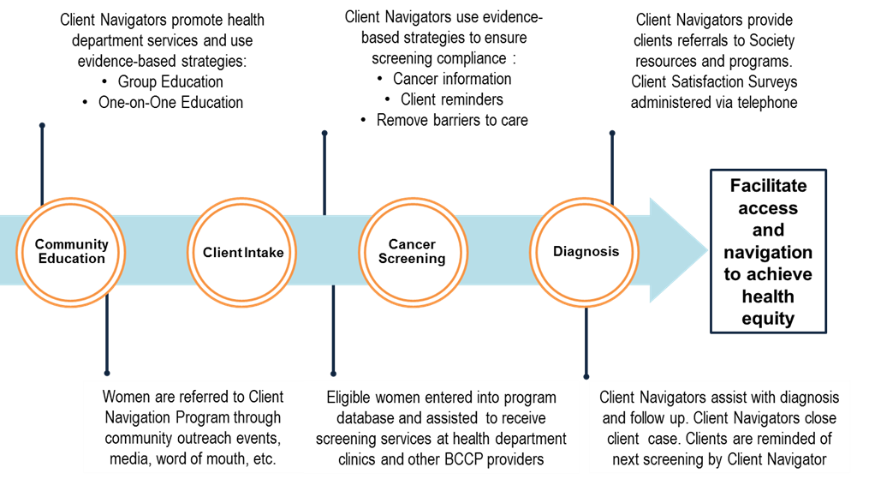
Figure 1. Client navigation program process and activities

In addition to providing community education, the CNs employed population-based approach to conduct reminders for breast and cervical cancer screening and contacted clients who were enrolled in this program as well as other women who participated in the community education events but had not been enrolled into the program. Also, the CNs identified and addressed barriers that hindered access to breast and cervical cancer screening and diagnosis. The following describes major barriers that CNs identified and strategies the CNP employed to reduce these barriers:
- Cost: The BCCP provided free services to low-income, uninsured women and low-cost services to women who are above the 200% Federal poverty level but are underinsured.
- Lack of information: The CNs informed clients how eligible women can receive the BCCP services, Women’s Health Medicaid Program (WHMP) for treatment of breast and cervical cancer, and other community resources related to breast, cervical and colorectal cancer care.
- Lack of knowledge: The CNs educated women about breast, cervical and colorectal cancer and cancer screening guidelines.
- Language barriers: The CNs, who are Certified Medical interpreters, assisted Hispanic/Latina women with medical interpretation and language translation.
- Transportation: The CNP provided shuttle service from health departments to hospitals.
- Other barriers: The CNs addressed other barriers, such as childcare and special needs, on a case-by-case basis.

Program Eligibility
Georgian women aged 21-64 who are at or below 200% of the Federal poverty level, uninsured or underinsured are eligible to participate in this program. Details of the program eligibility are provided in the ‘Policy No. 1 Client Eligibility Policy and Procedure’ in the Clinical Services Section of the BCCP Manual (Georgia DPH, 2014).

Geographic Location
The CNs are based in 9 health districts in Georgia and serve between 2-5 counties depending on the population needs, Georgia Cancer Registry data and screening capacity (ACS, 2014). Figures 2 and 3 show the counties that the CNs served in FY2015 (Figure 2) and FY2016 (Figure 3).

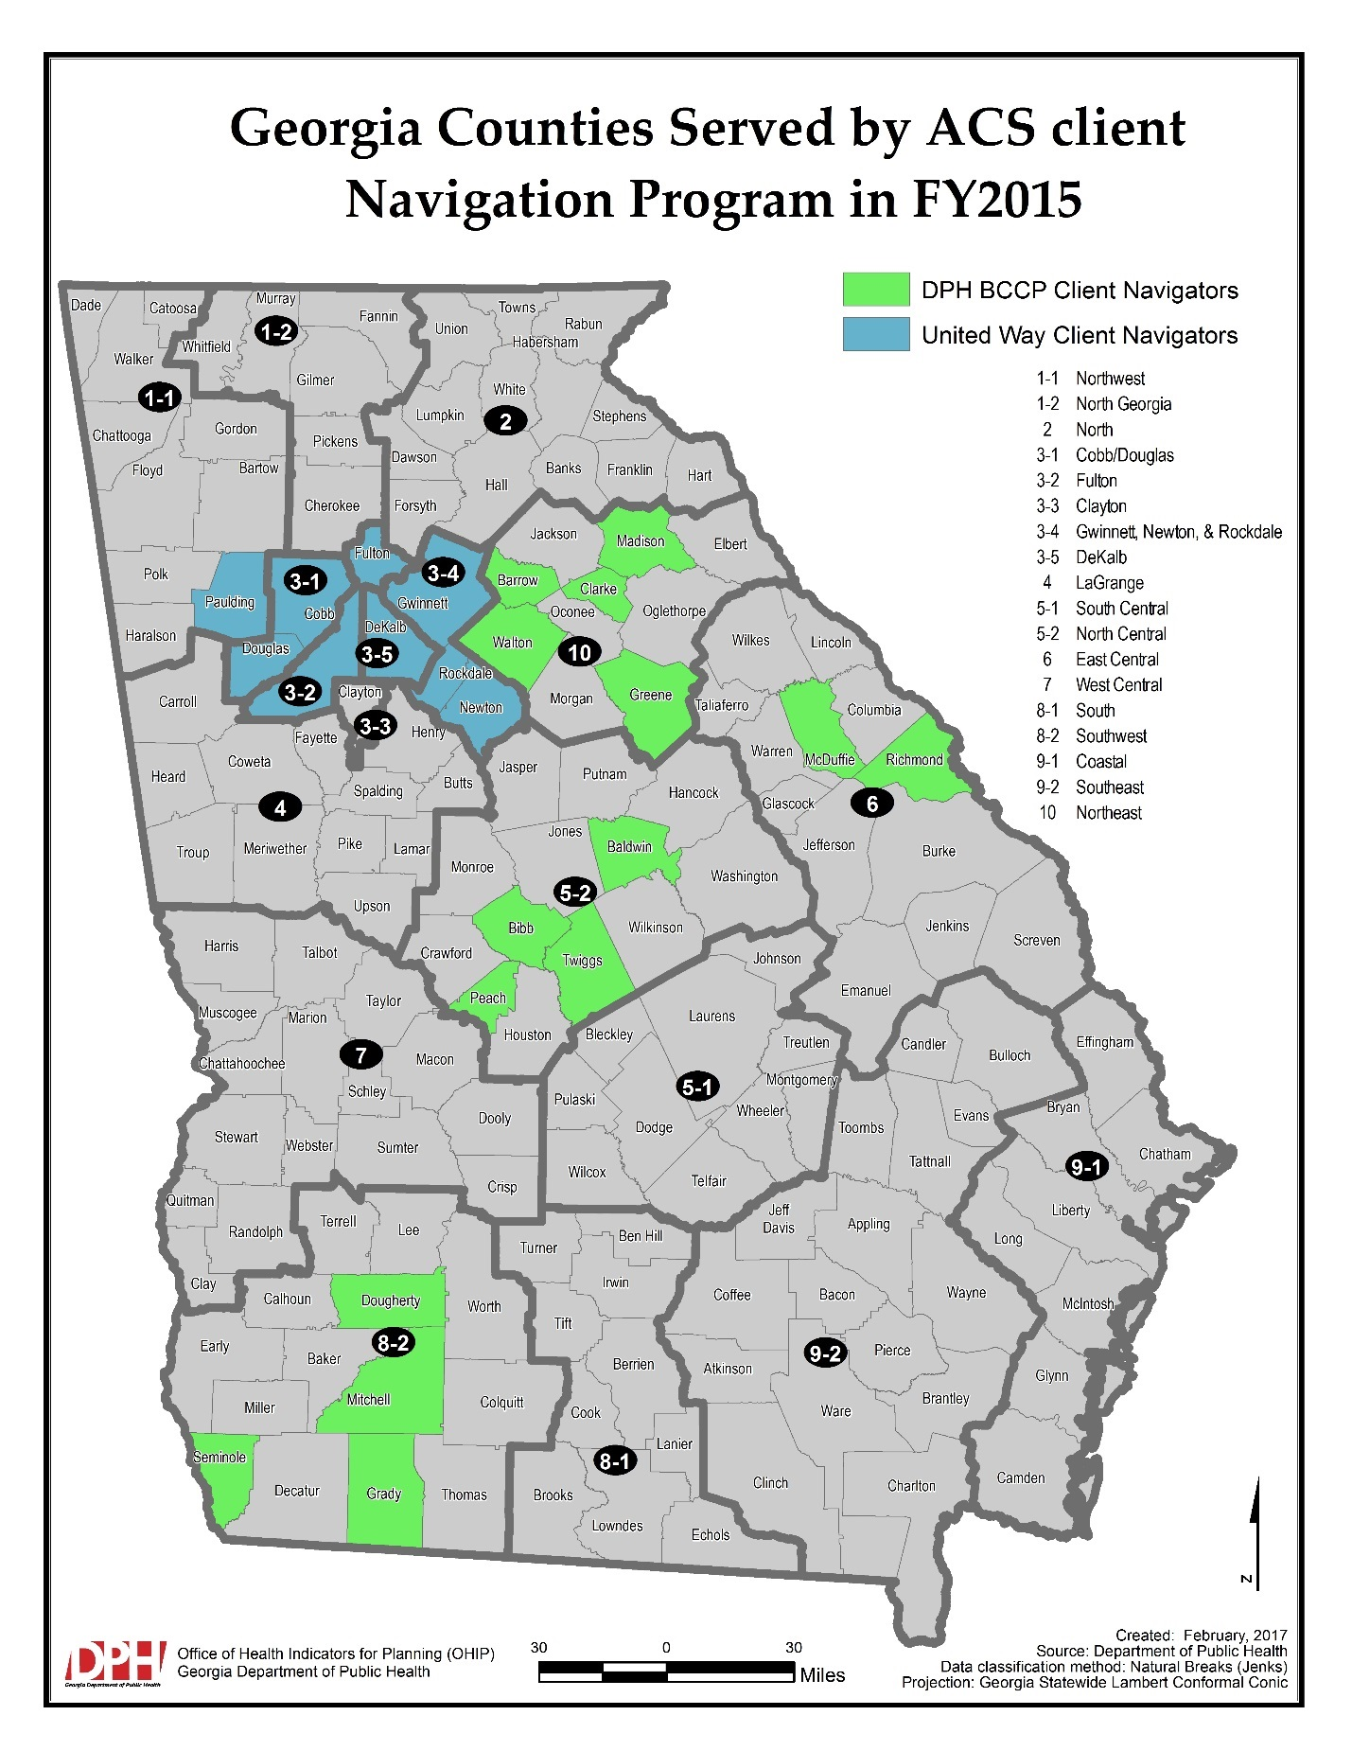
Figure 2. Georgia counties served by ACS client navigation program in FY2015

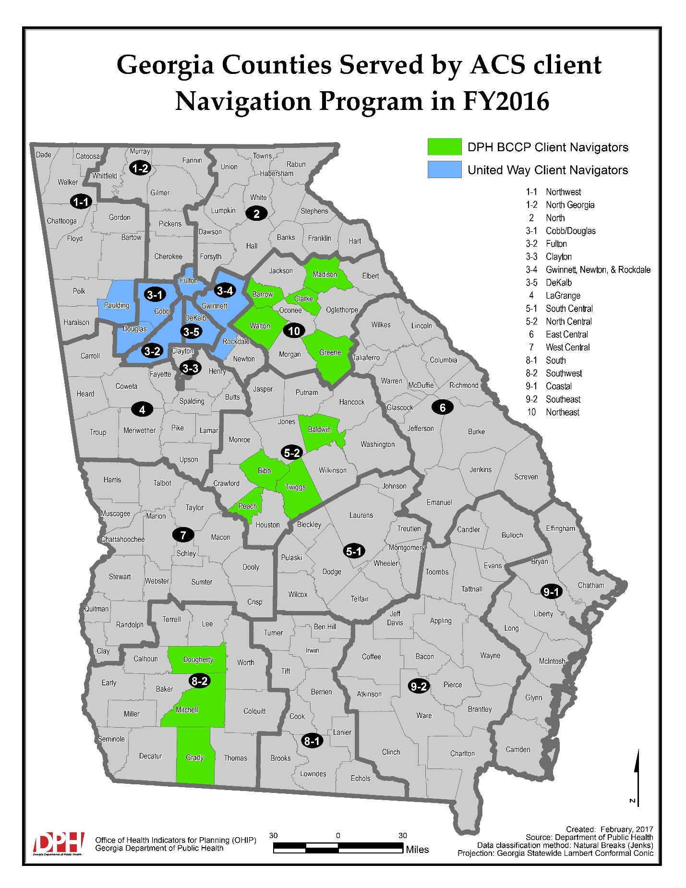
Figure 3. Georgia counties served by ACS client navigation program in FY2016

Program Evaluation

Principles and procedures recommended in the Framework for Program Evaluation (CDC, 1999) were used to plan and implement the program evaluation. Planning of the CNP Impact Assessment is described in the ACS CNP Evaluation Plan (ACS, 2016a). During FY2016, The CNP combined the roles of the Data Coordinator and the Evaluation Manager positions into a Community Outreach Data/Evaluation Manager position. Also, the program started assessing data accuracy and completeness in FY2016.

Data Accuracy
Data errors, such as misspellings and inaccurate entries, were assessed at the end of each month. Data error reports were sent to the CNs on the 5th of each month. The error reports were organized by the number of women or event entries along with the corresponding errors and instructions. The CNs corrected the data errors for the month. After two weeks, the CNs received reminders of any lingering errors. After two more weeks (i.e., one month after the initial error report was sent), the Data Specialist corrected any remaining errors and sent a follow-up report to the Community Outreach Data/Evaluation Manager. At the end of the fiscal year, data accuracy rates were calculated based on the ratio of women/event entries that did not have to be corrected by the Community Outreach Data/Evaluation Manager to the total women/event entries in the database.

Data Completeness
Data completeness, which was defined as the amount of fields completed per client or event entry, was assessed at the end of each month. Data completeness reports were sent to the CNs on the 5th of each month. The completeness report consisted of the missing fields per event or women among closed cases. The report also included a list of all open cases. This list was updated on a monthly basis. At the end of the year, data completeness was calculated based on the ratio of women/event entries without missing data to the total women/event entries in the database. Cases that were open for more than two months were assessed on an individual basis. Active cases due to standing appointments, or other issues were not counted as incomplete.

Weight Scale for Data Accuracy and Completeness
0 – 2 Errors = 100%
3 – 10 Errors = 90%
11 – 19 Errors = 80%
20 – 29 Errors =70%
30 or more Errors = 60% or below

Objectives
The main objective of this Impact Assessment is to evaluate the program effectiveness in providing community education and facilitating access to breast, cervical and colorectal cancer screening between FY2012 and FY2016. This paper seeks to show the program impact, outcomes and outputs regarding breast, cervical and colorectal cancer screening practices and highlight the program accomplishments and progress toward program goals. In addition, the report includes progress that the ACS team made in regards to program operations and data management during FY2015-FY2016. Specific goals, anticipated impact and outcomes of the CNP are provided in Table 1 in 2014 Baseline Impact Assessment (ACS, 2014). Program goals (ACS, 2014) and data accuracy and completeness goals are described below:

Program Goals
- Increase public education and awareness regarding breast, cervical and colorectal cancers
- Recruit at least 20% of clients to receive BCCP services from never or rarely screened target populations
- Ensure at least 90% of clients screened reach complete diagnosis

Data Accuracy and Completeness Goals
  - Meet at least 95% data accuracy
  - Meet at least 90% data completeness

Methods: Data Collection and Analysis

Data Overview
All the CNP databases are stored in Microsoft Access software in a secure folder accessible to the CNP team and in compliance with the Health Insurance Portability and Accountability Act (HIPAA) guidelines. The databases are managed by a Community Outreach Data/Evaluation Manager. Overview of the data collection and management is described in further detail in ‘IV. Methods: Data Collection & Analysis’ section in the ACS CNP Baseline Impact Assessment (ACS, 2014).

Data Sources and Data Collection
Between FY2012 and FY2016 (7/1/2011 - 6/30/2016), the CNP collected data in Client Navigator Activities Database, Client Intake Database and Client Satisfaction Survey. The CNs collected data from clients by conducting the traditional paper and pencil interviewing in the field and performed data entry into Client Navigator Activities Database and Client Intake Database. Starting in FY2015, the program collected success stories about clients who completed plan of cancer care. The CNs submitted at least two success stories on a monthly basis. The Client Satisfaction Survey was developed by using the web-based Survey Monkey platform. The Community Outreach Data/Evaluator Manager and ACS volunteers administered the telephone survey with eligible clients and entered the responses in Survey Monkey. Further details about the Client Satisfaction Survey can be found in the 2016 ACS CNP Client Satisfaction Survey Results Report (ACS, 2016b). Table 1 summarizes data sources and data collection methodology.

Table 1. Summary of client navigation program data collection
Data Source | Collection Period | Data Captured | Staff
Client Navigator Activities Database | FY2012 – FY2016 | Demographics, one on one education, group education, community partnerships, mass contact log | Client Navigators
Client Intake Database | FY2012 – FY2016 | Demographics, screening history, referrals, barriers to cancer care, case management, client reminders | Client Navigators
Client Satisfaction Survey | 12/2012 – 2/2014, 1/2015 – 11/2016 | Client feedback, satisfaction, knowledge, attitude, and confidence regarding cancer screening | Community Outreach Data/Evaluator, ACS volunteers
Success Stories | FY2015 – FY2016 | Stories of clients that successfully completed plan of cancer care | Client Navigators

Data Analysis
Databases in Microsoft Access were exported into Microsoft Excel and SPSS to conduct the statistical data analysis. Some key outcome variables were stratified by demographics, such as age, race/ethnicity and region.

Rates related to breast and cervical cancer screening and incidence were calculated by using the following equations:

Mammogram appointment rate = $\frac{Number of clients who had mammogram appointment }{Number of clients eligible for mammogram}$
Pap test appointment rate = $\frac{Number of clients who had Pap test appointment }{Number of clients eligible for Pap test}$
Breast cancer screening rate = $\frac{Number of clients who received mammogram }{Number of clients eligible for mammogram}$
Cervical cancer screening rate = $\frac{Number of clients who received Pap test }{Number of clients eligible for Pap test}$
Breast cancer incidence rate = $\frac{Number of clients newly diagnosed with breast cancer}{Number of clients in the program database}$
Cervical cancer incidence rate = $\frac{Number of clients newly diagnosed with cervical cancer}{Number of clients in the program database}$

Results

Between FY2012-FY2016, 5-10 full-time CNs served the CNP each year. During FY2015 and FY2016, 7-8 CNs were employed (Table 2). Overall, the number of counties served in Georgia increased from 6 counties in FY2012 to 20-25 counties (Education in 25 counties; Screening in 20 counties) in FY2016 (Table 2). The highest numbers of counties were served in FY2013 – i.e., education in 37 counties and screening in 29 counties (Table 2). There was a decrease in the number of counties served between FY2014-FY2016 because the program decided to focus on certain counties with a larger catchment area rather than multiple small rural counties. The number of clients without health insurance increased from 647 in FY2012 to 2326 in FY2016 (Table 2). Overall, client intake, retention and new recruitment increased between FY2012-FY2016. The number of clients enrolled in the CNP database increased from 710 in FY2012 to 2392 in FY2016. The number of clients who were previously enrolled increased from 309 in FY2012 to 1515 in FY2016. Also, number of clients who were newly recruited increased from 396 in FY2012 to 997 in FY2016 (Table 2, Figure 4).

Table 2. ACS client navigation program overview
Variable | FY2012 | FY2013 | FY2014 | FY2015 | FY2016
Client Navigators | 5 | 10 | 9 | 7 | 8
County served – Education | 6 | 37 | 36 | 27 | 25
County served – Screening | 6 | 29 | 25 | 27 | 20
Clients in database | 710 | 1641 | 1763 | 2089 | 2392
Clients previously enrolled | 309 | 704 | 1019 | 1350 | 1515
Clients newly recruited | 396 | 826 | 420 | 734 | 997
Clients without health insurance | 647 | 1519 | 1269 | 2038 | 2326
Clients newly recruited = clients who have never been enrolled in this program or have not been in the program for 18 months or longer

Figure 4. Client intake and recruitment

Between FY2012-FY2016, the CNs educated 48233 women about the importance and benefits of timely breast and cervical cancer screening. Additionally, 13124 women 50 years and over were educated about colorectal cancer care and prevention in FY2012-FY2016. The total number of women educated about breast and cervical cancer increased from 2352 in FY2012 to 13906 in FY2016 (Table 3, Figure 5). The number of participants in one-on-one education sessions increased from 867 in FY2012 to 3077 in FY2014 and then decreased to 597 in FY2016 (Table 3, Figure 5). The decrease in the number of participants in FY2015 and FY2016 may be attributed to the vacancies of several CNs in FY2015-FY2016. The number of women who participated in group education sessions increased progressively from 1485 in FY2012 to 11015 in FY2016 (Table 3, Figure 5). One thousand two hundred ninety-six women participated in the Cancer Cooking Schools between FY2012-FY2016, and 706 women participated in the Learning with My Mom events during this time period (Table 3). Between FY2012-FY2016, CNs referred 67 participants from these educational events for cancer screening (Table 3).

Table 3. Community education about breast and cervical cancer
Variable | FY2012 | FY2013 | FY2014 | FY2015 | FY2016
Women educated* | 2352 | 9102 | 10516 | 12357 | 13906
One-on-one education* | 867 | 2497 | 3077 | 706 | 597
Group education* | 1485 | 6612 | 7072 | 8718 | 11015
Cancer Cooking School events | 4 | 26 | 23 | 12 | 9
Cancer Cooking School participants | 67 | 496 | 367 | 199 | 167
Learning with My Mom events | N/A | 2 | 7 | 9 | 4
Learning with My Mom participants | N/A | 49 | 104 | 197 | 354
Participants from educational events who were referred for screening | 0 | 37 | 22 | 8 | 0
*Women received education about the importance and benefits of timely breast and cervical cancer screening; N/A = data not available

Figure 5. Community education by type of educational event

Between FY2013-FY2016, the program exceeded the goals (125-160%) for providing cancer education (Table 4). Community education demographics are described in Table 4 and Table 5. Except for the lower percentage (38.4%) of middle-aged women in FY2013, more than half (51.9-59.6%) of the participants in educational events were typically between 40-64 years old in FY2012 and between FY2014-FY2016 (Table 4).

Table 4. Community education by age
Fiscal Year | < 21 |  | 21-39 |  | 40-64 |  | > 65 |  | Total | Goal | Goal Met
FY2012 | 0 | 0.0% | 204 | 39.8% | 305 | 59.6% | 3 | 0.6% | 512 | N/A | N/A
FY2013 | 490 | 5.5% | 3885 | 43.8% | 3407 | 38.4% | 1079 | 12.2% | 8861 | 7100 | 125%
FY2014 | 1632 | 15.5% | 2829 | 26.8% | 5468 | 51.9% | 615 | 5.8% | 10544 | 6600 | 160%
FY2015 | 732 | 5.9% | 4080 | 3.3% | 7006 | 56.7% | 539 | 4.4% | 12357 | 9560 | 129%
FY2016 | 1527 | 11.0% | 3731 | 26.8% | 7924 | 57.0% | 724 | 5.2% | 13906 | 9560 | 145%
Total = number of women who received education except for women who refused to disclose their age; N/A = data not available

Table 5 indicates that the majority of female participants in the educational events were people of color, including African American and Hispanic/Latina between FY2012-FY2016. The percentage of Hispanic/Latina participants in community education increased from 17.0% in FY2013 to approximately 27% in FY2015-FY2016 (Table 5).

Table 5. Community education by race/ethnicity
Fiscal Year | African American |  | Caucasian |  | Hispanic/ Latina |  | Asian |  | Other |  | Total
FY2012 | 1217 | 50.9% | 172 | 7.2% | 967 | 40.4% | 32 | 1.3% | 4 | 0.2% | 2392
FY2013 | 5879 | 63.0% | 1769 | 18.9% | 1591 | 17.0% | 52 | 0.6% | 45 | 0.5% | 9336
FY2014 | 5977 | 56.7% | 2234 | 21.2% | 2174 | 20.6% | 109 | 1.0% | 50 | 0.5% | 10544
FY2015 | 6595 | 53.4% | 2073 | 16.8% | 3347 | 27.1% | 171 | 1.4% | 171 | 1.4% | 12357
FY2016 | 7270 | 52.3% | 2495 | 17.9% | 3730 | 26.8% | 329 | 2.4% | 82 | 0.6% | 13906
Total = number of women who received education except for women who refused to disclose their race/ethnicity

Figure 6 shows the methods that clients first had contact with a CN in FY2014 and FY2016 (ACS, 2016b). While about 40% of the Client Satisfaction Survey participants reported that they first met their CN at Health Fair or Community event in FY2014, a lower percentage (12.8%) chose Health Fair/Community Event in FY2016. The majority of the participants (65.1%) in FY2016 responded that they met the CN in the Health Department (Figure 6).

Figure 6. Method that client satisfaction survey respondents first had contact with a client navigator

Client intake demographics are described in Table 6 and Table 7.

Table 6. Client intake by age
Fiscal Year | < 39 |  | 40-64 |  | > 65 |  | Total
FY2013 | 284 | 17.4% | 1299 | 79.6% | 48 | 2.9% | 1631
FY2014 | 63 | 4.8% | 1244 | 94.1% | 14 | 1.1% | 1321
FY2015 | 107 | 5.2% | 1936 | 93.5% | 27 | 1.3% | 2070
FY2016 | 69 | 2.9% | 2248 | 95.1% | 48 | 2.0% | 2365
Data from FY2012 is not available; Total = number of clients who were enrolled in the database except for clients who refused to disclose their age

Table 7. Client intake by race/ethnicity
Fiscal Year | African American |  | Caucasian |  | Hispanic/ Latina |  | Asian |  | Other |  | Total
FY2013 | 802 | 49.0% | 358 | 21.9% | 436 | 26.7% | 23 | 1.4% | 17 | 1.0% | 1636
FY2014 | 836 | 47.4% | 319 | 18.1% | 554 | 31.4% | 37 | 2.1% | 18 | 1.0% | 1763
FY2015 | 872 | 42.1% | 254 | 12.3% | 912 | 44.0% | 23 | 1.1% | 10 | 0.5% | 2071
FY2016 | 1031 | 43.6% | 291 | 12.3% | 1005 | 42.5% | 24 | 1.0% | 14 | 0.6% | 2365
Data from FY2012 is not available; Total = number of clients who were enrolled in the database except for clients who refused to disclose their race/ethnicity

Figure 7 and Table 12 show the numbers and percentages of rarely or never screened clients identified and contacted by CNs. During FY2012-FY2016, the program exceeded the goal of serving at least 20% of rarely or never screened clients each year. In FY2016, about half (50.5%) of the clients who were enrolled in the database were identified as rarely or never screened women (Figure 7).

Figure 7. Rarely/never screened clients identified and contacted by client navigators

The reminder practices for clients and mass (i.e., other women at population-level) are presented in Table 8. During FY2012-FY2016, the CNs made a total of 30694 contacts to conduct reminders for cancer screening (Table 8). Specifically, the CNs sent 15189 letters or postcards, made 11030 phone calls, and conducted reminders during 918 in-office visits and 57 home visits (Table 8).

Table 8. Client reminder practices
Fiscal Year | Target Population | Phone Call | Letter or Postcard | In Office Visit | Home Visit | Total
FY2012 | Client | N/A | N/A | N/A | N/A | 3500
FY2012 | Mass | N/A | N/A | N/A | N/A | N/A
FY2013 | Client | 1871 | 740 | N/A | 7 | 2618
FY2013 | Mass | 1008 | 3978 | N/A | 6 | 4992
FY2014 | Client | 1362 | 799 | 77 | 3 | 2241
FY2014 | Mass | 923 | 2136 | N/A | 3 | 3062
FY2015 | Client | 2392 | 1172 | 356 | 10 | 3930
FY2015 | Mass | 578 | 2459 | N/A | 4 | 3041
FY2016 | Client | 2600 | 1429 | 485 | 6 | 4520
FY2016 | Mass | 296 | 2476 | 0 | 18 | 2790
FY2012-  2016 | Total | 11030 | 15189 | 918 | 57 | 30694
N/A = data not available; Mass = women who were not enrolled into this program but have participated in at least one community education event

Table 9 describes the barriers to cancer care that the CNs identified and reduced. During the FY2012-2016, clients consistently reported that cost, lack of information, lack of knowledge, and language barrier were the most important barriers to cancer screening and services (Table 9).

Table 9. Reducing barriers to cancer care
Fiscal Year | Cost | Information | Language | Knowledge | Other
FY2013 | 1505 | 597 | 288 | 618 | 334
FY2014 | 1267 | 259 | 179 | 226 | 128
FY2015 | 2046 | 418 | 330 | 332 | 156
FY2016 | 1197 | 203 | 469 | 154 | 28
Data from FY2012 is not available; Definitions for these variables are described in the ‘Program Background’ section

Tables 10 and 11 show the barriers to care among various racial/ethnic groups in FY2015 (Table 10) and FY2016 (Table 11).

Table 10. Reducing barriers to cancer care by race/ethnicity in FY2015
Race/Ethnicity | Cost | Information/ Knowledge | Language | Other Barrier
African American | 864 | 517 | 3 | 65
Asian | 20 | 2 | 1 | 0
Caucasian | 252 | 14 | 3 | 6
Hispanic/Latina | 900 | 205 | 321 | 85
Other | 10 | 12 | 2 | 0
Total | 2046 | 750 | 330 | 156
Definitions for these variables are described in the ‘Program Background’ section

Table 11. Reducing barriers to cancer care by race/ethnicity in FY2016
Race/Ethnicity | Cost | Information/ Knowledge | Language | Other Barrier
African American | 472 | 218 | 5 | 15
Asian | 7 | 3 | 0 | 0
Caucasian | 147 | 25 | 5 | 3
Hispanic/Latina | 560 | 100 | 457 | 10
Other | 11 | 11 | 2 | 0
Total | 1197 | 357 | 469 | 28
Definitions for these variables are described in the ‘Program Background’ section

Figures 8, 9 and 10 show clients’ knowledge and attitudes about breast, cervical and colorectal cancer care. The majority of the participants agreed or strongly agreed that the CNs increased their knowledge about cancer and the ACS cancer screening guidelines (Figure 8).
Data from 2016 Client Satisfaction Survey Report is presented; Data from FY2012-15 is not available
Figure 8. Knowledge about cancer screening

Figure 9 demonstrates that the CNP increased the clients’ willingness to receive cancer screening.

Data from 2016 Client Satisfaction Survey Report is presented; Data from FY2012-15 is not available Figure 9. Willingness to receive cancer screening

The majority of the survey participants agreed or strongly agreed that the CNs gave them more confidence navigating the health care system (Figure 10). Further details of the findings related to these short-term outcomes (Figures 8, 9 and 10) are described in the 2016 ACS CNP Client Satisfaction Survey Results Report (ACS, 2016b).

Data from 2016 Client Satisfaction Survey Report is presented; Data from FY2012-15 is not available Figure 10. Confidence navigating the health care system

Table 12 and Figure 11 describe the breast cancer screening practices in FY2012-FY2016. In FY2015, of 1982 women who were identified as eligible for a mammogram, 1813 clients (91.5%) received mammograms; 59 clients received abnormal breast procedures; and 15 women were positively diagnosed with breast cancer (Table 12). In FY2016, among 2341 women who were identified as eligible for a mammogram, 2220 clients (94.8%) completed the plan of care. Out of 2220 women who received screening, 93 clients (4%) received abnormal breast procedures. 19 women were positively diagnosed with breast cancer (Table 12). The mammogram appointment rate increased progressively from 83.4% in FY2013 to 98.0% in FY2016. Most importantly, breast cancer screening rate increased progressively from 72.1% in FY2013 to 94.8% in FY2016 (Figure 11).

Table 12. Breast and cervical cancer screening
Variable | FY2012 | FY2013 | FY2014 | FY2015 | FY2016
GENERAL (Breast and Cervical Cancer)
Rarely or never screened clients | 257 | 536 | 354 | 802 | 1208
Awaiting to be screened due to lack of funding | 538 | 396 | 229 | 267 | 137
BREAST CANCER
Eligible for breast cancer screening | N/A | 1228 | 1629 | 1982 | 2341
Had mammogram appointment | 335 | 1024 | 1563 | 1913 | 2295
Received mammogram | 328 | 885 | 1503 | 1813 | 2220
Did not keep mammogram appointment | 7 | 139 | 60 | 100 | 75
Had CBE appointment | N/A | 1228 | 1629 | 1969 | 2341
Received CBE | 467 | 798 | 1501 | 1899 | 2289
Received abnormal breast procedure | 14 | 235 | 107 | 59 | 93
Diagnosed with breast cancer | 16 | 45 | 25 | 15 | 19
CERVICAL CANCER
Eligible for Pap test | N/A | 627 | 607 | 877 | 888
Had Pap test appointment | 249 | 435 | 561 | 679 | 797
Received Pap test | 249 | 335 | 546 | 641 | 776
Did not keep Pap test appointment | 0 | 100 | 15 | 38 | 21
Received abnormal cervical procedure | 0 | 7 | 21 | 6 | 4
Diagnosed with cervical cancer | 0 | 1 | 3 | 6 | 3
Rarely or never screened clients = Rarely or never screened clients who were identified and contacted by Client Navigators; N/A = data not available; Awaiting to be screened due to lack of funding = Eligible clients were unable to receive mammogram or Pap test; CBE = Clinical Breast Exam

Data for FY2012 is not available; Definitions for these variables are described in the ‘Data Analysis’ section
Figure 11. Breast cancer screening

Table 12 and Figure 12 show the results regarding cervical cancer screening during FY2012-FY2016. In FY2015, out of 877 clients identified as eligible for a Pap test, 641 women received Pap tests, and 6 women were positively diagnosed with cervical cancer (Table 12). During FY2016, among 888 eligible women, 776 clients obtained the Pap tests, and 3 women received positive diagnosis (Table 12). The numbers of missed Pap test appointments decreased from 100 cases in FY2013 to 21 in FY2016 (Table 12). The Pap appointment rates increased from 69.4% in FY2013 to 89.8% in FY2016 (Figure 12). From FY2013 to FY2016, the cervical cancer screening rate increased from 53.4% to 87.4% (Figure 12). The highest cervical cancer screening rate was reported as 90.0% in FY2014 (Figure 12).

Data for FY2012 is not available; Definitions for these variables are described in the ‘Data Analysis’ section
Figure 12. Cervical cancer screening

In FY2015, out of 827 clients who were eligible to receive colorectal screening, 23 clients received colonoscopies, and 503 received FOBT/FIT. In FY2016, among 776 clients eligible to receive colorectal screening, 40 women received colonoscopies, 408 obtained FOBT/FIT, and 1 woman received screening by using another colorectal cancer screening tool.

Tables 13 and 14 show the breast and cervical screening practices by regions during FY2013-FY2016.

Table 13. Breast cancer screening by region
Fiscal Year | Urban | Rural | Total
FY2013 | 555 | 330 | 885
FY2014 | 1046 | 457 | 1503
FY2015 | 1352 | 461 | 1813
FY2016 | 1493 | 727 | 2220
Data for FY2012 is not available

Table 14. Cervical cancer screening by region
Fiscal Year | Urban | Rural | Total
FY2013 | 209 | 126 | 335
FY2014 | 305 | 241 | 546
FY2015 | 422 | 219 | 641
FY2016 | 445 | 331 | 776
Data for FY2012 is not available

Figures 13 describes the findings related to follow-up breast procedures and diagnosis, and Figure 14 shows the results about follow-up cervical procedures and diagnosis.

Figure 13. Follow-up breast procedure and diagnosis

Figure 14. Follow-up cervical procedure and diagnosis

Table 15 describes the breast and cervical cancer incidence rates. Breast cancer incidence rate decreased considerably over time – i.e., 2253.5 per 100,000 women in FY2012 to 710.7 in FY2016. Cervical cancer incidence rates fluctuated with time (Table 15).

Table 15. Breast and cervical cancer incidence rate
Variable | FY2012 | FY2013 | FY2014 | FY2015 | FY2016
Breast cancer incidence rate | 2253.5 | 2742.2 | 1418.0 | 718.1 | 710.7
Cervical cancer incidence rate | 0 | 60.9 | 170.2 | 287.2 | 125.4
Rates are per 100,000; Definitions for these variables are described in the ‘Data Analysis’ section
Table 16 and Figure 15 show the closed cases by reasons. The percentage of participants who completed the plan of cancer care (i.e., received diagnosis) progressively increased from 73.1% in FY2013 to 95.7% in FY2016. Also, the percentage of loss of communication decreased from 7.2% in FY2013 to 1.1% in FY2016. Similarly, the percentage of missed appointments progressively decreased from 8.9% in FY2013 to 2.4% in FY2016 (Table 16 and Figure 15).

Table 16. Closed cases by reason
 |  | Total Cases Closed | Loss of Communication | Missed Appointments | Negative Diagnosis | Non-Eligible | Other | Positive Diagnosis | No Reason Indicated
FY2013 | N | 1567 | 113 | 140 | 1117 | 44 | 118 | 28 | 7
FY2013 | % | 100.0 | 7.2 | 8.9 | 71.3 | 2.8 | 7.5 | 1.8 | 0.4
FY2014 | N | 1754 | 21 | 69 | 1579 | 22 | 44 | 19 | 0
FY2014 | % | 100.0 | 1.2 | 3.9 | 90.0 | 1.3 | 2.5 | 1.1 | 0.0
FY2015 | N | 1857 | 25 | 60 | 1719 | 16 | 22 | 15 | 0
FY2015 | % | 100.0 | 1.3 | 3.2 | 92.6 | 0.9 | 1.2 | 0.8 | 0.0
FY2016 | N | 2336 | 26 | 57 | 2216 | 7 | 11 | 19 | 0
FY2016 | % | 100.0 | 1.1 | 2.4 | 94.9 | 0.3 | 0.5 | 0.8 | 0.0
Data for FY2012 is not available

Data for FY2012 is not available
Figure 15. Closed cases by reason

In FY2016, the program met the goals for data accuracy and completeness rate by achieving 100% data accuracy rate and 90% data completeness rate (Table 17).

Table 17. Data accuracy and completeness rates
Fiscal Year | Data Accuracy Rate | Completeness Rate
FY2016 | 100.0% | 90.0%
Data for FY2012-FY2015 is not available

Success Stories

Success stories that the CNs reported in FY2016 are highlighted in this section. These narratives demonstrate that the CNs went extra miles to facilitate their clients throughout the cancer care journey and assisted these women to complete their cancer care plans successfully.

Dougherty County
“The patient happened to be a custodian in the local ACS office in Albany, Georgia. One day, the patient and I were having a causal conversation. In the midst of the conversation, I asked her when was the last time she had a mammogram and pap smear done. She proceeded to tell me that it had been over five years. The patient informed me that she could not afford health insurance through her employer, as a result she was uninsured. I told her that I was a BCCP Client Navigator and I worked with helping women secure breast and cervical screenings free of charge to the women. I told her that she was eligible for the program and that I would call her the next day to make an appointment. The smile on her face was from ear to ear. All she could do was thank me for giving the information to her about the program and helping her to get a mammogram screening that was long overdue.”

“This particular client was referred to the BCCP from an outside agency. She had no idea that a program such as BCCP existed in her community. Initially, she was not aware of which cancer screenings were available to her. Therefore, I educated her on the importance of getting her annual mammogram screenings. It was very difficult to schedule an appointment for her because there was a fear of not knowing what would happen during the screening process. I explained that the actual mammogram screening was painless and that the nurses were experts at performing Clinical Breast Exams (CBEs). The client missed three appointments. As a result, I made another effort to reach out to her to reassure her that I would be there every step of the way to provide comfort and support through the entire process. Soon after, she attended her appointment. I was there to greet her and answer any questions she had before seeing her nurse. The client was able to receive her CBE, mammogram, and pap smear. Before leaving, I gave her information on breast, cervical, and colorectal cancers, information on living and eating healthy, and a smile to let her know that she was making all the right decisions in joining the BCCP. All of the results came back negative and she was very happy that the Client Navigation Program gave her the information she needed to make the informed decision to get her annual cancer screenings completed.”

Fulton County
“This client deeply expressed how much she appreciates the BCCP and Grady Hospital. She is currently receiving Social Security disability benefits and does not have health insurance. She wanted to thank the BCCP of Georgia from the “bottom of her heart” for assisting her in getting all the annual screenings that were ’so desperately’ needed done.”

“The client thanks Grady Hospital and the BCCP of Georgia because she is unemployed and uninsured. She needed an interpreter to assist her with understanding of the program and the services. In addition, she needed help with knowledge and information on cancer screenings and she was able to receive that help through Grady Hospital and the BCCP. She stated that she will forever be grateful for Grady Hospital and the BCCP for assisting her in the time of need.”
“The client wanted to thank the BCCP and Grady Hospital for the services she received. She was currently unemployed and uninsured. She was unaware about the resources that were available to her. She was overjoyed that she attended the outreach event where I was present, giving out information on BCCP and cancer prevention. She also expressed how happy she was that her test results were negative. It had been over four years since she last received cancer screenings.”

Gwinnett County
“I met this client at an outreach event. She was 48 years old and had never been screened for breast cancer. I was able to convince her to get the screening done and guide her through the screening process. Although she was not diagnosed with breast cancer, she did receive an abnormal mammogram and would need additional follow up screening in the near future. She was thankful for our assistance, because she realized that if left unattended, it could have become a more serious situation for her.”

Clarke County
“I met this client at "Our Daily Bread" which is a food bank for the homeless. She kept calling me at least three times a day changing her clinical breast exam appointment at the health department. She has no transportation and has to walk everywhere. She kept forgetting the day and time that she was scheduled to come in. There was some difficulty in finding an appointment that would fit her schedule giving her transportation issues. Finally, a date was scheduled that worked for her. On the date that the appointment was scheduled for, it was a day of continuous rain and the client could not come to the health department. So we rescheduled her appointment for a later date. After numerous calls, she finally came in to have her screening completed.”

Walton County
“This particular client had an appointment for a screening mammogram at St. Mary's Hospital. When at the hospital, she stated that she had a previous mammogram in 2013 at another facility, St. Mary's requested that she obtain those films before they would do another mammogram. I called the patient to find out why her appointment was not kept and she informed me of the problem that she was having acquiring these films. She stated that she had the last mammogram at Southside Medical Center in Norcross. They are a Federally Qualified Health Center and have locations around the area. I started calling the main office in Atlanta to find out who was in charge of sending films out. They told me that they would send out the film that afternoon. I called the client the next day and she informed me that the films had not yet been received. After much investigation, I contacted the Administrative Offices who told me that they would let me know when the films would be sent out. I finally was told that the films would be sent out that day. I called back the next day just to make sure that they were sent out and yes, they were indeed mailed out. About four days later the films arrived at St. Mary's and the client was able to receive her mammogram screening. The client thanked me for being persistent and following up with the Southside Medical Center to ensure the requested films would be received by St. Mary’s Hospital.”

Peach County
“After several attempts to make contact, I made a home visit to the client's home to inform her of the immediate need for a biopsy to be scheduled. The client's mammogram was abnormal and the next step of the screening process was going to be a biopsy. I had trouble making contact with the client to see which date and time would be best for the biopsy appointment. Due to unanswered calls, I visited her home again on June 30, 2015. While making the visit, I was unable to speak to her because I was chased by the dogs at the residence. However, upon arriving back to the local health department, she called in and stated she believed that the BCCP staff was trying to make contact with her. As a result, we were able to go ahead and schedule the biopsy appointment for the following morning. The biopsy results were a positive diagnosis and the client was able to go ahead and proceed with treatment. She stated she was grateful that the client navigator cared enough to go the "extra mile" to make a house visit after the initial phone calls were unanswered.”

Cobb County
“This client’s 30+ year old sister was diagnosed with breast cancer about 4 years ago. Concerned that it might be hereditary, the client called and scheduled an appointment for a CBE with a follow-up mammogram screening. At her CBE appointment I noticed that she had not had a pap in more than 3 years. I asked for permission to assist and schedule her for a pap smear. The client agreed for me to do so. Therefore, I scheduled her to come in for a pap test, in which she did attend the appointment. Thankfully, her mammogram results came back negative. She was thankful for me assisting her and was happy that the BCCP exists.”

“This client was a patient at one of the breast clinics held at the Marietta Health Department. As a Client Navigator, I worked her up by updating her medical record. Asking simple questions regarding screening, I learned that she was proactive in getting mammogram and pap screening. When I questioned her about colorectal screening, she told me that she had never had either a colonoscopy or a FIT test. I was able to educate her on the importance of colorectal screening and the differences and similarities between colonoscopies and FIT tests and what they do. I gave her an FOBT kit to take home with her. I told her to read the directions and once she completed the testing to mail the kit back to the health department. Her test came back and it was negative.”

Discussion

This section highlights and discusses the key findings:
- Between FY2012-FY2016, the Client Navigators provided education to 61357 women about breast, cervical and colorectal cancer care in community settings. The number of women who participated in the breast and cervical cancer education increased progressively from 2352 in FY2012 to 13906 in FY2016. Between FY2013-FY2016, the program exceeded the goals (125-160%) for providing community education.
- Over time, this program made measurable progress in educating, recruiting and enrolling higher number of women of color, including African American and Hispanic/Latina between FY2012-FY2016. In particular, the proportions of Hispanic/Latina participants in community education increased by approximately 10% between FY2013 and FY2015-FY2016. The percentages of Hispanic/Latina women that enrolled in this program also increased from 26.7% in FY2013 to 42.5% in FY2016. One explanation for this trend may be that all the CNs in the metropolitan areas are currently bilingual Hispanic Navigators, and have actively targeted the Hispanic/Latina women. This trend is in line with the changing demographics of the DPH’s BCCP recipients. According to the BCCP data findings, the percentage of Hispanic/Latina women served by the BCCP increased from 16% in FY2012 to 31% in FY2016.
- During FY2012-FY2016, the CNs implemented reminders for cancer screening at population level and made 30694 contacts, including 15189 letters/postcards, 11030 phone calls, 918 in-office visits, and 57 home visits.
- The program improved clients’ knowledge and attitude about cancer screening. For instance, the clients reported that they gained knowledge about cancer care. The results also show that the program increased the clients’ willingness to receive cancer screening and gave the clients more confidence navigating the health care system.
- The Client Navigators improved access to cancer screening by addressing various structural barriers, such as cost, lack of information, lack of knowledge, language barrier during FY2012-FY2016.
- Client intake, retention and new recruitment increased between FY2012-FY2016.
- The program surpassed the goal of enrolling at least 20% of rarely or never screened women during FY2012-FY2016. Furthermore, about one out of two clients in the database was identified as rarely or never screened clients in FY2016. These findings are in line with the DPH’s BCCP data findings, which demonstrate that the BCCP served between 27-33% of rarely or never screened women during FY2012-FY2016.
- Both the mammogram appointment rates and the breast cervical cancer screening rates increased progressively from FY2013 to FY2016. In particular, the breast cancer screening rate was reported as 94.8% in FY2016. Moreover, breast cancer incidence rate decreased considerably from FY2012 to FY2016, demonstrating that this program has contributed to reducing breast cancer morbidity in the long run.
- Both the Pap test appointment rates and the cervical cancer screening rates increased from FY2013 to FY2016. The highest cervical cancer screening rate was reported as 90.0% in FY2014, while the Pap test appointment rates and cervical cancer screening rates decreased between FY2014-FY2016. The cervical cancer incidence rates increased from FY2012 to FY2015 and decreased from FY2015 to FY2016. One plausible explanation for this trend may be due to a loss of the Family Planning grant. After losing this grant, the Health Departments started charging administrative fees for Pap tests. As a result, many women stopped obtaining the Pap tests due to the financial burden. Another reason may be the change in the cervical cancer screening guideline, which recommends women 30-64 years old to be screened 3 years with a Pap test or HPV co-testing with a Pap test every 5 years (Georgia DPH, 2014).
- The percentage of participants who completed the plan of breast and cervical cancer care progressively increased from FY2013 to FY2016. In FY2016, 95.7% of the clients, whose cases were closed, were able to complete the plan of cancer care by receiving diagnosis (positive diagnosis: 0.8%; negative diagnosis: 94.9%). The percentages of missed appointments and loss of communication progressively decreased from FY2013 to FY2016.

Lessons learned in data management and evaluation are described below:
- From time to time, the CNs faced technology issues related to databases while entering data at the Health Departments. The Senior Program Manager is exploring opportunities to improve this database management system.
- Since the CNs close cases when the clients receive the diagnostic results, the CNs do not have access to data that indicate the death cases. Thus, the program impact on cancer-related mortality rate could not be assessed. In the future, the program will work closely with the BCCP Epidemiologist to potentially link the ACS database with the Georgia cancer registry database or the Georgia cancer death clearance database in order to evaluate the long-term program impact on cancer mortality rate.

Conclusion

The findings clearly demonstrate the effectiveness of the CNP in facilitating access to breast, cervical and colorectal cancer screening through community education and navigation activities during FY2012-FY2016. The program made measurable progress in enhancing awareness and attitude related to cancer care; increasing recruitment and retention of at-risk population, including never or rarely screened women and women of color; increasing the breast and cervical screening rates; and decreasing the breast cancer incidence rate. The program also achieved measurable progresses in regards to program operation and data management over the project period. The results indicate that this program has greatly contributed to the public health community’s efforts to promote early detection in breast, cervical and colorectal cancer among underserved women and reduce disparities in cancer care and prevention.

References

American Cancer Society. (2014). American Cancer Society Client Navigation Program Baseline Impact Assessment.
American Cancer Society. (2016a). American Cancer Society Client Navigation Program Evaluation Plan.
American Cancer Society. (2016b). American Cancer Society’s Breast and Cervical Cancer Program: Client Navigation Program Client Satisfaction Survey Results Report.
Centers for Disease Control and Prevention. (1999). Framework for Program Evaluation in Public Health. Morbidity and Mortality Weekly Report. 48(RR-11): 1-25.
Centers for Disease Control and Prevention. (2012). National Breast and Cervical Cancer Early Detection Program Guidance Manual.
Georgia Department of Public Health. (2014). Georgia Breast and Cervical Cancer Program Manual.

