Georgia Department of Public Health
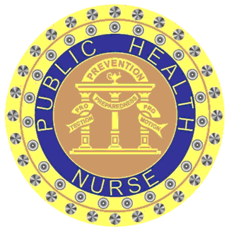
2 Peachtree Street, NW 9th Floor
Atlanta, GA 30303

CERTIFICATE OF ATTENDANCE

(Name of Learner)

has successfully completed the continuing education activity entitled:

Vaccine Administration Techniques

held on ________________________________________________________________
(Date and Location)

______________________________________
(Signature of Offering Leader)
Provider#___________
Activity ID#_________
Contact Hour(s):1.5 Hours_
Georgia Department of Public Health is an approved provider of continuing nursing education by the Alabama State Nurses Association, an accredited approver by the American Nurses Credentialing Center's Commission on Accreditation.

