World Asthma Day Pitch Letter

Dear [Insert Appropriate Name],

May 3 is World Asthma Day and the start of Asthma Awareness Month. The [Georgia Department of Public Health or local district] would like to remind the community that even with our busy schedules, it’s important to take time to remember the symptoms and risk of asthma.

Proper control and management of asthma triggers is the first step in controlling asthma symptoms. We ask that you help us spread the message that asthma control is vital in keeping the community healthy on World Asthma Day. In this spring and summer season, it is important to spread awareness about asthma and urge families to take control of this disease.

In Georgia, more than 126,000 children under 9 years of age have asthma, which costs Georgia nearly $50 million in emergency department and hospitalization charges in 2011. Keeping individuals healthier through asthma trigger management and adherence to long-term asthma control medication results in lower associated social and financial costs for families, including time lost from school and work, as well as the expense of medical bills. Please help us raise awareness about this important but often-neglected issue.

For more information on World Asthma Day, visit the Centers for Disease Control and Prevention’s website at http://www.cdc.gov/asthma/world_asthma_day.htm.

We hope you will use this information to keep Georgians healthy and productive this spring and summer season by spreading the message of asthma control. I am happy to provide any additional information on World Asthma Day or Asthma Awareness Month.

Kind regards,

[NAME]
[TITLE]
On Behalf of the [Georgia Department of Public Health or local district]

Asthma Facts
May is Asthma Awareness Month

FACT: World Asthma Day was established in 1998 to raise awareness, care and support for those affected by asthma.

FACT: Over 22 million people living in the United States have asthma.

FACT: More than 16 million adults have asthma. That’s equal to 1 in 12 adults.²

FACT: Six (6) million children have asthma. That’s equal to 1 in 11 children.²

FACT: Nearly 2 million people visit an emergency department for asthma care each year.²

FACT: More than 439,000 people were hospitalized due to asthma in 2010.²

FACT: Asthma is seen more often among children, females, African Americans, and those with a lower household income. ²

FACT: The annual economic cost of asthma, including direct medical costs from hospital stays and indirect costs such as lost school and work days, amount to more than $56 billion annually.

FACT: Indoor and outdoor environmental factors can trigger asthma attacks: dust mites, molds, cockroaches, pet dander, and secondhand smoke.

FACT: Asthma can be controlled with a plan that includes medical treatment and control of environmental triggers, people with asthma can lead healthy, active lives.⁴

FOR IMMEDIATE RELEASE CONTACT: [INSERT LOCAL CONTACT]

World Asthma Day Is May 3, 2016
May is Asthma Awareness Month
More than 22 million people living in the United States have asthma, a chronic lifelong disease that affects the lungs. Asthma can cause wheezing, breathlessness, chest tightness, and coughing. Although asthma cannot be cured, it is possible to manage asthma to reduce and prevent asthma attacks, also called episodes. In the United States, approximately half of people with asthma had at least one asthma attack in 2013. More children (58%) than adults (47%) had an attack.
In Georgia, nearly 1 in 10 children has asthma; and Black children are twice as likely as White children to have asthma. Additionally, asthma-related emergency room visits and hospitalizations for children cost Georgia nearly $50 million in 2011. These costs are preventable if asthma is controlled.
Asthma attacks cause adults to miss work and children to miss school. These dangerous and sometimes life-threatening episodes reduce the quality of life for people with asthma. The good news is that we can raise awareness and learn how asthma can be controlled.
People with asthma can prevent attacks if they learn how to avoid triggers like tobacco smoke, mold, outdoor air pollution, and colds and flu. Asthma episodes can also be prevented by using prescribed daily long-term control medicines correctly.
Studies show that fewer than 50 percent of people with asthma report being taught how to avoid triggers. Almost half of adults who were taught how to avoid triggers did not properly follow the advice.
To raise awareness about the health consequences and personal and financial costs of asthma, the Georgia Department of Public Health (DPH) Georgia Asthma Control Program (GACP) is participating in World Asthma Day on May 3, 2016, and Asthma Awareness Month throughout May. GACP joins the Centers for Disease Control and Prevention (CDC), the U.S. Environmental Protection Agency (EPA), and the Global Initiative for Asthma (GINA) in encouraging people with asthma to learn more about how to control this disease and prevent future attacks/episodes.

This year’s World Asthma Day theme is "You Can Control Your Asthma."

It's Time to Control Asthma in Georgia and throughout the world. To learn more about asthma control and management, visit CDC at www.cdc.gov/asthma. To learn how to raise awareness about asthma, visit GINA at www.ginasthma.org and use CDC’s Online Asthma Awareness Toolkit (http://www.cdc.gov/asthma/world_asthma_day.htm). For air quality information, visit EPA AirNow at www.enviroflash.info.

###

YOU CAN CONTROL YOUR ASTHMA!
WORLD ASTHMA DAY IS TUESDAY MAY 3, 2016.
MAY IS ASTHMA AWARENESS MONTH.

Millions of people in the United States have asthma, a chronic lifelong disease that affects the lungs. Asthma can cause wheezing, breathlessness, chest tightness, and coughing. Although asthma cannot be cured, it is possible to manage asthma to reduce and prevent asthma attacks, also called episodes.

It’s time to get asthma under control. Tips for successful asthma management include:
- Know the warning signs of an attack
- Avoid things that may trigger an attack
- Follow the advice of your healthcare provider
- Create a personal asthma management plan
- Use your asthma medicine as prescribed

Using what you know about managing your asthma can give you control over this chronic disease. When you control your asthma, you will breathe easier, be as active as you would like, sleep well, stay out of the hospital, and be free from coughing and wheezing.

To raise awareness about the health consequences and personal and financial costs of asthma, the Georgia Department of Public Health is participating in World Asthma Day on May 3, 2016 and Asthma Awareness Month throughout May. Georgia Department of Public Health – Georgia Asthma Control Program (GACP) joins Centers for Disease Control and Prevention (CDC), the U.S. Environmental Protection Agency (EPA), and the Global Initiative for Asthma (GINA) in encouraging people with asthma to learn more about how to control this disease and prevent episodes.

To learn more about how you can control your asthma, visit CDC's asthma site.

To learn how to raise awareness about asthma, visit GINA’s website at www.ginasthma.org and use CDC’s Online Asthma Awareness Kit (http://www.cdc.gov/asthma/world_asthma_day.htm).

To stay informed about air quality, visit the EPA AirNow website at http://www.enviroflash.info.

This year’s World Asthma Day theme is "You Can Control Your Asthma."

It's Time to Control Asthma in Georgia and throughout the world.

SAMPLE SOCIAL MEDIA MESSAGES
MAY IS ASTHMA AWARENESS MONTH.
Facebook:
May is Asthma Awareness Month. Asthma is a chronic disease that affects your lungs, but you can control it by taking the right medicine and avoiding triggers that cause an asthma attack. Learn more at www.cdc.gov/asthma/.
Living with asthma? You're not alone. The good news: you can control asthma by taking the right medicine and avoiding triggers that cause an asthma attack. Learn more about creating an asthma action plan at dph.georgia.gov/asthma-control-and-self-management
Asthma is common. One in 12 children has asthma, while 1 in 14 adults suffer from the disease. Learn more at www.cdc.gov/asthma/
Asthma is disruptive. Nearly 1 in 2 children with asthma report missing at least 1 day of school each year because of asthma.
Asthma is expensive, costing $56 billion each year.
Twitter:
#Asthma is a chronic disease that affects your lungs. Learn to control it with an Asthma Action Plan. Learn more here: dph.georgia.gov/asthma-control-and-self-management
1 in 12 children has #asthma. Nearly 11% of Georgia’s children has #asthma. Learn more here: dph.georgia.gov/Asthma
#Asthma is expensive. It costs the nation $56 billion per year.
Create an #asthma friendly #school with this toolkit from GACP: dph.georgia.gov/asthma-friendly-schools-0

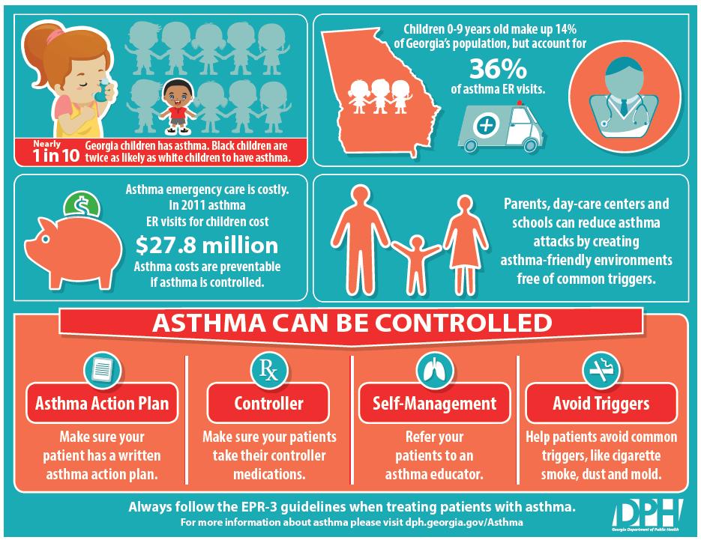

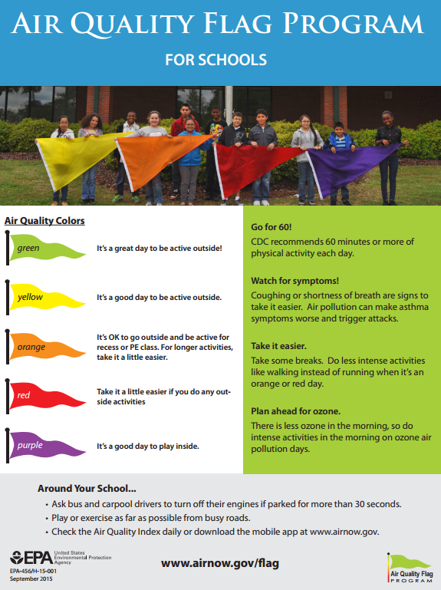

WhatHealth, 2016, http://www.whathealth.com/awareness/event/worldasthmaday.html
National Health Interview Survey (NHIS) Data, 2013, http://www.cdc.gov/asthma/most_recent_data.htm
Centers for Disease Control and Prevention (May 2011), Asthma in the US Vital Signs, http://www.cdc.gov/vitalsigns/asthma/
US Environmental Protection Agency, Asthma Awareness Month, Event Planning Kit, http://www.epa.gov/sites/production/files/2013-08/documents/event_planning_kit.pdf

