OUTBREAK SHIPPING KITS:
What you need to ship FRESH stool specimens to the Georgia Public Health Laboratory to test for
norovirus, C. perfringens, B. cereus,
and other organisms which require fresh specimens

Outside → Inside

- Cardboard container labeled for Category B specimens and contact information including return address (i.e. SafTPack)

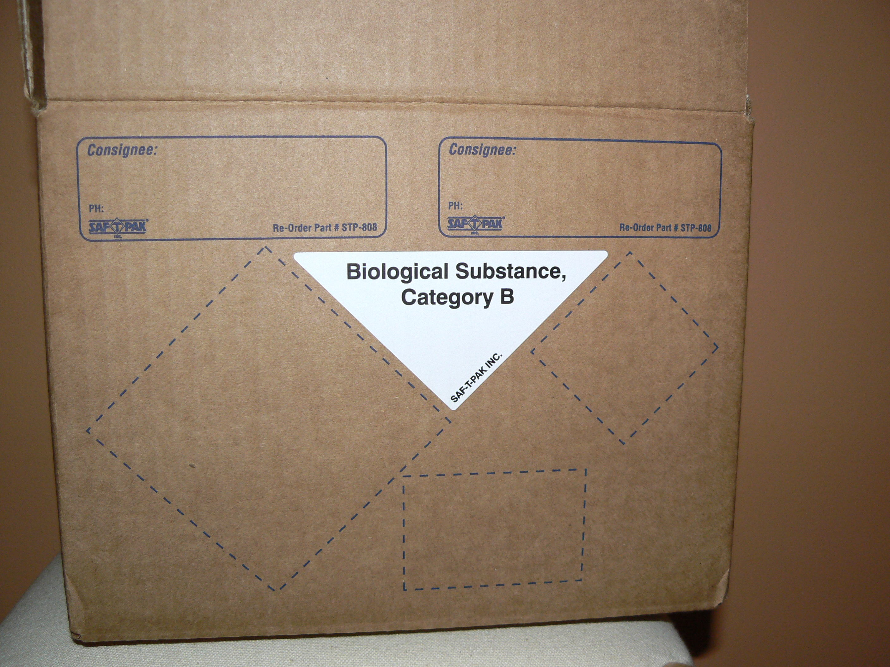

- Styrofoam cooler with cold pack

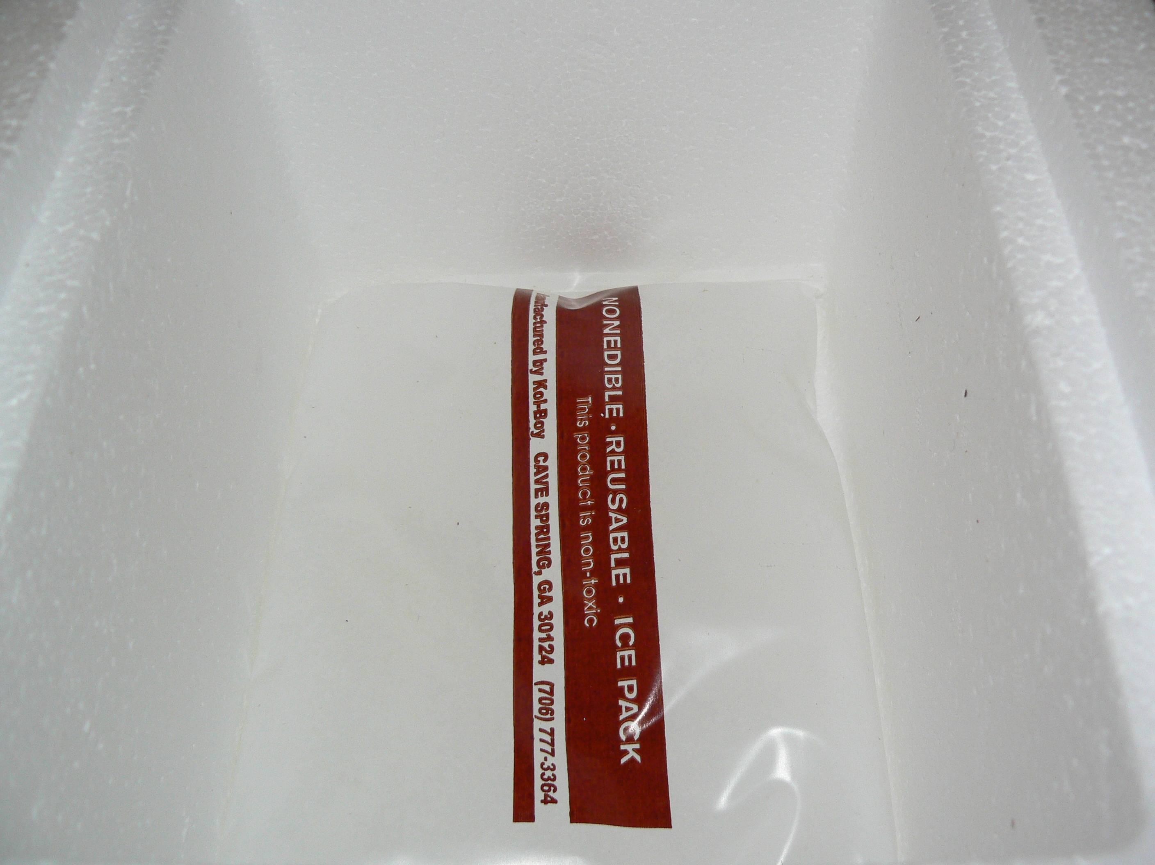

- Tyvek envelope

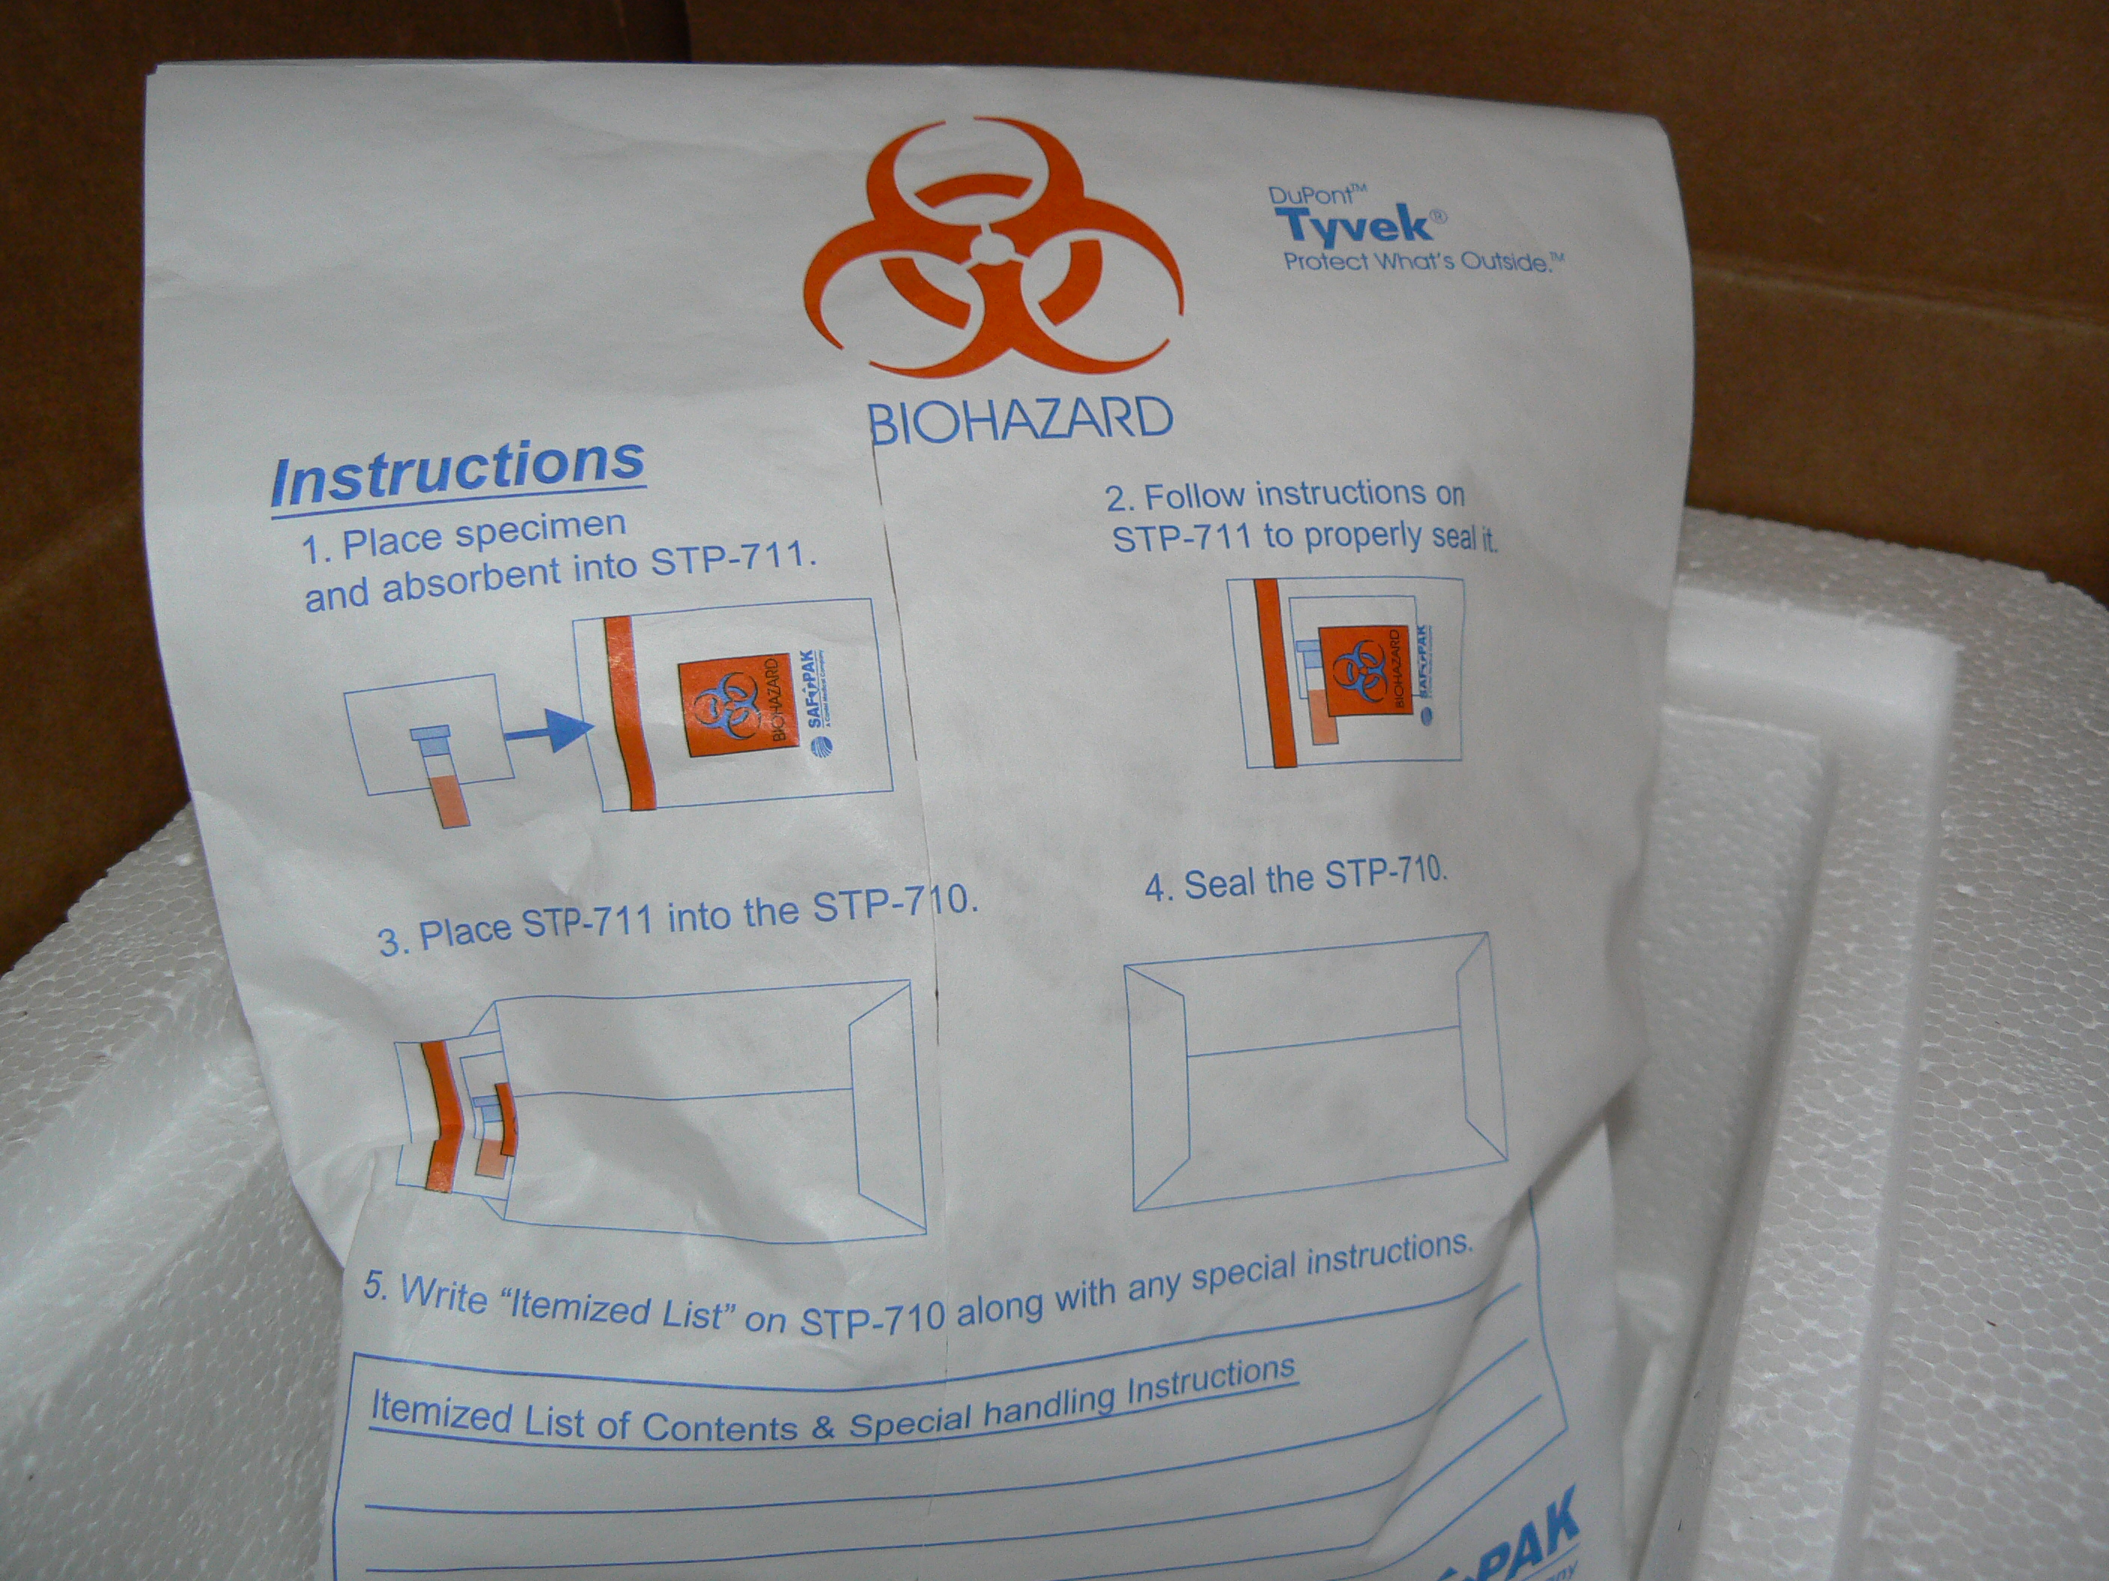

- Paperwork—Laboratory Submission Form 3595 (Norwalk identification by EM) or Laboratory Submission Form 3416 (C. perfringens or B. cereus)

Please see attachments

- Biohazard bag

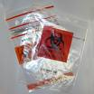

- Absorbent sheet

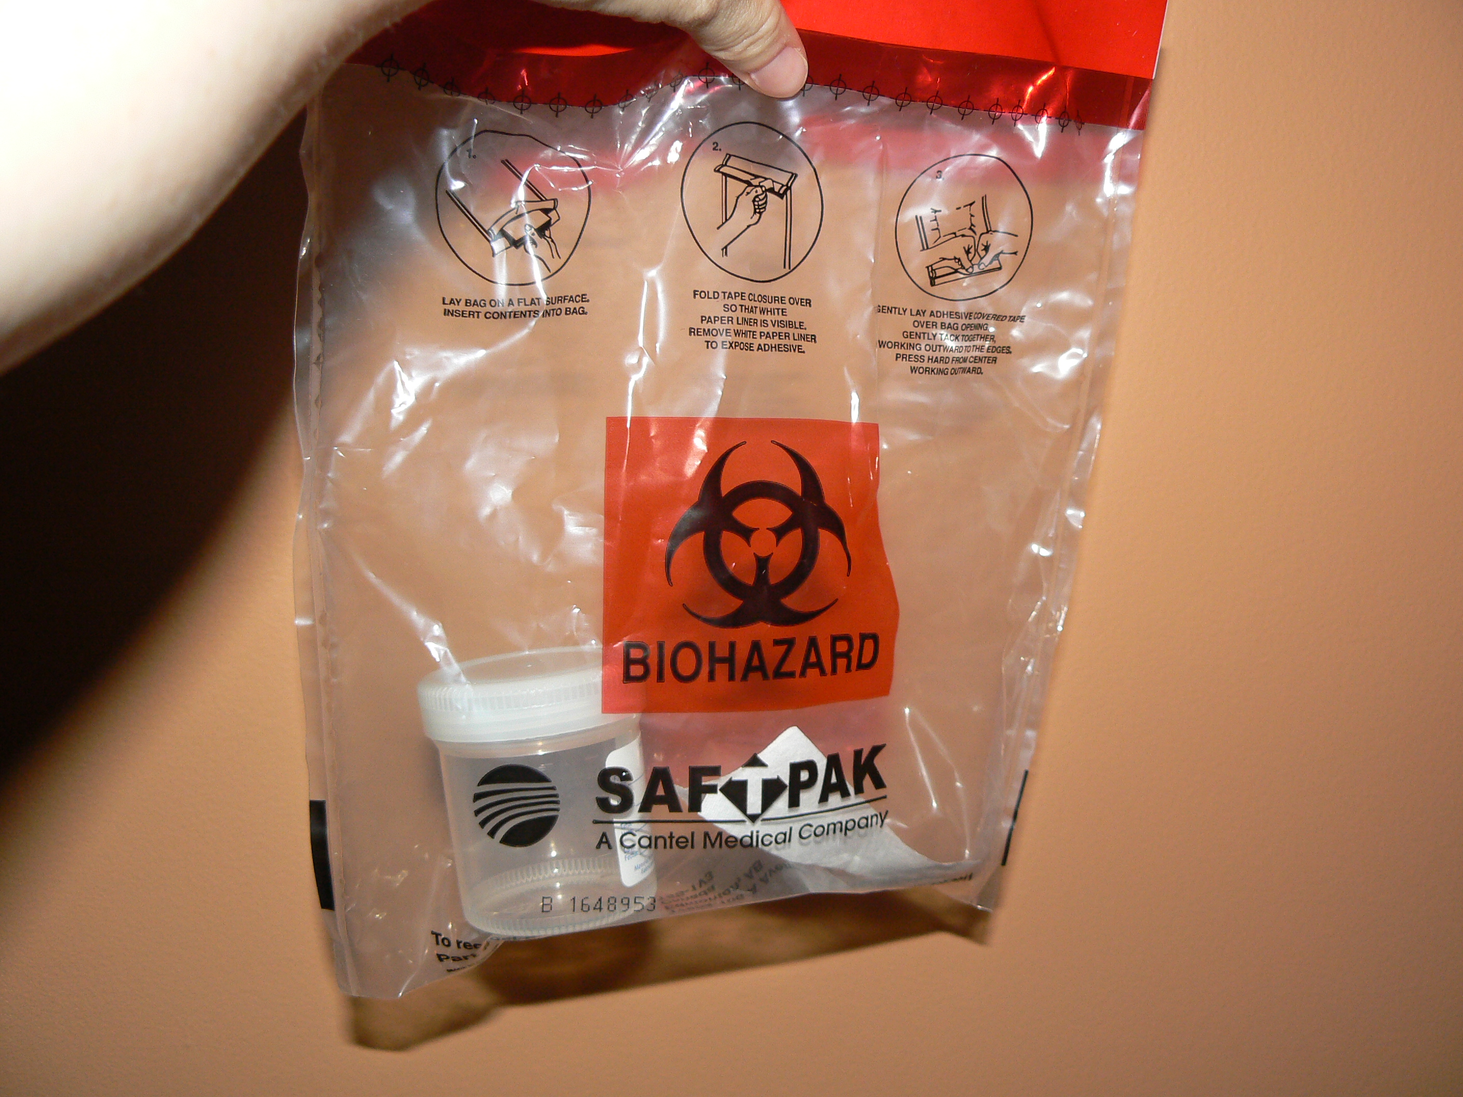

- Specimen: fresh stool in clean container

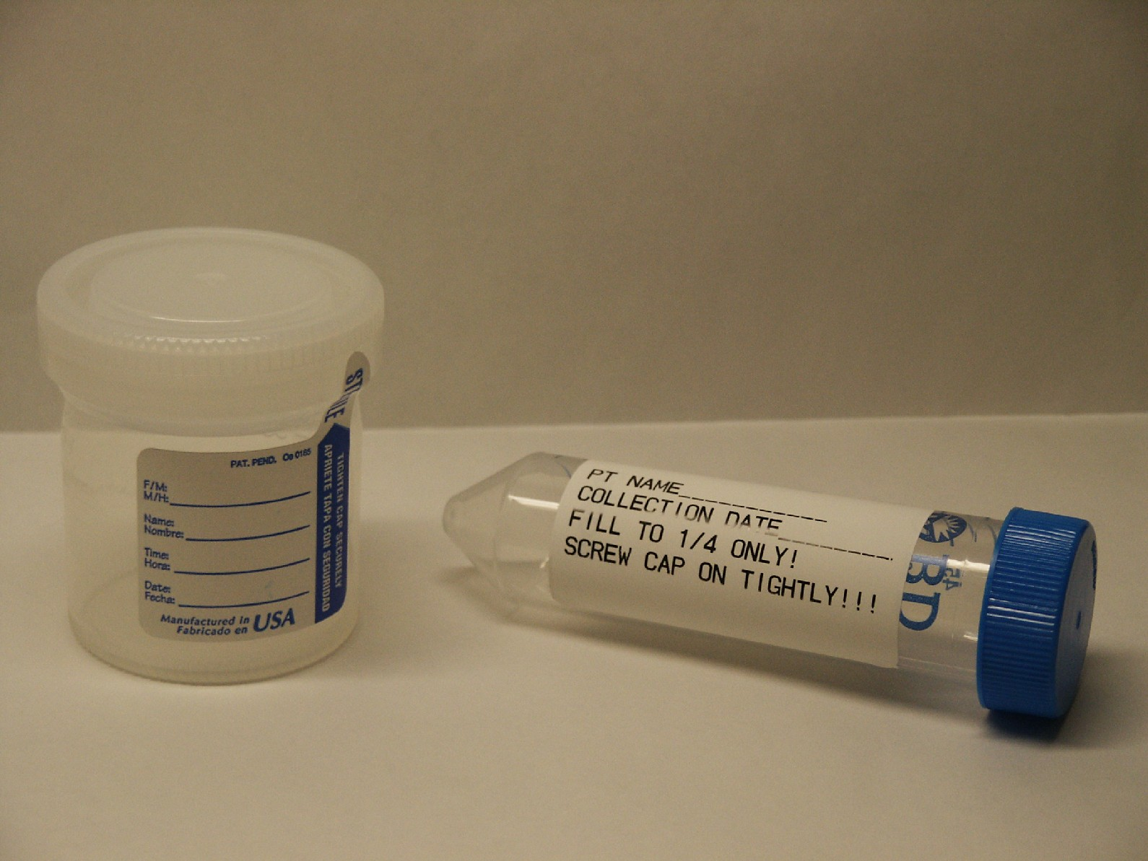
LABELED WITH PATIENT INFORMATION!!

