Opioid Overdose Surveillance
Georgia, 2018

Drug Surveillance Unit
Epidemiology Section
Division of Health Protection
Georgia Department of Public Health


https://dph.georgia.gov/drug-surveillance-unit

Opioid Overdose Surveillance, Georgia, 2018

The purpose of this report is to describe fatal (mortality) and nonfatal (morbidity) opioid-involved overdoses, which occurred in Georgia during 2018, including prescription opioids, and illicit opioids such as heroin, fentanyl, and fentanyl analogs. Opioid overdose data were analyzed by the Georgia Department of Public Health (DPH) Epidemiology Program, Drug Surveillance Unit, using Georgia hospital discharge inpatient and emergency department (ED) visit data, and DPH Vital Records death data.

Key Findings
- Opioid-involved overdose deaths rapidly increased in Georgia from 2010-2017, driven largely by increased use and misuse of prescription opioids (e.g., Oxycodone and Hydrocodone). Beginning in 2013, illicit opioids, such as heroin and fentanyl, drove the sharp increase in opioid-involved overdose deaths through 2017.
  - From 2010 to 2018, the total number of opioid-involved overdose deaths occurring in Georgia increased by 87%, from 514 to 962 deaths.
- From 2017-2018 all drug overdose death categories decreased except for heroin.
- In 2018, among Georgia residents:
  - Any opioid-involved overdoses accounted for 4,985 ED visits, 2,353 hospitalizations, and 910 deaths.
  - Heroin-involved overdoses accounted for 1,353 ED visits, 325 hospitalizations, and 314 deaths.
  - Fentanyl-involved overdoses accounted for 327 deaths.
  - Quarterly opioid-involved overdose ED visit rates trended slightly downward in 2018.
  - Quarterly heroin-involved overdose ED visit rates trended slightly downward during 2018, with the exception of Quarter 3 (Q3).
  - Opioid-involved ED visit rates among males remained steady from 2018 Q1 (12.1) to 2018 Q3 (12.2) then trended downwards in 2018 Q4 (10.7).
  - Opioid-involved ED visit rates among females slightly trended downwards during 2018, with the exception of Q4.
  - Persons aged 35-44 years died from an opioid-involved overdose more frequently than persons of other age categories.
  - Persons aged 25-34 years more frequently died from a heroin- or fentanyl-involved overdose, and visited an ED for an opioid-involved overdose than persons of other age categories, yet older persons aged 45 and older were more frequently hospitalized because of an opioid-involved overdose.
  - Males aged 25-34 years died from an opioid-involved overdose more frequently than any other age category, and were 3.0 times more likely to die from an overdose than females of the same age.
  - Males were 1.9 times more likely to die from any opioid-involved overdose, and 3.1 times more likely to die from a heroin-involved overdose than females. However, females, particularly those aged 55 years and older, were more frequently hospitalized for an opioid-involved overdose than males.
  - Quarterly opioid-involved overdose death rates among males trended downward from 2018 Q1 (2.9) to 2018 Q2 (2.7) then increased from 2018 Q3 (2.7) to 2018 Q4 (3.1).
  - Opioid-involved overdose deaths rates among females trended downward from 2018 Q1 (1.7) to 2018 Q2 (1.4), upwards in 2018 Q3 (1.6), then down in 2018 Q4 (1.4).
  - Quarterly opioid-involved ED visit rates among Whites trended downwards in 2018.
  - Quarterly opioid-involved ED visit rates among Blacks remained steady during 2018.
  - Whites were 3.4 times more likely to die from an opioid-involved overdose, 2.5 times more like to visit an ED for any opioid-involved overdose, and 4.7 times more likely to visit an ED for a heroin-involved overdose than Blacks.
  - Quarterly opioid-involved overdose death rates among Whites trended downward slightly in 2018.
  - Quarterly opioid-involved overdose death rates among Blacks remained steady in 2018.
  - The highest numbers of heroin- and opioid-involved overdose deaths, ED visits, and hospitalizations occurred predominantly among residents in urban areas (Atlanta Metropolitan Area, Augusta, Macon, Columbus, and Savannah). However, high rates of opioid overdose-involved ED visits and hospitalizations occurred among residents in both urban and rural areas, particularly in North, South Central, and Southeast Georgia.

For more information:
- County level data and other Georgia drug surveillance reports:
https://dph.georgia.gov/drug-surveillance-unit
- Georgia Department of Public Health (DPH) Main Opioid Page:
- https://dph.georgia.gov/stopopioidaddiction
- Georgia drug overdose mortality interactive maps and statistics: https://oasis.state.ga.us/PageDirect.aspx?referer=MortalityDrugOverdoses
- Prescription Drug Monitoring Program (PDMP) information: GA PDMP Overview and FAQs
https://dph.georgia.gov/pdmp

Fatal Drug Overdoses (Mortality), Georgia, 2018
Data Source
Overdose-involved deaths were derived from DPH Vital Records death certificates. The following data include all deaths that occurred in Georgia among Georgia residents and deaths that occurred outside of Georgia among Georgia residents, unless otherwise specified.
Case Definitions
(Note: categories are not mutually exclusive, includes only drug overdose deaths caused by acute poisoning)
Any drug overdose death
May involve any over-the-counter, prescription, or illicit drug
- Deaths with any of the following ICD-10 codes as any underlying cause of death: X40-44, X60-64, X85, Y10-14
Drug overdose death involving any opioid
Involves both prescription opioid pain relievers (e.g., hydrocodone, oxycodone, and morphine), opioids used to treat addiction (e.g., methadone), as well as heroin, opium, and synthetic opioids (e.g., tramadol and fentanyl that may be prescription or illicitly manufactured)
- Deaths with any of the following ICD-10 codes as any underlying cause of death: X40-44, X60-64, X85, Y10-14
AND one of the following:
- Any of the following ICD-10 codes as any other listed cause of death: T40.0, T40.1, T40.2, T40.3, T40.4, T40.6
- Any cause of death text field contains one of the following terms (or common misspelling): heroin, fentanyl (and fentanyl analogs), methadone, buprenorphine, butalbital, codeine, eddp, hydrocodone, hydromorphone, levorphanol, meperidine, norbuprenorphine, oxycodone, oxymorphone, tapentadol, tramadol

OR (for cases without an X or Y code in the underlying cause of death):
- Any cause of death text field contains the word “TOXIC” AND at least one of the following terms (or common misspelling): heroin, fentanyl (and fentanyl analogs), methadone, buprenorphine, butalbital, codeine, eddp, hydrocodone, hydromorphone, levorphanol, meperidine, norbuprenorphine, oxycodone, oxymorphone, tapentadol, tramadol
Drug overdose death involving synthetic opioids other than methadone
Involves synthetic opioids other than methadone (e.g., tramadol and fentanyl that may be prescription or illicitly manufactured). Note: polysubstance abuse deaths may also involve methadone or other opioids
- Deaths with any of the following ICD-10 codes as any underlying cause of death: X40-44, X60-64, X85, Y10-14
AND one of the following:
- The following ICD-10 code as any other listed cause of death: T40.4
- Any cause of death text field contains the following keywords and common misspellings: fentanyl (and fentanyl analogs), tramadol

OR (for cases without an X or Y code in the underlying cause of death):
- Any cause of death text field contains the word “TOXIC” AND at least one of the following terms (or common misspelling): fentanyl (and fentanyl analogs), tramadol
Drug overdose death involving heroin
Involves heroin. Note: polysubstance abuse deaths may also involve other opioids
- Deaths with any of the following ICD-10 codes as any underlying cause of death: X40-44, X60-64, X85, Y10-14
AND one of the following:
- The following ICD-10 code as any other listed cause of death: T40.1
- Any cause of death text field contains the following keywords and common misspellings: heroin, morphine

OR (for cases without an X or Y code in the underlying cause of death):
- Any cause of death text field contains the word “TOXIC” AND at least one of the following terms (or common misspelling): heroin, morphine
Drug overdose death involving fentanyl
Note: polysubstance abuse deaths may also involve other opioids
Any cause of death text field contains the word “TOXIC” AND at least one of the following terms (or common misspelling): fentanyl (and fentanyl analogs)
Other Definitions or Limitations
Deaths represent individual people who died in Georgia and deaths among Georgia residents outside of Georgia.
Overdose death county represents the county of residence, or the place of injury (where the overdose occurred) as specified; when the place of injury field or the county of residence field was blank the county of the death certifier was used.
Rate indicates the number of deaths among Georgia residents per 100,000 population using 2018 Census data as the denominator, and all rates are age- adjusted unless age category is presented.
Rates for categories with fewer than 5 deaths may not be accurate and are not presented in this report.
ICD-10 Code Description
X40-X44 (accidental poisonings by drugs), X60-X64 (intentional self-poisoning by drugs), X85 (assault by drug poisoning), Y10-Y14 (drug poisoning of undetermined intent), T40.0 (opium), T40.1 (heroin), T40.2 (natural and semisynthetic opioids), T40.3 (methadone), T40.4 (synthetic opioids, other than methadone, T40.6 (other and unspecified narcotics)

Nonfatal Overdoses (Morbidity), Georgia, 2018
Data Source
Nonfatal overdose counts were derived from Georgia hospitalization and emergency department (ED) visit discharge data, and included all ED visits or hospitalizations occurring in a non-Federal acute care hospital in Georgia, among Georgia residents, with a discharge diagnosis indicating acute drug overdose during 2018.
Case Definitions (categories are not mutually exclusive)
ED visit or hospitalization involving any drug overdose
May include any over-the-counter, prescription, or illicit drug
- Any mention of ICD-10CM codes: T36-T50
AND
- 6th character: 1-4, and a 7th character of A or missing
ED visit or hospitalization involving any opioid overdose
Includes prescription opioid pain relievers (e.g., hydrocodone, oxycodone, and morphine), opioids used to treat addiction (e.g., methadone), as well as heroin, opium, and synthetic opioids (e.g., tramadol and fentanyl that may be prescription or illicitly-manufactured)
- Any mention of ICD-10CM codes: T40.0X, T40.1X, T40.2X, T40.3X, T40.4X, T40.60, T40.69
AND
- 6th character: 1-4, and a 7th character of A or missing
ED visit or hospitalization involving a heroin overdose
- Any mention of ICD-10CM code: T40.1X
AND
- 6th character: 1-4, and a 7th character of A or missing

Other Definitions or Limitations
Any opioid may include prescription or illicit opioids.
ED Visits and Hospitalization categories are not mutually exclusive. Hospitalizations may also appear in the ED Visits category if they were admitted to the hospital through the ED.
ED visits and hospitalizations may represent multiple visits by individuals in Georgia.
County indicates the patient’s county of residence.
Only Black and White are indicated for race because of incomplete or sparse data on other races and ethnicities.
Rate indicates the number of ED visits or hospitalizations among Georgia residents per 100,000 population using 2018 Census data as the denominator, and all rates are age-adjusted unless age category is presented.
Rates for categories with fewer than 5 ED visits or hospitalizations may not be accurate and are not presented in this report.
ICD-10 CM Code Description
Poisoning by: T36-T50 (range includes all drugs), T40.0X (opium), T40.1X (heroin), T40.2X (other opioids), T40.3X (methadone), T40.4X (synthetic narcotics), T40.60 (unspecified narcotics), T40.69 (other narcotics)
6th Character: 1 (accidental, unintentional), 2 (intentional self-harm), 3 (assault), 4 (undetermined intent)
7th Character: A (initial encounter) or missing

Drug-Involved Overdose Deaths (Mortality)
Note: Any opioid may include prescription or illicit opioids. Categories are not mutually exclusive. Overdose-involved deaths were derived from DPH Vital Records death certificates.
The following data include deaths that occurred in Georgia regardless of the patient’s residence state.

- From 2010 to 2018, the number of opioid-involved overdose deaths increased by 87%, from 514 to 962 deaths.
- Beginning in 2013, illicit opioids, such as heroin and fentanyl, drove the sharp increase in opioid-involved overdose deaths through 2017. Note: fentanyl is included in the synthetic opioid category.
- From 2017 to 2018 drug-involved overdose death categories decreased except for heroin.

- Opioid-involved overdose deaths trended downward during 2018 Q1 to 2018 Q2, then leveled off.
- Fentanyl-involved overdose deaths remained steady during 2018.
Note: The following data include all deaths that occurred in Georgia among Georgia residents and deaths that occurred outside of Georgia among Georgia residents, unless otherwise specified.

- In 2018, overdose deaths involving fentanyl (327) were similar in number to deaths involving heroin (314). Note: fentanyl is included in the synthetic opioid category.
- From 2017 to 2018, drug overdose death categories decreased except for heroin.

- Persons aged 35-44 years died from an opioid-involved overdose more frequently than persons of other age categories.
- Persons aged 25-34 years died from a heroin- or fentanyl-involved overdose more frequently than persons of other age categories.

- Whites were 3.4 times more likely to die from an opioid-involved overdose than Blacks.

- Opioid-involved overdose death rates among Whites trended downward slightly in 2018.
- Opioid-involved overdose death rates among Blacks remained steady in 2018.

- Males were 1.9 times more likely to die from any opioid-involved overdose, and 3.1 times more likely to die from a heroin-involved overdose than females.

- Males aged 25-34 years died from an opioid-involved overdose more frequently than persons of any other age category, and were 3.0 times more likely to die from an overdose than females of the same age.

- Opioid-involved overdose death rates among males trended downward from 2018 Q1 to 2018 Q2 then increased from 2018 Q3 to 2018 Q4.
- Opioid-involved overdose deaths rates among females trended downward from 2018 Q1 to 2018 Q2, upwards in 2018 Q3, then down in 2018 Q4.

Opioid-Involved Overdose Emergency Department Visits and Hospitalizations (Morbidity)
Any opioid may include prescription or illicit opioids. ED visits and hospitalization categories are not mutually exclusive. Hospitalizations may also appear in the ED visits category if they were admitted to the hospital through the ED (95% of opioid hospitalizations were admitted from the ED in 2018).
Opioid-Involved Overdose Emergency Department Visits and Hospitalizations, by Drug Type, Georgia, 2018
Any opioid may include prescription and/or illicit opioids; categories are not mutually exclusive
 | Number represents events that occurred in Georgia regardless of the patient’s residence state | Number represents events that occurred in Georgia among Georgia residents
Drug Category | No. | No.
Any Opioid ED Visits | 5386 | 4985
Any Opioid Hospitalizations | 2523 | 2353
Heroin ED Visits | 1509 | 1353
Heroin Hospitalizations | 349 | 325

Note: The following data include all ED visits and hospitalizations that occurred in Georgia among Georgia residents.

- From 2017 to 2018, ED visits for opioid- and heroin-involved overdoses decreased by 12% and 11% respectively.
- Hospitalizations for opioid- and heroin-involved overdoses decreased by 10% and 3% respectively.

- Opioid-involved overdose ED visit rates trended slightly downward in 2018.
- Heroin-involved overdose ED visit rates trended slightly downward during 2018, with the exception of Q3.

- Persons aged 25-34 years were more likely to visit an ED because of an opioid-involved overdose than persons of other age categories, yet persons aged 45 and older were more frequently hospitalized because of an opioid-involved overdose.
- Heroin-involved overdoses occurred most frequently among persons aged 25-34 years, and were less common among younger and older persons.

- Whites were 2.5 times more likely to visit an ED for any opioid-involved overdose, 4.7 times more likely to visit an ED for a heroin-involved overdose, and 2.4 times more likely to be hospitalized for an opioid-involved overdose than Blacks.

- Opioid-involved ED visit rates among Whites trended downwards in 2018.
- Opioid-involved ED visit rates among Blacks remained steady during 2018.

- Males aged 25-34 years visited an ED and/or died from an opioid-involved overdose more frequently than females of the same age category.
- Females, particularly those aged 55-74 years, more frequently visited an ED, and were more frequently hospitalized for an opioid-involved overdose than males.

- Opioid-involved ED visit rates among males remained steady from 2018 Q1 to 2018 Q3 then trended downwards in 2018 Q4.
- Opioid-involved ED visit rates among females slightly trended downwards during 2018, with the exception of Q4.

HEROIN-INVOLVED OVERDOSES
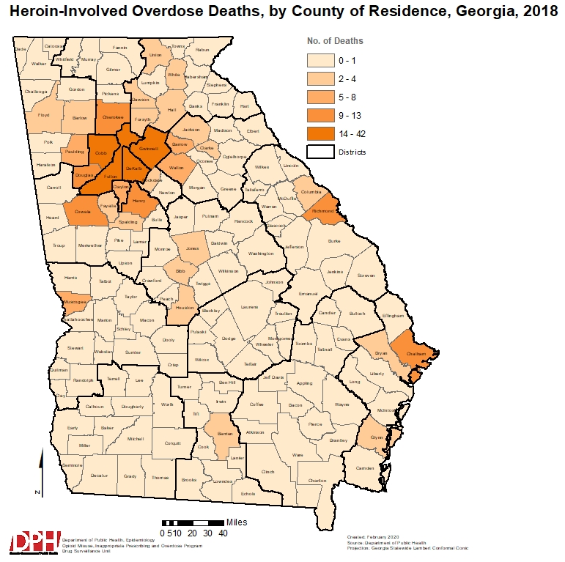
NOTE: Rates could not be calculated for most counties due to the low number of heroin-involved overdose deaths, ED visits and hospitalizations. Therefore, the number (not rate) of overdoses are presented in this map.

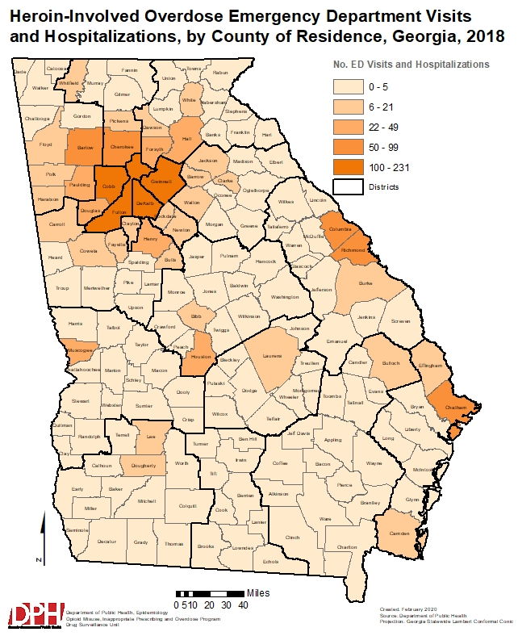
NOTE: Rates could not be calculated for some counties due to the low number of heroin-involved overdose deaths, ED visits and hospitalizations. Therefore, the number (not rate) of overdoses are presented in this map.

ANY OPIOID-INVOLVED OVERDOSES
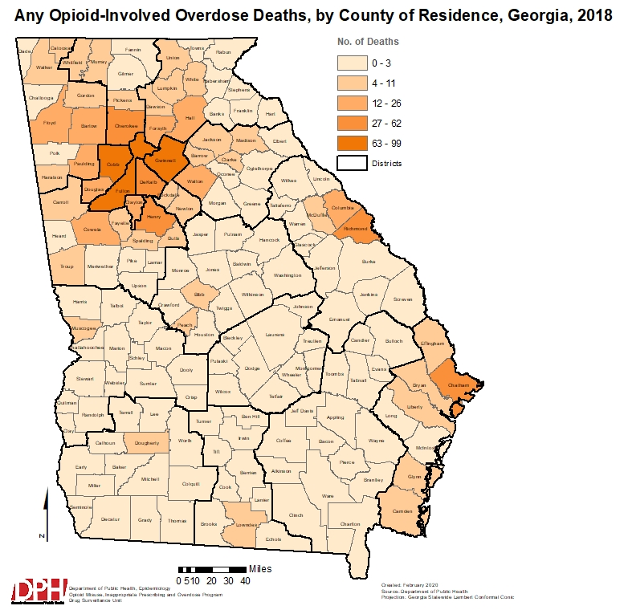

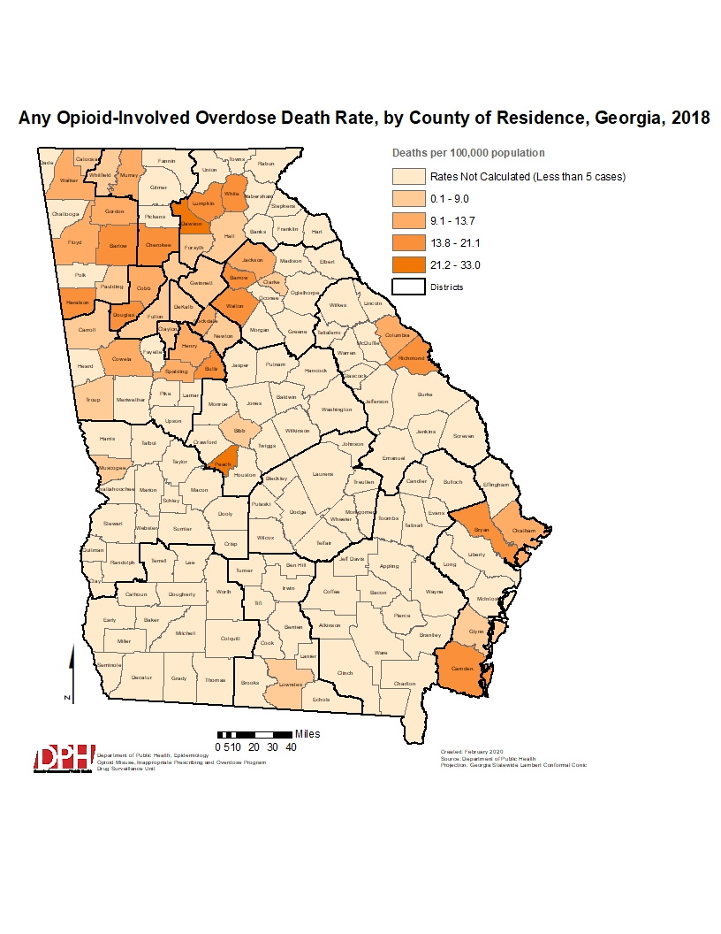

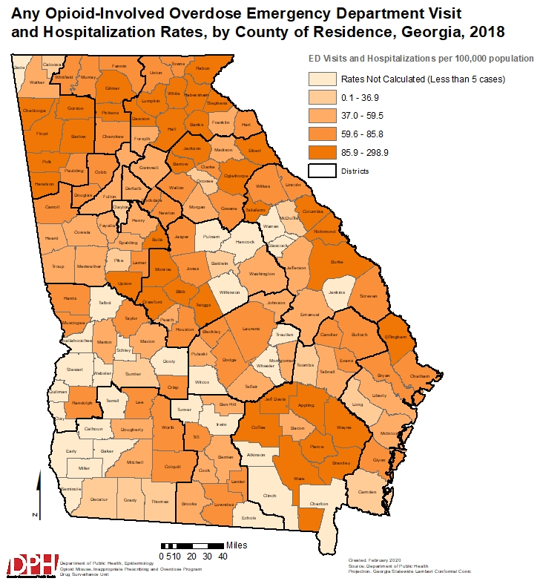
Georgia Bureau of Investigations (GBI) Crime Laboratory Submissions
Crime laboratory submissions are evidence items (pills, powders, etc.) seized by law enforcement and submitted to the GBI Crime Laboratory (https://dofs-gbi.georgia.gov/) for forensic chemical identification. A case may contain one submission or several. For example, a case may consist of a single plastic bag with powder material inside, or a case may have been a result of a massive search warrant and contain many bags of powder, plus pills and liquids. Each submission that is tested is recorded and tracked. These data represent only items tested during each calendar year; these numbers may change slightly as untested items are completed. Note: Data as of July 2019.

- From 2014 to 2018, heroin submissions to the GBI Crime Laboratory decreased by 8.4% and Fentanyl submissions increased by 348%.

- Oxycodone, hydrocodone, and heroin were the opioids most frequently submitted to the GBI Crime Laboratory for identification, and in the top six drugs most commonly submitted. Oxycodone and hydrocodone were also the two most frequently prescribed opioids in Georgia in 2018. Hydrocodone was the most frequently prescribed opioid in Georgia while oxycodone was the 2nd highest prescribed opioid in Georgia in 2018. (see the Georgia PDMP 2018 Report available at https://dph.georgia.gov/drug-overdose-surveillance-unit).

Counties with the Highest Number or Rate of Any Opioid-Involved Overdose Deaths, Emergency Department (ED) Visits and Inpatient Hospitalizations — Georgia, 2018
Number, and age-adjusted rate per 100,000 population. Note: rates could not be calculated for some counties due to the low number of any opioid-involved overdose ED visits, hospitalizations, and deaths, only counties with >15 were included in the top 10 rate ranking
Rank | No. deaths  County of residence | No. deaths  County of injury | Death rate  County of residence | No. ED visits and hospitalizations  County of residence | ED visit and hospitalization rate  County of residence
1 | Fulton (99) | Fulton (119) | Richmond (20.1) | Fulton (612) | Polk (181.6)
2 | Cobb (85) | Cobb (88) | Bartow (17.5) | Cobb (522) | Haralson (170.4)
3 | Gwinnett (76) | DeKalb (62) | Walton (16.4) | Gwinnett (430) | Bartow (170.0)
4 | DeKalb (56) | Gwinnett (50) | Cherokee (14.9) | DeKalb (340) | White (150.9)
5 | Cherokee (38) | Cherokee (31) | Douglas (14.1) | Richmond (261) | Chattooga (132.5)
6 | Richmond (38) | Richmond (25) | Henry (11.2) | Chatham (252) | Elbert (131.0)
7 | Chatham (30) | Henry (22) | Chatham (10.8) | Hall (244) | Jeff Davis (130.3)
8 | Henry (28) | Hall (18) | Cobb (10.8) | Cherokee (189) | Richmond (128.7)
9 | Douglas (19) | Bartow (16) | Coweta (10.8) | Bartow (184) | Lumpkin (123.6)
10 | Bartow (18) | Chatham (16) | Columbia (10.7) | Columbia (176) | Jackson (123.5)

Note: The following data include deaths that occurred in Georgia regardless of the patient’s residence state.

Drug Overdose Deaths (Mortality) — Georgia, 2010–2018
Any opioid may include prescription and/or and illicit opioids; categories are not mutually exclusive
Number represents events that occurred in Georgia regardless of the patient’s residence state.
 | Any Drug | Any Opioid | Synthetic Opioids | Heroin | Fentanyl
Year | No. | No. | No. | No. | No.
2018 | 1582 | 962 | 476 | 341 | 348
2017 | 1591 | 1051 | 506 | 284 | 381
2016 | 1436 | 954 | 399 | 228 | 245
2015 | 1364 | 901 | 411 | 252 | 255
2014 | 1041 | 637 | 164 | 236 | 138
2013 | 1113 | 556 | 82 | 131 | 52
2012 | 1066 | 554 | 65 | 106 | 48
2011 | 1042 | 519 | 84 | 29 | N/A
2010 | 1059 | 514 | 102 | 4 | N/A

Drug Overdose Emergency Department (ED) Visits and Hospitalizations (Morbidity) — Georgia Residents, 2016-2018
Number, and age-adjusted rate per 100,000 population
Any opioid may include prescription and/or illicit opioids; categories are not mutually exclusive.
 | Any Opioid |  |  |  | Heroin
 | ED Visits |  | Hospitalizations |  | ED Visits |  | Hospitalizations
Year | No. | Rate | No. | Rate | No. | Rate | No. | Rate
2018 | 4985 | 45.6 | 2353 | 20.7 | 1353 | 13.1 | 325 | 3.2
2017 | 5656 | 52.6 | 2622 | 23.5 | 1521 | 14.9 | 335 | 3.3
2016 | 5195 | 48.9 | 2639 | 24.3 | 1204 | 11.8 | 306 | 3.0

Opioid Related Overdose Morbidity and Mortality — Georgia Residents, 2018
(for emergency department (ED) visits, inpatient hospitalizations, and deaths)
Number and rate per 100,000 population (rate is age-adjusted except when age categories are presented)
Any opioid may include prescription and/or illicit opioids; categories are not mutually exclusive
Rates for counts under 5 may be unstable and are not presented.
Any Opioid
 | ED Visits |  | Hospitalizations |  | Deaths
 | No. | Rate | No. | Rate | No. | Rate
Total | 4985 | 45.6 | 2353 | 20.7 | 910 | 8.7
Age group (yrs)
<1 year | 8 | 6.3 | 1 | N/A | 0 | N/A
1-4 years | 55 | 10.4 | 12 | 2.3 | 0 | N/A
5 -14 years | 23 | 1.6 | 9 | 0.6 | 1 | N/A
15-24 years | 498 | 34.5 | 123 | 8.5 | 69 | 4.8
25-34 years | 1200 | 81.5 | 335 | 22.7 | 228 | 15.5
35-44 years | 752 | 54.8 | 287 | 20.9 | 239 | 17.4
45-54 years | 726 | 51.4 | 395 | 28.0 | 176 | 12.5
55-64 years | 901 | 70.1 | 596 | 46.4 | 140 | 10.9
65-74 years | 553 | 61.8 | 409 | 45.7 | 51 | 5.7
75-84 years | 201 | 48.0 | 147 | 35.1 | 3 | N/A
85+ years | 68 | 46.4 | 39 | 26.6 | 3 | N/A
Sex (age group)
Male | 2450 | 47.0 | 987 | 18.6 | 580 | 11.4
<1 year | 5 | 7.7 | 1 | N/A | 0 | N/A
1-4 years | 28 | 10.4 | 9 | 3.3 | 0 | N/A
5-14 years | 6 | 0.8 | 3 | N/A | 0 | N/A
15-24 years | 277 | 37.7 | 74 | 10.1 | 53 | 7.2
25-34 years | 769 | 105.3 | 205 | 28.1 | 171 | 23.4
35-44 years | 401 | 60.6 | 146 | 22.1 | 146 | 22.1
45-54 years | 299 | 43.6 | 136 | 19.8 | 104 | 15.2
55-64 years | 373 | 61.1 | 216 | 35.4 | 78 | 12.8
65-74 years | 203 | 49.8 | 141 | 34.6 | 26 | 6.4
75-84 years | 65 | 36.3 | 44 | 24.5 | 1 | N/A
85+ years | 24 | 48.5 | 12 | 24.3 | 1 | N/A
Female | 2532 | 43.9 | 1365 | 22.4 | 330 | 6.0
<1 year | 3 | N/A | 0 | N/A | 0 | N/A
1-4 years | 27 | 10.4 | 3 | N/A | 0 | N/A
5-14 years | 17 | 2.5 | 6 | 0.9 | 1 | N/A
15-24 years | 221 | 31.1 | 49 | 6.9 | 16 | 2.3
25-34 years | 431 | 58.0 | 130 | 17.5 | 57 | 7.7
35-44 years | 351 | 49.4 | 141 | 19.8 | 93 | 13.1
45-54 years | 427 | 58.8 | 259 | 35.7 | 72 | 9.9
55-64 years | 528 | 78.2 | 380 | 56.3 | 62 | 9.2
65-74 years | 350 | 71.8 | 268 | 55.0 | 25 | 5.1
75-84 years | 136 | 56.9 | 103 | 43.1 | 2 | N/A
85+ years | 41 | 42.2 | 26 | 26.8 | 2 | N/A
Race
White | 3819 | 65.1 | 1842 | 28.5 | 757 | 14.0
Black | 898 | 26.4 | 402 | 11.8 | 139 | 4.1

Opioid Overdose Surveillance and Response Information/Resources

To report an increase in overdoses, a potential overdose cluster, or any other unusual drug-related event, call the Georgia Poison Center at 1-800-222-1222.
Please see https://dph.georgia.gov/stopopioidaddiction for more information on how the Georgia Department of Public Health (DPH) is working to combat the opioid epidemic, including:
- Opioid and substance misuse response: https://dph.georgia.gov/georgias-opioid-response
- Prescription Drug Monitoring Program (PDMP): https://dph.georgia.gov/pdmp
- Drug Surveillance Unit: https://dph.georgia.gov/drug-surveillance-unit
Please see https://dph.georgia.gov/opioid-epidemic-individuals-and-families for information on the opioid epidemic for individuals and families, including:
- Addiction prevention
- Drug take-back
- Signs of an overdose and steps to take
- Naloxone information
- Georgia’s Prescription Drug Monitoring Program (PDMP)
- Georgia’s Medical Amnesty Law
- Harm reduction
- Neo-natal abstinence syndrome
- Treatment resources
Please see https://dph.georgia.gov/opioid-epidemic-medical-providers-and-pharmacists for information on the opioid epidemic for medical providers and pharmacists, including:
- Steps providers can take to help prevent opioid misuse and addiction in their patients
- Prescribing guidelines
- Georgia’s Prescription Drug Monitoring Program (PDMP)
- Georgia’s Naloxone Standing Order
- Georgia’s Medical Amnesty Law
Please see https://dph.georgia.gov/opioid-epidemic-first-responders-and-ems for information on the opioid epidemic for Law Enforcement and EMS, including:
- Georgia’s Prescription Drug Monitoring Program (PDMP)
- Responder safety
- Georgia’s Medical Amnesty Law
- Georgia’s Naloxone Standing Order
- Naloxone administration
- Case documentation guidelines
Georgia Department of Public Health (DPH), Epidemiology Section, Drug Surveillance Unit
https://dph.georgia.gov/drug-surveillance-unit

