November 20, 2019
Dear Georgia WIC Vendor:
The WIC Vendor Agreement provides that vendors must “comply with the provisions of this agreement, and all federal and state laws, policies, procedures, rules and regulations . . . and any subsequent revisions to the policies, procedures, laws, rules and regulations issued by the federal government and Georgia WIC during the agreement period.” The Georgia WIC Program has recently amended its program requirements. These amendments are contained in the Georgia WIC Program Notice of Change in WIC Requirements, Addendum No. 20-01, which goes into effect on December 13, 2019.
You are required to review Addendum 20-01 in its entirety and complete the enclosed Addendum Verification Checklist. The Addendum and current version of the Georgia WIC Program Vendor Handbook (effective December 13, 2019) will also be accessible on the Georgia WIC Program Vendor website at http://dph.georgia.gov/vendor-information. You must return the signed and dated checklist by December 11, 2019 to the following address:
Georgia WIC Program
Office of Vendor Management
Attn: WIC Program Addendum 20-01
2 Peachtree Street, Floor 10
Atlanta, Georgia 30303-3142

Documents will not be accepted via hand-delivery, facsimile, or e-mail. We urge you to use a traceable delivery method.

Please note that failure to complete and submit the Addendum Verification Checklist by December 11, 2019 may result in the termination of your Vendor Agreement. If you have any questions, please contact Vendor Customer Service at (866) 814-5468, or (404) 657-2900, between the hours of 8:00 a.m. and 5:00 p.m. EST.

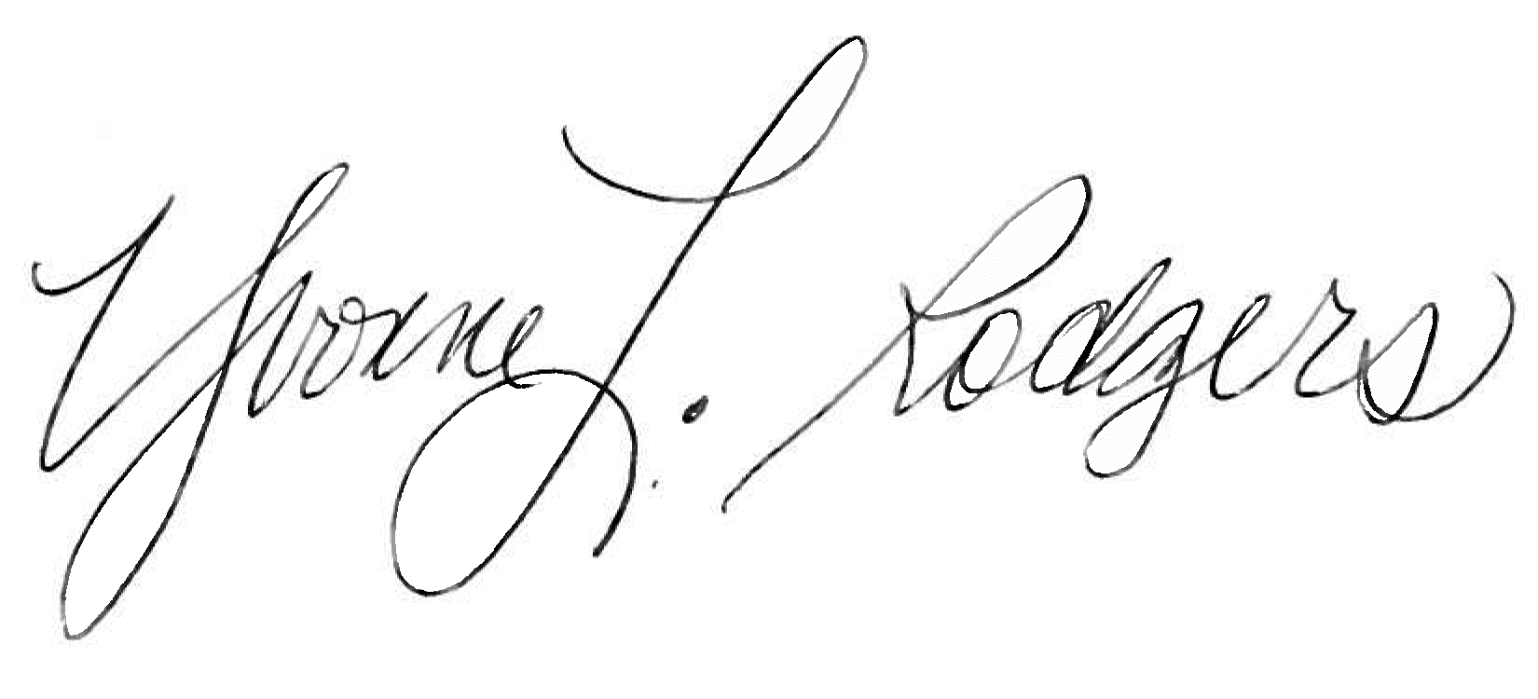
Sincerely,
Yvonne L. Rodgers, MBA
Deputy Director – Vendor Management
Georgia WIC Program

Enclosures

