Georgia Department of Public Health
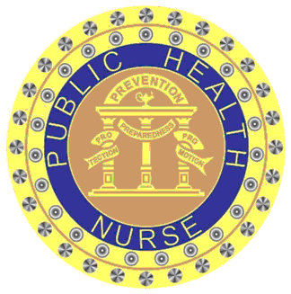
2 Peachtree Street, NW 9th Floor
Atlanta, GA 30303

CERTIFICATE OF ATTENDANCE

has successfully completed the nursing continuing professional development activity entitled:
Childhood, Adolescent, and Adult Immunization Schedule: Review of the Recommended Schedule
held on

Ashlie L Pullen
Provider # 5-167
Activity ID# 434-22
Ashlie Pullen, DNP, APRN, WHNP-BC
Contact Hour(s): 2.0 Deputy Chief Nurse Emergency Preparedness

Georgia Department of Public Health is an approved provider of nursing continuing professional development by the Georgia Nurses Association, an accredited approver by the American Nurses Credentialing Center's Commission on Accreditation.

