Georgia Department of Public Health
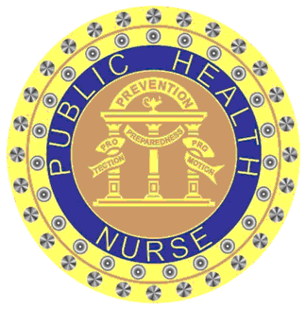
2 Peachtree Street, NW 9th Floor
Atlanta, GA 30303

CERTIFICATE OF ATTENDANCE

(Name of Learner)

has successfully completed the continuing education activity entitled:

Vaccine Storage and Handling

held on ___________________
(Date and Location)

Meshell McCloud, MS, APRN
(Signature of Offering Leader)
Provider#____5-167_______
Activity ID#___254-16______
Contact Hour(s):____1.5___
Georgia Department of Public Health is an approved provider of continuing nursing education by the Alabama State Nurses Association, an accredited approver by the American Nurses Credentialing Center's Commission on Accreditation.

