Georgia Department of Public Health
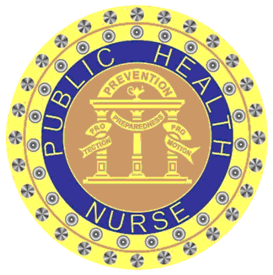
2 Peachtree Street, NW 9th Floor
Atlanta, GA 30303

CERTIFICATE OF ATTENDANCE

(Name of Learner)

has successfully completed the continuing education activity entitled:

A Pediatric Guide: Caring for Infants Exposed to Hepatitis B-Infected Mothers

held on ________________________________________________________________
(Date and Location)

Meshell McCloud, RN, MS, APRN, WHNP-BC
(Signature of Offering Leader)
Provider#__5-167_________
Activity ID#___280-18______
Contact Hour(s):_1.00_____
Georgia Department of Public Health is an approved provider of continuing nursing education by the Alabama State Nurses Association, an accredited approver by the American Nurses Credentialing Center's Commission on Accreditation.

