Latest Changes to DHD System
The DHD staff has pushed some changes and new features to the live system. I need to explain these changes and provide some instruction for their use.
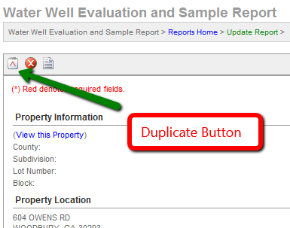
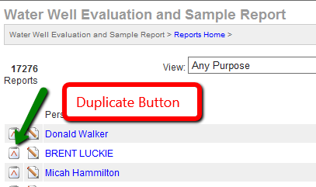
- Add Duplicate Sample Record Button – You can now add a duplicate water sample record for repeat sampling in the cases where only the sample date is the new information. You will need to edit the new/duplicate record before submitting it. This was put in place to help reduce some of the work when there are no changes to the well conditions between sampling.

- Confusion on Public Website Listing – We used to have tourist accommodation and food service facilities both listed on the public web search page. Now visitors can choose between them to help shorten the list and find the information they want.
- Deletion Report not allowing access to all records – The deletion report used to not allow access to some record types. Now any record that is deleted is accessible for review or for un-deleting.
- Food Temp-Item Location Description: printing – The food location information you record for temperature records in food service inspection now prints on the inspection form.
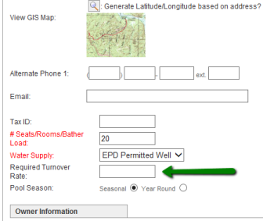
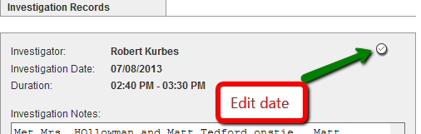
- Last Investigation Date on Complaint Manager Screen – The latest date a complaint was investigated is now listed on the Complaint Manager list screen. Remember, the investigation date is editable for complaints so that the true measure of the number of days from receiving a complaint to the investigation date can be recorded. Please check you records and keep them as accurate as possible.
- Must Re-Enter Required Turnover Rate on every inspection – You now record the required minimum turnover rate in hours for swimming pools on the Facility record once, and this rate will print on the respective inspection records. Please remember to use this rate and the calculations needed to validate the rate from the flow meters during inspections.
- Next Inspection Due-Tourist – The next due date is now automatically set for 180 days forward from the current inspection date for tourist inspections. This date can be edited for local needs.
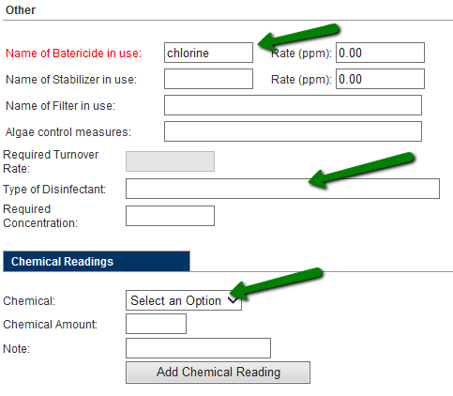
- No place to enter pool chemical readings – The pool chemical records have been confusing. Now you can record every chemical test you perform on the pool water. We did not remove the required field for Bactericide, and tou will still need to record something in Disinfectant, such as “See Addendum” but you can record each of the readings and they print on the addendum.
- Public search needs last 5 inspections listed – The public search page for inspection now lists the last five inspection dates an scores when any facility comes up in a search. This allows people to make a better choice by giving them some historical results.
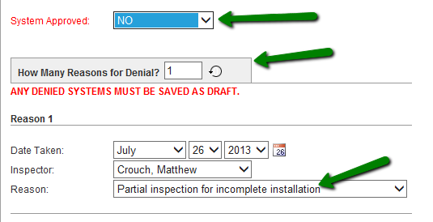
- Septic Inspection-System not approved – Because not every onsite inspection ends with the system approved, we added reason for denial or incomplete inspection to the data entry form. For each incomplete inspection where the system is not approved, change the count of Reasons for Denial up. If 3 inspections are required before the fourth and final inspection where a system is approved, change the How Many Reasons for Denial to 3 and record the issues foun in the 3 incomplete inspections. We manage this list, so please send any suggestions for items to be included in this list of reasons for incomplete inspection or denial to Chris Kumnick for them to be added.
- Copy From in Complaints – If a Facility has a complaint, you can now pull the facility information over to save data entry time. Please note that this information will pull over as soon as you chose Copy From for Facility, Owner, or Billing. If you select the wrong item, you will either need to type the correct information in, or re-open the record for a new selection in that field.
- Closed Facilities on Last Food Inspection List – If you mark a facility closed/inactive by adding a closure date, it will not list in this Last Inspection report.

