NO SMOKING BEYOND THIS POINT
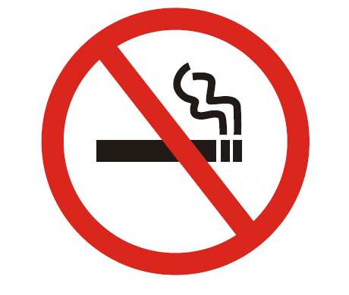

Georgia Smokefree Air Act of 2005
O.C.G.A. § 31-12A-1 et seq.

