Updating the DHD Offline Part I - Resubscribing
03/18/2013

- Save syncFix_SGA.zip file to the desk top.
- Open the syncFix_SGA.zip file by double clicking on it.
- Extract all three files to the root of the C: drive (IMPORTANT: This MAY be permission based on a machine, sometimes only the admins on the machine have write permissions to the C: drive)

Open a dos command window
  - Click on the Windows "Start" button
  - Select "Programs"
  - Select "Accessories"
  - Select "Command Prompt"
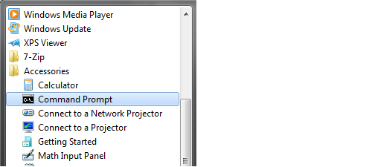

- If needed - Rename the two batch files by replacing the underscore at the end of the file name with the letter “t”. Eg., syncFix_SGA.ba_ is renamed to syncFix_SGA.bat
- In the dos window, next to the C: drive (cd\), type in the name of the resubscribing .bat file (syncFix_SGA.bat) and press enter.(MUST BE RUN FIRST TO PRESERVE UNSYNCED DATA)
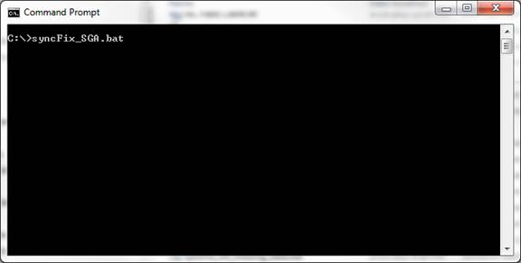

The batch file will give you status updates as it executes. Once complete, sync from within the offline user interface like you normally would. If you have missing data that was previously entered on your field client but not showing up in the Live system, proceed with Part II below to restore missing data.

Updating the DHD Offline Part II – Restoring Missing Data

Open a dos command window if you don’t already have one open
  - Click on the Windows "Start" button
  - Select "Programs"
  - Select "Accessories"
  - Select "Command Prompt"

In the dos window, next to the C: drive (cd\), type in the name of the data restore .bat file (syncFix_SGA_missing_data.bat) and press enter.

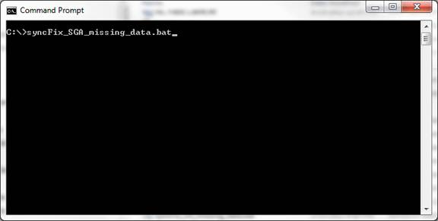

This will restore the data locally on the field client from a previous backup database. Once complete, sync from within the offline user interface again so that missing data will show up in the Live system.

That’s it! If you should run into any problems during this process, please contact our technicians by going to: http://support.gegov.com/

Thank you
Guthrie Chamberlain
gchamberlain@garrisonenterprises.net
740.350.5732

