2015 Georgia Tuberculosis Report

2015 Georgia Tuberculosis Report

Georgia Department of Public Health…………………Brenda Fitzgerald, M.D.

Commissioner

Division of Health Protection………….........................J. Patrick O’Neal, M.D.

Director

Epidemiology Branch…………………………………Cherie Drenzek, D.V.M., M.S.

State Epidemiologist

Tuberculosis Program…………………………………Dr. Rose-Marie F. Sales
Program Director

Antoine Perrymon, M.P.H.
Epidemiologist

Lauren DiMiceli, DrPH, M.S.P.H.
Epidemiologist

Acknowledgments:

We thank the County Health Department staff, District Health Office TB coordinators, and state
TB surveillance staff that collected and reported the data used in this annual report.

Further information on this report can be obtained by contacting:
Dr. Rose-Marie F. Sales
Georgia Department of Public Health
Tuberculosis Program
Division of Health Protection
2 Peachtree St., NW, Atlanta, GA 30303
Phone: (404) 657-2634
E-mail: RoseMarie.Sales@dph.ga.gov

Suggested citation: Georgia Department of Public Health, 2015 Georgia Tuberculosis Report, Atlanta, Georgia, November 2016

Table of Contents

TB Surveillance in Georgia……………………………………………........3

Current Epidemiology of TB in Georgia……………………………………4

High-Risk Populations………………………………………………………5

Drug Resistance……………………………………………………………..6

Indicators of Infectiousness…………………………………………………7

Initial Diagnosis, Health Provider Data,
And Directly Observed Therapy…………………………………………….7

TB Mortality…………………………………………………………………7

TB Treatment Outcomes……………………………………………………..8

TB Contact Investigations and Latent TB Infection………………………....8

TB Genotype Clusters………………………………………………………..8

Tables: Morbidity Trends and Program Performance Indicators by Health District……………………………………………………………………….11

Figures: Descriptive Epidemiology………………………………………….20

Graphs: Tuberculosis Morbidity Trends by Health District, 1995-2015…… 29

Tuberculosis (TB) Surveillance in Georgia

TB is a reportable disease in Georgia. All Georgia physicians, laboratories and other health care providers are required by law to immediately report clinical and laboratory confirmed TB cases under their care to Georgia public health authorities. TB cases may be directly reported to a County Health Department, a District Health Office, or to the state TB Program and TB Epidemiology Section of the Georgia Department of Public Health (DPH), which is responsible for the systematic collection of all reported TB cases in the state. Immediate reporting of TB cases enables appropriate public health follow-up of patients, including administration of directly observed therapy, monitoring TB treatment until completion, screening persons exposed to a TB case, and outbreak investigation and control.

TB cases in Georgia can be reported electronically through the State Electronic Notifiable Disease Surveillance System (SendSS), a secure web-based surveillance software developed by DPH, or by calling, mailing or faxing a report to public health authorities. Hospital infection control preventionists as well as public health nurses, outreach staff, epidemiologists, and communicable disease specialists involved in disease surveillance are encouraged to report TB through SendSS and register to become a SendSS user by logging into the system’s Web site at: https://sendss.state.ga.us.

Public health authorities collect data on reported TB cases that include demographic, clinical, risk factor, and contact information, which are analyzed to describe the distribution of the disease among Georgia’s population, identify high risk groups and TB clusters, describe trends in morbidity, mortality, drug resistance patterns, treatment outcomes, and TB infection rates. The data are used to guide policy and decision making, set priorities for program interventions, evaluate program performance for the prevention and control of TB in Georgia, and educate the general public on TB. Georgia’s TB surveillance data are transmitted electronically to the U.S. Centers for Disease Control and Prevention (CDC) and become part of the national TB surveillance database.

TB Case Definition for Public Health Surveillance
Clinical case definition
A case that meets all of the following criteria:
- A positive tuberculin skin test or positive interferon gamma release assay for M. tuberculosis
- Signs and symptoms compatible with TB (abnormal chest imaging study or clinical evidence of current disease)
- Treatment with two or more anti-TB medications
- A completed diagnostic evaluation
Laboratory criteria for diagnosis
- Isolation of M. tuberculosis complex on a culture from a clinical specimen, or
- Demonstration of M. tuberculosis complex from a clinical specimen by nucleic acid amplification test
Confirmed case: A case that meets the clinical case definition or is laboratory confirmed
Current Epidemiology of Tuberculosis in Georgia

Georgia reported 321 new tuberculosis (TB) cases in 2015. This represents a 4% decrease from 334 TB cases reported in 2014. TB case numbers have decreased 65% since 1991 when the peak of a resurgent period of tuberculosis occurred in Georgia (Figure 1). The TB case rate in Georgia decreased from 3.3 cases per 100,000 population during 2014 to 3.1 cases per 100,000 in 2015, slightly higher than the U.S. TB case rate in 2015 of 3.0 cases per 100,000 (Figure 2). Georgia had the fifth highest number of new TB cases and ranked eighth highest for TB case rates among the 50 reporting states in the United States in 2015.

Geographic Distribution

Among the 159 counties in Georgia, four counties in the metropolitan Atlanta area and their corresponding Health Districts reported the highest number of TB cases in 2015: Fulton (63), DeKalb (58 cases), Gwinnett (29), and Cobb (26) (Table 1, Figure 1). These four counties accounted for 55% of TB cases reported in Georgia in 2015.

Among Georgia’s 18 Health Districts, which has oversight responsibility for public health in the state’s 159 counties, DeKalb Health District had the highest TB case rate in 2015 (7.9 per 100,000), followed by Fulton (6.2 per 100,000) and Columbus (4.5 per 100,000) (Table 2, Figure 2).

Sex and Age Distribution

In 2015, TB in Georgia occurred predominantly among males (201 cases, 63%), compared to females (120, 37%). The highest proportion of TB cases by age group occurred among persons 45-64 years old (122 cases, 38%), which is a change from 2014 when the highest proportion of TB cases occurred among 25-44 year olds (120 cases, 36%). Among the 45-64 age group, (87 cases, 71%) were male and (35 cases, 29%) were female (Figure 5). This age group also had the highest TB case rate (4.7 per 100,000) while the lowest was among children 5-14 years old (0.2 per 100,000) (Figure 6). The TB case rate for children younger than 5 years of age, an age group at high risk for developing deadly forms of TB, decreased from 2.3 per 100,000 in 2014 to 2.1 per 100,000 in Georgia during 2015.

Race/Ethnicity Distribution and TB Disparities

TB disproportionately affects racial/ethnic minorities in Georgia. In 2015, non-Hispanic blacks, Asians and Hispanics, accounted for 48%, 25% and 13% of TB cases in Georgia respectively, but only represented 32%, 4% and 10% of Georgia’s population respectively (Figure 7). The highest TB case rate among race/ethnic groups was among Asians (20.2 per 100,000), followed by non-Hispanic blacks (5.0 per 100,000) and Hispanics (4.1 per 100,000) (Figure 8). The Hispanic case rate decreased 34% from 6.2 per 100,000 in 2014, which is the largest decrease in over five years. The black non-Hispanic TB case rate in 2015 represents an 84% decrease from the TB case rate in 1993 (30.6 per 100,000) in this population. The black non-Hispanic TB case rate, however, was still about six times higher than the white non-Hispanic TB case rate (0.8 per 100,000) in Georgia during 2015 (Figure 9).

High-Risk Populations

Foreign-Born

TB cases among persons born outside of the United States accounted for 46% of TB cases in Georgia in 2015. Most foreign-born cases reported in 2015 came from India (15%), Mexico (14%), and Vietnam (11%) - countries where TB is an endemic disease (Figures 10-11). Among 149 foreign-born cases, 62 (42%) were diagnosed in the first five years of their arrival in the U.S. This represents a 44% increase from 43 foreign-born cases being diagnosed within first five years in 2014.

In 2015, four counties reported 64% of the total number of foreign-born TB cases in Georgia: DeKalb (40 cases), Gwinnett (22), Fulton (19) and Cobb (14). Among these counties, foreign-born TB cases accounted for more than half of the TB cases in Gwinnett (76%), DeKalb (69%), and Cobb (54%). Foreign-born TB cases in Fulton County accounted for 30% of reported TB cases.

HIV Co-Infection

All TB patients need to be tested for HIV infection because TB treatment may change when antiretroviral therapy for HIV is given, and active TB often accelerates the natural progression of HIV infection. HIV status was reported in 93% of TB cases in 2014 and 2015. Among 298 TB cases in Georgia with known HIV status in 2015, 9% were HIV-positive compared to 12% in 2014 (Figure 12). Among 27 HIV co-infected TB cases in 2015, 85% were non-Hispanic blacks, 70% were male and 59% were 45-64 years old.

In the high-risk age group of adults 25-44 years of age, the percentage of TB cases for which HIV was reported was 98% in 2014 and 2015. In 2015, HIV testing was not offered to 10 TB cases (3%), 8 (2%) refused HIV testing, and the HIV test result was unknown in five cases (2%), Half of the TB cases that were not offered the HIV test were children younger than 5 years old, the other half not offered the test were adults 45 years old and older.

Congregate Settings and Substance Abuse

Persons residing in crowded congregate settings such as homeless shelters, prisons, and nursing homes are at risk for acquiring TB. In 2015, 27 (8%) TB cases in Georgia were homeless, 8 (2%) were residents of correctional facilities, and 4 (1%) were residents of long-term care facilities. Of the eight TB cases incarcerated in correctional facilities, five (62%) were inmates in county jails and three (38%) were inmates in state prisons. No TB cases were reported from the Immigration and Customs Enforcement (ICE) detention center in Stewart County. Substance abuse is the most commonly reported behavioral risk factor among patients with TB in the United States. TB patients who abuse substances often experience treatment failure and remain infectious longer because treatment failure presumably extends periods of infectiousness. In Georgia, abuse of either illicit drugs or alcohol was reported in 54 (17%) TB cases in 2015 (Table 3, Figure 13).
Pediatric TB

TB in children is considered a sentinel public health event because it often indicates recent transmission from an infectious adult case. Additionally, potentially lethal forms of TB such as TB meningitis or disseminated TB can develop in very young children. In 2015, children younger than 15 years old comprised 6% of Georgia TB cases; 15 TB cases (2.1 per 100,000) were reported in children younger than 5 years old, 3 cases (0.2 per 100,000) were reported in children 5-14 years old. Two children younger than 5 years old had TB meningitis, two other children in this same age group developed disseminated TB; all four completed TB treatment and survived

Latent tuberculosis infection (LTBI) in children younger than five years old is also a reportable disease in Georgia. When LTBI in a child less than five years of age is reported, public health personnel will initiate contact investigations to identify the source of the infection, recommend treatment for latent TB infection, follow up with the child to ensure completion of treatment and monitor for development of active TB disease. Early identification of TB infection and treatment in children can prevent progression to active disease and identify a previously undiagnosed and untreated case of active TB.

In 2015, 47 children younger than five years old were reported to have LTBI in Georgia; 16 of who were identified by contact investigations. Public health staff identified the source case of the child’s infection in 33 (39%) of these children.

Drug Resistance

Among 235 culture-positive TB cases in Georgia during 2015, 100% were tested for initial drug susceptibility however two patients of private physicians had incomplete test results: one case was only tested for isoniazid and rifampin and one other case only had a molecular drug resistance test performed for rifampin. Both cases were culture negative by the time they were referred to public health for case management and therefore the state public health laboratory had no isolate to perform a complete drug susceptibility test. Of 226 tested isolates from Georgia cases with no previous history of TB, 30 (13%) had primary resistance to isoniazid (INH), three (1%) to rifampin (RIF), and none to ethambutol (EMB) (Table 4). No cases of multidrug-resistant TB (MDR-TB, i.e. TB resistant to at least INH and RIF) were reported in 2015 compared to three (0.9%) MDR-TB cases in 2014. The percentage of cases with primary INH resistance (INH-R) ranged from 8% to 22% in the past five years while an average of less than two MDR-TB cases per year was reported in Georgia over that same time period (Figure 14).

Indicators of Infectiousness

Persons with pulmonary or laryngeal TB have the potential to infect others with TB, and infectiousness is higher if their sputum smears are positive for acid-fast bacilli (AFB), sputum cultures are positive for Mycobacterium tuberculosis, or cavitary lesions are present on chest radiography. In 2015, 81% of all Georgia TB cases had pulmonary TB, 50% had sputum cultures that were positive for Mycobacterium tuberculosis, 36% were sputum AFB smear-positive, and 20% showed cavitary lesions on chest radiography.

Health Provider Data and Directly Observed Therapy

In Georgia, the majority of TB patients are initially diagnosed in a hospital and patients are followed up by county health departments after discharge to continue their TB treatment. In 2015, 186 (58%) of the 321 TB cases in Georgia were reported initially by a hospital. Seven hospitals in Georgia reported five or more TB cases in 2015: Grady Memorial Hospital (42 cases), Children’s Healthcare of Atlanta (6 cases), Emory Midtown Hospital (6 cases), Gwinnett Hospital (5 cases), Emory University Hospital, Medical Center of Central GA, and Phoebe Putney Memorial Hospital reported 5 cases each.

Among TB cases with available data on type of outpatient healthcare provider, county health departments provided sole case management for 85% of all Georgia TB cases, 11% were co-managed by a county health department and private physician, 3% were treated solely by a private physician, correctional facilities treated 0.7%, and 0.3% were managed solely as in-patients. County health department staff provides directly observed therapy (DOT) to TB patients, which entails watching a patient swallow every dose of their TB medications for at least 6 months. Among 275 Georgia TB cases reported in 2015 with available case completion data, 90% received TB treatment entirely by DOT, 8% were treated by a combination of DOT and self-administered therapy, and 2% self-administered their medications for the entire duration of their treatment.

TB Mortality

According to Georgia Vital Records data, six persons died of TB in Georgia in 2015, where the age-adjusted TB mortality rate in 2015 was 0.1 per 100,000. From 2011 to 2015, an average of 12 people died of TB in Georgia each year. Within these years, the highest number of deaths from TB was reported in 2012 with 20 deaths.

TB Treatment Outcomes

Among 292 TB cases in Georgia who started treatment for TB in 2014, (the most recent year with completed treatment outcome data), 284 (97%) completed treatment, 4 (1%) were lost to follow-up, 2(1%) are still undergoing treatment in 2016, 1(0.3%) stopped treatment due to an adverse treatment reaction, and 1(0.3%)
non-infectious extrapulmonary case was uncooperative and refused to complete TB treatment.

TB Contact Investigations and Latent TB Infection

Public health authorities routinely conduct a contact investigation among persons exposed to a TB case to identify secondary TB cases and contacts with latent TB infection (LTBI). Index TB cases with positive acid-fast bacillus (AFB) sputum-smear results or pulmonary cavities have the highest priority for investigation. During a contact investigation, public health staff ask recent contacts to a case if they have TB-like symptoms, administer a TB skin test (TST) or interferon gamma release assay (IGRA), repeat the TST or IGRA 8-10 weeks after the last exposure to the index case if the initial TST or IGRA is negative, and have a chest radiology exam performed if the TST or IGRA is positive. Persons with LTBI have a positive TST or IGRA, but are asymptomatic and have a normal chest radiology exam. They are not contagious but have a 10% chance of developing TB disease later in life if they do not receive treatment for LTBI.

Among 2,907 identified contacts of sputum smear positive TB cases reported in Georgia in 2014 (the most recent year with completed contact investigation data), 2,378 (82%) were completely evaluated for TB disease and LTBI. Among the completely evaluated contacts, 420 (18%) had LTBI and 20 (0.5%) had TB disease. Among the 420 contacts with LTBI, 319 (76%) started LTBI treatment and among these contacts who started LTBI treatment, 218 (68%) completed LTBI treatment, 37 (12%) chose to stop LTBI treatment on their own, 27 (8%) were lost to follow-up, 17 (5%) stopped treatment due to their health provider’s decision, 12 (4%) stopped treatment due to adverse side-effects to the TB medications, 6 (2%) moved out-of-state and 2 (0.6%) developed active TB.

Surveillance Summary of TB Genotype Clusters

TB Genotyping

TB genotyping is a laboratory method that determines the genetic relatedness of TB strains among different patients with culture-positive TB disease. Identical genotypes among persons with TB disease suggest recent person-to-person transmission. The state TB program routinely analyzes TB genotype clusters, which are comprised of two or more TB cases with identical genotypes, to identify recent TB transmission, to describe risk factors for transmission, to identify possible sources of transmission, and to determine ways to stop transmission.

From 2011-2015, 94 small (2-3 cases), 20 medium (4-9 cases), and 11 large (≥ 10 cases) genotype clusters were identified in Georgia (Figure 17). Some genotype clusters such as the cluster associated with a TB outbreak among homeless persons persisted throughout this 5-year time period and an upsurge of TB cases associated with this outbreak strain occurred in 2014 and 2015. Table 10 summarizes the distribution of fourteen medium and five large TB genotyped clusters across several counties in Georgia from 2013-2015. These clusters were predominantly reported from Fulton County (42%), DeKalb (37%), Gwinnett (16%), and Glynn (16%) counties.

TB Outbreak among Homeless Persons

From 2014-2015, a TB outbreak comprised of 42 TB cases with the genotype G05625 was reported among persons who had either stayed or volunteered at homeless shelters in Fulton (n=37), DeKalb (n=3), Chatham (n=1) and Paulding (n=1) counties (Figure 18). All the cases were resistant to a first-line anti-tuberculosis medication, isoniazid (INH). Of the 42 cases, all were male, 93% were US-born and 84% were African-American. TB cases in this cluster had a high prevalence of homelessness (83%), substance abuse (36%), HIV infection (26%), and 19% had sputum smear positive and cavitary pulmonary disease. The first TB case in the United States with the genotype G05625 was reported in Fulton County, Georgia in March 2008 when the TB outbreak started and since then, 13 other states in the U.S. have reported 38 TB cases with this genotype.

The Fulton County Health Department, the Georgia TB program, and CDC are providing resources to control this INH-resistant TB outbreak. The Fulton County TB Program is conducting contact tracing, performing TB screenings at the county TB clinic and in homeless shelters, and providing treatment to cases and infected contacts. The state TB program is providing temporary housing for the homeless TB cases through a contract with the American Lung Association and assisting with shelter screening through a contract with Mercy Care, a federally qualified health center. A TB Task Force which includes homeless service providers, state and county TB program representatives and Emory University volunteers, developed guidelines and administrative practices to prevent and control TB in homeless shelters. A memorandum of agreement between Fulton County and homeless shelter administrators was signed to implement the guidelines which include a requirement for TB clearance by a health clinic before admission for overnight stay at a homeless shelter and TB symptom screening of clients before admittance to a shelter.

Statewide Cluster Investigation Involving Two Separate Populations

From 2013-2015, a TB outbreak consisting of 13 TB cases with the genotype G10763 which was also characterized by INH resistance was reported from Hart (n=5), Richmond (n=5), Gwinnett (n=1), Houston (n=1) and Newton (n=1) counties. Among the 13 TB cases, all were US-born, 92% were African-American between the ages of 40 and 60, 92% reported INH resistance, 69% were male, 31% reported a history of substance abuse and 31% reported a history of excessive alcohol use. One case developed resistance to both INH and rifampin (multidrug-resistant TB). The county and state TB programs initiated a cluster investigation to identify epidemiologic links among the cases and conducted extensive TB screening of persons exposed to the cases in this cluster. The investigation suggested that two separate modes of transmission were occurring in this cluster. In Hart County, all five cases were African-American and the majority (80%) were males; 80% reported substance abuse, 80% reported excessive alcohol use and cases were either relatives or close friends of the cases who were relatives. In Richmond County, the cases were identified from a school contact investigation with no apparent epidemiologic linkage to the Hart County cases. Whole genome sequencing (WGS), a laboratory method that provides greater resolution than routine genotyping testing methods and improves the ability to distinguish genetic variations between culture-positive specimens, was performed for all cases with this genotype. WGS confirmed that the TB cases from Hart County and Richmond County differed in their genetic makeup, thus providing evidence that the cases from these two counties and cases with the genotype G10763 in other counties were not epidemiologically linked. CDC, state, and local personnel discussed the WGS results and determined that a thorough contact investigation had been conducted and no additional follow up was needed.

Statewide Cluster Investigation Involving Correctional Facilities and an Apartment Complex

Another large statewide genotype cluster comprised of 12 TB cases (G12352) was identified from 2013-2015. Of the cases in this cluster, 7 (58%) were reported from Hall County, two in Clarke County, and one case each was reported from Jackson, Columbia, and Stephens counties. The majority of the cases were US-born (92%) and African-American (75%). Half of the cases were sputum smear positive with cavitary pulmonary disease and 25% reported a history of substance abuse. The state TB program conducted a cluster investigation which involved searching publicly available online databases for records of incarceration at Hall County jail and other correctional facilities throughout Georgia. WGS was performed for 11 TB cases in the cluster and helped confirm the epidemiologic links of several TB cases associated with incarceration in correctional facilities and an association among TB cases who were residents of an apartment complex with cases in their social networks. CDC, state, and local health department personnel held meetings to discuss this cluster and agreed that thorough contact investigation activities had been conducted and that no further follow up was needed.

Table 1. Number of TB Cases and TB Case Rates* per 100,000 population
by County, Georgia, 2014-2015

COUNTY | 2014 |  | 2015
 | Number of cases | Case Rate | Number of cases | Case Rate
Appling | 0 | 0 | < 5 | --
Atkinson | 0 | 0 | < 5 | --
Bacon | < 5 | -- | 0 | 0
Baker | < 5 | -- | < 5 | --
Baldwin | 0 | 0 | 0 | 0
Banks | 0 | 0 | < 5 | --
Barrow | <5 | -- | < 5 | --
Bartow | < 5 | -- | < 5 | --
Ben Hill | <5 | -- | 0 | 0
Berrien | <5 | -- | 0 | 0
Bibb | 6 | 3.9 | < 5 | --
Bleckley | 0 | 0 | 0 | 0
Brantley | 0 | 0 | 0 | 0
Brooks | 0 | 0 | 0 | 0
Bryan | 0 | 0 | 0 | 0
Bulloch | 0 | 0 | 0 | 0
Burke | 0 | 0 | < 5 | --
Butts | 0 | 0 | < 5 | --
Calhoun | 0 | 0 | 0 | 0
Camden | 0 | 0 | < 5 | --
Candler | 0 | 0 | 0 | 0
Carroll | < 5 | -- | < 5 | --
Catoosa | < 5 | -- | < 5 | --
Charlton | 0 | 0 | < 5 | --
Chatham | 8 | 2.8 | <5 | --
Chattahoochee | 0 | 0 | 0 | 0
Chattooga | < 5 | -- | 0 | 0
Cherokee | < 5 | -- | < 5 | --
Clarke | 0 | 0 | < 5 | --
Clay | 0 | 0 | 0 | 0
Clayton | 10 | 3.7 | 8 | 2.9
Clinch | 0 | 0 | 0 | 0
Cobb | 25 | 3.4 | 26 | 3.5
Coffee | 0 | 0 | < 5 | --
Colquitt | < 5 | -- | 0 | 0
Columbia  Augusta State Med Prison (ASMP) | 0  <5 | 0  na | <5  <5 | --  na
Cook | 0 | 0 | < 5 | --
Coweta | < 5 | -- | < 5 | --
Crawford | 0 | 0 | 0 | 0
Crisp | < 5 | -- | < 5 | --

COUNTY | 2014 |  | 2015
 | Number of cases | Case Rate | Number of cases | Case Rate
Dade | < 5 | -- | 0 | 0
Dawson | 0 | 0 | 0 | 0
Decatur | 0 | 0 | 0 | 0
DeKalb | 60 | 8.3 | 58 | 7.9
Dodge | 0 | 0 | 0 | 0
Dooly | 0 | 0 | 0 | 0
Dougherty | 5 | 5.4 | < 5 | --
Douglas | 0 | 0 | 0 | 0
Early | 0 | 0 | 0 | 0
Echols | 0 | 0 | 0 | 0
Effingham | < 5 | -- | < 5 | --
Elbert | 0 | 0 | 0 | 0
Emanuel | 0 | 0 | < 5 | --
Evans | 0 | 0 | 0 | 0
Fannin | 0 | 0 | 0 | 0
Fayette | < 5 | -- | 0 | 0
Floyd | 0 | 0 | < 5 | --
Forsyth | < 5 | -- | 7 | 3.3
Franklin | 0 | 0 | 0 | 0
Fulton | 77 | 7.7 | 63 | 6.2
Gilmer | < 5 | -- | 0 | 0
Glascock | 0 | 0 | 0 | 0
Glynn | < 5 | -- | < 5 | --
Gordon | < 5 | -- | 0 | 0
Grady | < 5 | -- | < 5 | --
Greene | 0 | 0 | < 5 | --
Gwinnett | 35 | 4.0 | 29 | 3.1
Habersham | 0 | 0 | < 5 | --
Hall | 9 | 4.7 | 6 | 3.1
Hancock | < 5 | -- | 0 | 0
Haralson | < 5 | -- | 0 | 0
Harris | 0 | 0 | 0 | 0
Hart | 0 | 0 | < 5 | --
Heard | 0 | 0 | 0 | 0
Henry | 0 | 0 | < 5 | --
Houston | < 5 | -- | 6 | 4.0
Irwin | 0 | 0 | 0 | 0
Jackson | < 5 | -- | 0 | 0
Jasper | < 5 | -- | 0 | 0
Jeff Davis | 0 | 0 | < 5 | --
Jefferson | 0 | 0 | 0 | 0
Jenkins | 0 | 0 | 0 | 0
Johnson | 0 | 0 | 0 | 0

COUNTY | 2014 |  | 2015
 | Number of cases | Case Rate | Number of cases | Case Rate
Jones | < 5 | -- | 0 | 0
Lamar | 0 | 0 | < 5 | --
Lanier | 0 | 0 | 0 | 0
Laurens | < 5 | -- | < 5 | --
Lee | 0 | 0 | < 5 | --
Liberty | < 5 | -- | < 5 | --
Lincoln | 0 | 0 | 0 | 0
Long | < 5 | -- | 0 | 0
Lowndes | 0 | 0 | < 5 | --
Lumpkin | 0 | 0 | 0 | 0
Macon | < 5 | -- | < 5 | --
Madison | 0 | 0 | 0 | 0
Marion | 0 | 0 | 0 | 0
McDuffie | 0 | 0 | 0 | 0
McIntosh | < 5 | -- | < 5 | --
Meriwether | 0 | 0 | < 5 | --
Miller | 0 | 0 | 0 | 0
Mitchell | < 5 | -- | < 5 | --
Monroe | 0 | 0 | 0 | 0
Montgomery | 0 | 0 | 0 | 0
Morgan | 0 | 0 | 0 | 0
Murray | 0 | 0 | 0 | 0
Muscogee | 8 | 4.0 | 11 | 5.5
Newton | < 5 | -- | < 5 | --
Oconee | 0 | 0 | 0 | 0
Oglethorpe | 0 | 0 | 0 | 0
Paulding | < 5 | -- | < 5 | --
Peach | 0 | 0 | 0 | 0
Pickens | 0 | 0 | 0 | 0
Pierce | < 5 | -- | 0 | 0
Pike | 0 | 0 | 0 | 0
Polk | 0 | 0 | 0 | 0
Pulaski | 0 | 0 | < 5 | --
Putnam | 0 | 0 | < 5 | --
Quitman | 0 | 0 | < 5 | --
Rabun | 0 | 0 | < 5 | --
Randolph | 0 | 0 | 0 | 0
Richmond | 7 | 3.5 | 7 | 3.5
Rockdale | < 5 | -- | 5 | 5.6
Schley | < 5 | -- | 0 | 0
Screven | 0 | 0 | < 5 | --
Seminole | 0 | 0 | < 5 | --
Spalding | 0 | 0 | < 5 | --

COUNTY | 2014 |  | 2015
 | Number of cases | Case Rate | Number of cases | Case Rate
Stephens | < 5 | -- | 0 | 0
Stewart  ICE Detention Center | <5  <5 | --  -- | 0  0 | 0  0
Sumter | < 5 | -- | 0 | 0
Talbot | 0 | 0 | 0 | 0
Taliaferro | 0 | 0 | 0 | 0
Tattnall | 0 | 0 | 0 | 0
Taylor | 0 | 0 | 0 | 0
Telfair | 0 | 0 | 0 | 0
Terrell | 0 | 0 | 0 | 0
Thomas | 0 | 0 | 0 | 0
Tift | < 5 | -- | 0 | 0
Toombs | 0 | 0 | < 5 | --
Towns | 0 | 0 | 0 | 0
Treutlen | 0 | 0 | 0 | 0
Troup | < 5 | -- | < 5 | --
Turner | 0 | 0 | 0 | 0
Twiggs | 0 | 0 | 0 | 0
Union | 0 | 0 | 0 | 0
Upson | 0 | 0 | < 5 | --
Walker | 0 | 0 | < 5 | --
Walton | 0 | 0 | 0 | 0
Ware | < 5 | -- | 0 | 0
Warren | 0 | 0 | 0 | 0
Washington | 0 | 0 | 0 | 0
Wayne | 0 | 0 | 0 | 0
Webster | < 5 | -- | 0 | 0
Wheeler | 0 | 0 | 0 | 0
White | 0 | 0 | 0 | 0
Whitfield | < 5 | -- | < 5 | --
Wilcox | 0 | 0 | 0 | 0
Wilkes | 0 | 0 | 0 | 0
Wilkinson | 0 | 0 | 0 | 0
Worth | 0 | 0 | 0 | 0
GEORGIA | 334 | 3.3 | 321 | 3.1

Note: In counties where one to four cases were reported and the county population is less than 100,000, “< 5” is used to represent the number of reported cases, and the case rate is not calculated.

Table 2. Number of TB Cases and TB Case Rates* per 100,000 population
by Health District, Georgia, 2014- 2015
Health District | 2014 |  | 2015
 | Number of Cases | Case rate | Number of Cases | Case rate
1.1 Rome | 12 | 1.9 | 8 | 1.2
1.2 Dalton | 7 | 1.5 | 4 | 1.2
2.0 Gainesville | 13 | 2.0 | 20 | 3.0
3.1 Cobb | 25 | 2.9 | 26 | 2.9
3.2 Fulton | 77 | 7.7 | 63 | 6.2
3.3 Clayton | 10 | 3.7 | 8 | 2.9
3.4 Lawrenceville | 38 | 3.6 | 35 | 3.2
3.5 DeKalb | 60 | 8.3 | 58 | 7.9
4.0 LaGrange | 6 | 0.7 | 15 | 1.8
5.1 Dublin | 1 | 0.7 | 2 | 1.3
5.2 Macon | 11 | 2.1 | 11 | 2.1
6.0 Augusta  ASMP | 6  3 | 1.3  na | 12  2 | 2.5  na
7.0 Columbus  ICE Detention Center | 18  2 | 4.8  na | 17  0 | 4.5  na
8.1 Valdosta | 5 | 2.0 | 2 | 0.8
8.2 Albany | 16 | 4.5 | 10 | 2.8
9.1 Coastal | 18 | 3.0 | 12 | 2.0
9.2 Waycross | 3 | 0.8 | 10 | 2.7
10 Athens | 3 | 0.6 | 6 | 1.2
Total | 334 | 3.3 | 321 | 3.1

Table 3. Percentage of TB Cases with Risk Factors for TB by Health District, Georgia, 2015
HEALTH DISTRICT | Foreign-born % | HIV*  Infected % | Homeless  % | Inmate  % | Nursing  Home % | Substance  Abuse %
1.1 Rome | 13 | 0 | 0 | 0 | 0 | 25
1.2 Dalton | 75 | 0 | 0 | 0 | 0 | 0
2.0 Gainesville | 60 | 0 | 0 | 0 | 0 | 30
3.1 Cobb | 54 | 11 | 0 | 0 | 0 | 8
3.2 Fulton | 30 | 19 | 30 | 6 | 0 | 27
3.3 Clayton | 75 | 14 | 0 | 0 | 0 | 0
3.4 Lawrenceville | 66 | 3 | 0 | 0 | 3 | 11
3.5 DeKalb | 69 | 4 | 9 | 2 | 0 | 7
4.0 LaGrange | 20 | 13 | 13 | 7 | 0 | 20
5.1 Dublin | 50 | 0 | 0 | 0 | 0 | 0
5.2 Macon | 36 | 27 | 0 | 0 | 0 | 9
6.0 Augusta  ASMP | 50  50 | 17  0 | 0  0 | 0  100 | 0  0 | 25  50
7.0 Columbus  ICE Detention Ctr | 18  0 | 7  0 | 0  0 | 0  0 | 12  0 | 35  0
8.1 Valdosta | 0 | 0 | 0 | 0 | 0 | 0
8.2 Albany | 10 | 0 | 10 | 0 | 10 | 30
9.1 Coastal | 50 | 9 | 0 | 0 | 0 | 8
9.2 Waycross | 30 | 0 | 0 | 0 | 0 | 10
10 Athens | 50 | 0 | 0 | 0 | 0 | 0
Georgia | 46 | 9 | 8 | 2 | 1 | 17
*Percentage of HIV infection among TB cases with known HIV status

Table 4. Primary Resistance to Anti-TB Medications by Health District, Georgia, 2015*
TB Drug | Isoniazid |  | Rifampin |  | Ethambutol
HEALTH DISTRICT | No. | % | No. | % | No. | %
1.1 Rome | 1 | 14 | 0 | 0 | 0 | 0
1.2 Dalton | 0 | 0 | 0 | 0 | 0 | 0
2.0 Gainesville | 4 | 22 | 0 | 0 | 0 | 0
3.1 Cobb | 0 | 0 | 2 | 12 | 0 | 0
3.2 Fulton | 14 | 28 | 0 | 0 | 0 | 0
3.3 Clayton | 0 | 0 | 0 | 0 | 0 | 0
3.4 Lawrenceville | 2 | 8 | 1 | 3 | 0 | 0
3.5 DeKalb | 3 | 9 | 0 | 0 | 0 | 0
4.0 LaGrange | 0 | 0 | 0 | 0 | 0 | 0
5.1 Dublin | 0 | 0 | 0 | 0 | 0 | 0
5.2 Macon | 2 | 22 | 0 | 0 | 0 | 0
6.0 Augusta  ASMP | 3  0 | 43  0 | 0  0 | 0  0 | 0  0 | 0  0
7.0 Columbus | 0 | 0 | 0 | 0 | 0 | 0
8.1 Valdosta | 0 | 0 | 0 | 0 | 0 | 0
8.2 Albany | 0 | 0 | 0 | 0 | 0 | 0
9.1 Coastal | 0 | 0 | 0 | 0 | 0 | 0
9.2 Waycross | 0 | 0 | 0 | 0 | 0 | 0
10 Athens | 1 | 25 | 0 | 0 | 0 | 0
Georgia Total | 30 | 13 | 3 | 1 | 0 | 0
* Drug resistance among culture positive TB cases with no previous history of TB treatment

Table 5. Completion of TB Treatment by Health District, Georgia, 2013-2014
HEALTH DISTRICT | 2013 | 2014
 | No. Cases that Completed Tx/No. Cases Started Tx* |  | % | No. Cases that Completed Tx/No. Cases Started Tx* | %
1.1 Rome | 10/10 |  | 100 | 11/11 | 100
1.2 Dalton | 4/4 |  | 100 | 6/6 | 100
2.0 Gainesville | 13/14 |  | 93 | 12/12 | 100
3.1 Cobb | 17/17 |  | 93 | 18/19 | 95
3.2 Fulton | 44/44 |  | 100 | 65/66 | 98
3.3 Clayton | 9/9 |  | 100 | 9/9 | 100
3.4 Lawrenceville | 40/41 |  | 98 | 33/34 | 97
3.5 DeKalb | 71/72 |  | 99 | 53/55 | 96
4.0 LaGrange | 6/6 |  | 100 | 5/6 | 83
5.1 Dublin | 2/2 |  | 100 | 2/2 | 100
5.2 Macon | 10/11 |  | 91 | 9/11 | 91
6.0 Augusta  ASMP | 20/20  2/2 |  | 100  100 | 6/6  3/3 | 100  100
7.0 Columbus | 3/4 |  | 75 | 12/14 | 86
8.1 Valdosta | 9/9 |  | 100 | 4/4 | 100
8.2 Albany | 15/15 |  | 100 | 11/11 | 100
9.1 Coastal | 8/8 |  | 100 | 17/17 | 100
9.2 Waycross | 9/9 |  | 100 | 3/3 | 100
10 Athens | 5/5 |  | 100 | 2/2 | 100
Georgia Total | 298/302 |  | 99 | 284/292 | 97

*Cases who died or who left the U.S. while on TB treatment are excluded

Table 6. Completion of TB Treatment (Tx) within 12 months among TB cases eligible for 12-month TB Treatment by Health District, Georgia, 2013-2014
HEALTH DISTRICT | 2013 |  |  |  | 2014
 | No. Cases Completed Tx in 12 months/ No. Started Tx |  | % | No. Cases Completed Tx in 12 months/ No. Started Tx |  | %
1.1 Rome |  | 8/8 | 100 |  | 11/11 | 100
1.2 Dalton |  | 3/4 | 75 |  | 6/6 | 100
2.0 Gainesville |  | 11/12 | 92 |  | 10/12 | 83
3.1 Cobb |  | 13/14 | 93 |  | 14/16 | 88
3.2 Fulton |  | 42/43 | 98 |  | 58/64 | 91
3.3 Clayton |  | 8/8 | 100 |  | 9/9 | 100
3.4 Lawrenceville |  | 37/38 | 97 |  | 30/32 | 94
3.5 DeKalb |  | 67/69 | 97 |  | 50/52 | 96
4.0 LaGrange |  | 4/6 | 67 |  | 3/5 | 60
5.1 Dublin |  | 1/2 | 50 |  | 2/2 | 100
5.2 Macon |  | 8/10 | 80 |  | 9/11 | 91
6.0 Augusta  ASMP |  | 14/17  2/2 | 82  100 |  | 5/6  3/3 | 83  100
7.0 Columbus |  | 3/4 | 75 |  | 12/14 | 86
8.1 Valdosta |  | 9/9 | 100 |  | 4/4 | 100
8.2 Albany |  | 14/14 | 100 |  | 11/11 | 100
9.1 Coastal |  | 6/7 | 86 |  | 17/17 | 100
9.2 Waycross |  | 8/8 | 100 |  | 3/3 | 100
10 Athens |  | 5/5 | 100 |  | 2/2 | 100
Georgia Total |  | 262/280 | 94 |  | 260/281 | 93
*Cases who died or who left the U.S. during TB treatment, rifampin-resistant cases, meningeal TB, TB of the bone, joint or central nervous system, and children < 15 with miliary TB are excluded

Table 7. Completely Evaluated Contacts of Sputum Smear Positive Cases
by Health District, Georgia, 2013-2014
HEALTH DISTRICT | 2013 |  | 2014
 | No. Contacts Evaluated/ No. Contacts Identified | % | No. Contacts Evaluated/ No. Contacts Identified | %
1.1 Rome | 18/24 | 75 | 24/27 | 89
1.2 Dalton | 18/22 | 81 | 51/54 | 94
2.0 Gainesville | 120/145 | 83 | 141/164 | 86
3.1 Cobb | 60/72 | 83 | 58/77 | 75
3.2 Fulton | 226/447 | 51 | 890/964 | 92
3.3 Clayton | 65/71 | 92 | 27/29 | 93
3.4 Lawrenceville | 187/230 | 81 | 79/92 | 86
3.5 DeKalb | 122/212 | 58 | 347/414 | 84
4.0 LaGrange | 4/6 | 67 | 12/14 | 86
5.1 Dublin | 14/14 | 100 | 1/1 | 100
5.2 Macon | 37/60 | 62 | 20/133 | 15
6.0 Augusta | 164/180 | 91 | 393/544 | 72
7.0 Columbus | 11/16 | 69 | 77/87 | 88
8.1 Valdosta | 24/41 | 59 | 6/10 | 60
8.2 Albany | 12/12 | 100 | 194/233 | 83
9.1 Coastal | 38/42 | 90 | 48/54 | 89
9.2 Waycross | 25/40 | 62 | 0/0 | na
10 Athens | 11/17 | 61 | 10/10 | 100
Georgia Total | 1162/1662 | 70 | 2387/2907 | 82

Table 8. Infected Contacts exposed to Sputum Smear Positive Cases started on
LTBI Treatment by Health District, Georgia, 2013-2014
HEALTH DISTRICT | 2013 |  | 2014
 | No. Infected Contacts on LTBI Treatment /  No. Infected Contacts | % | No. Infected Contacts on LTBI Treatment /  No. Infected Contacts | %
1.1 Rome | 5/7 | 71 | 2/3 | 67
1.2 Dalton | 6/6 | 100 | 16/16 | 100
2.0 Gainesville | 53/53 | 100 | 30/42 | 71
3.1 Cobb | 11/16 | 69 | 19/24 | 79
3.2 Fulton | 23/55 | 42 | 63/90 | 70
3.3 Clayton | 10/15 | 67 | 6/7 | 86
3.4 Lawrenceville | 46/72 | 64 | 14/18 | 78
3.5 DeKalb | 37/59 | 63 | 53/77 | 69
4.0 LaGrange | 2/2 | 100 | 5/7 | 71
5.1 Dublin | 6/7 | 86 | 0/1 | 0
5.2 Macon | 2/4 | 50 | 6/8 | 75
6.0 Augusta | 9/17 | 53 | 21/33 | 64
7.0 Columbus | 3/4 | 75 | 39/45 | 87
8.1 Valdosta | 6/9 | 67 | 2/2 | 100
8.2 Albany | 4/4 | 100 | 14/16 | 88
9.1 Coastal | 6/6 | 100 | 29/31 | 94
9.2 Waycross | 4/11 | 36 | 0/0 | na
10 Athens | 7/7 | 100 | 0/0 | na
Georgia Total | 240/354 | 68 | 319/420 | 76

Table 9. LTBI Treatment Completion of Infected Contacts exposed to Sputum
Smear Positive Cases by Health District, Georgia, 2013-2014
HEALTH DISTRICT | 2013 |  |  |  | 2014
 | No. Contacts that Completed LTBI Treatment  / Contacts Treated |  | % |  | No. Contacts that Completed LTBI Treatment  / Contacts Treated | %
1.1 Rome | 2/5 |  | 40 |  | 2/2 | 100
1.2 Dalton | 5/6 |  | 83 |  | 13/16 | 81
2.0 Gainesville | 42/53 | 79 |  |  | 21/30 | 70
3.1 Cobb | 8/11 | 72 |  |  | 10/19 | 53
3.2 Fulton | 13/23 | 56 |  |  | 36/63 | 57
3.3 Clayton | 9/10 | 90 |  |  | 3/6 | 50
3.4 Lawrenceville | 39/46 | 85 |  |  | 12/14 | 86
3.5 DeKalb | 27/37 | 73 |  |  | 44/53 | 83
4.0 LaGrange | 1/2 | 50 |  |  | 5/5 | 100
5.1 Dublin | 3/6 | 50 |  |  | 0/0 | na
5.2 Macon | 1/1 | 50 |  |  | 4/6 | 67
6.0 Augusta | 5/9 | 56 |  |  | 8/21 | 38
7.0 Columbus | 3/3 | 100 |  |  | 23/39 | 59
8.1 Valdosta | 1/6 | 17 |  |  | 2/2 | 100
8.2 Albany | 4/4 | 100 |  |  | 11/14 | 79
9.1 Coastal | 5/6 | 83 |  |  | 24/29 | 83
9.2 Waycross | 3/4 | 75 |  |  | 0/0 | na
10 Athens | 2/7 | 29 |  |  | 0/0 | na
Georgia Total | 173/240 | 72 |  |  | 218/319 | 68
Table 10. Number of TB Cases in Medium and Large TB Genotype Clusters
by County, Georgia, 2013-2015
Medium Genotype Clusters  (4 – 9 TB cases per cluster) |  | Large Genotype Clusters  (≥ 10 TB cases per cluster)
Genotype Name | Counties | Genotype Name | Counties
G10063 | Muscogee (n=7) | G05625 | Fulton (n=33) DeKalb (n=4)  Chatham (n=1) Paulding (n=1)
G05614 | Fulton (n=5)  Cobb (n=1)  DeKalb (n=1) Spalding (n=1) | G10763 | Richmond (n=5) Hart (n=5)  Houston (n=1) Newton (n=1)  Gwinnett (n=1)
G15727 | Fulton (n=5)  Bibb (n=1) | G00013 | Fulton (n=8) DeKalb (n=2)  Clayton (n=1) Glynn (n=1)  Dawson (n=1)
G00518 | DeKalb (n=4)  Gwinnett (n=2) | G12352 | Hall (n=7) Clarke (n=2)  Jackson (n=1) Stephens (n=1)  Columbia (n=1)
G07486 | Liberty (n=4)  Cobb (n=1) | G10265 | Dougherty (n=5) Troup (n=3)  Upson (n=2) Mitchel (n=1)  Lee (n=1)
G10773 | DeKalb (n=3) Fulton (n=1)  Muscogee (n=1)
G10753 | Whitfield (n=3)  Catoosa (n=1)
G15752 | Fulton (n=2) Appling (n=1)  Walker (n=1)
G07343 | Gwinnett (n=2) DeKalb (n=1)  Crisp (n=1)
G00628 | DeKalb (n=2) Fulton (n=1)  Clayton (n=1) Macon (n=1)
G16216 | Houston (n=2)  Laurens (n=2)
G00010 | Fulton (n=1) Cobb (n=1)  Clayton (n=1) Effingham (n=1)
G13198 | McIntosh (n=2) Lowndes (n=1)  Glynn (n=1)
G14729 | Rockdale (n=1) Glynn (n=1)  Grady (n=1) Forsyth (n=1)

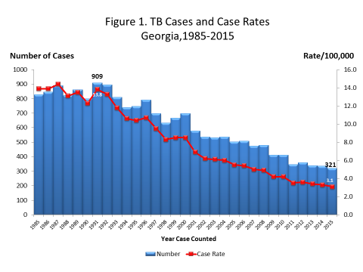
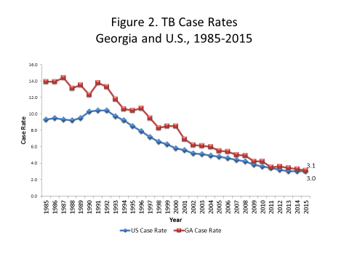

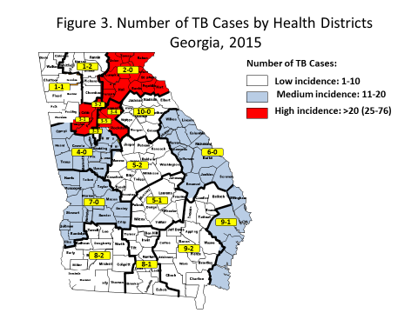

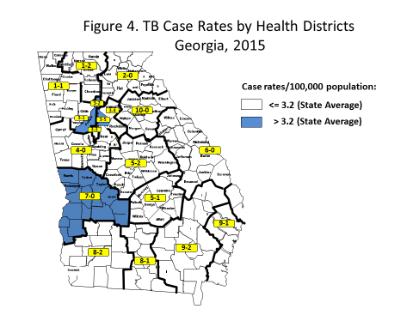

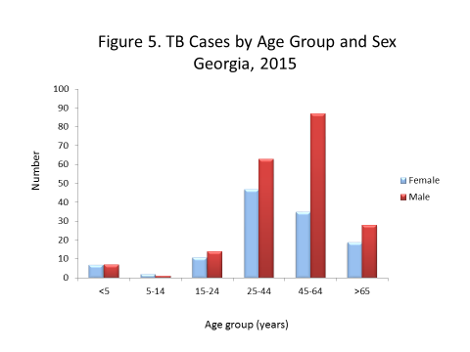

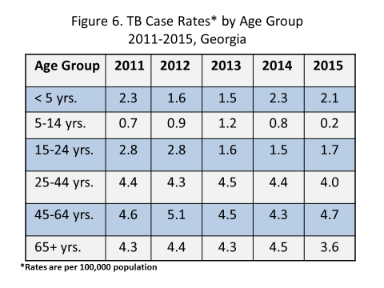
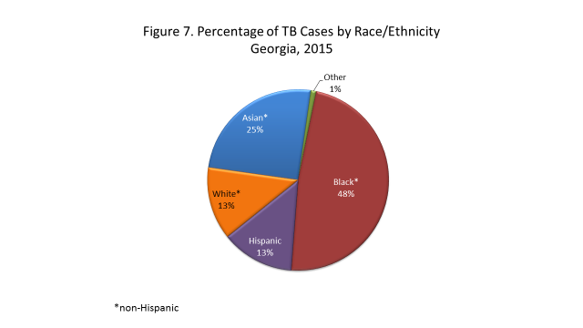

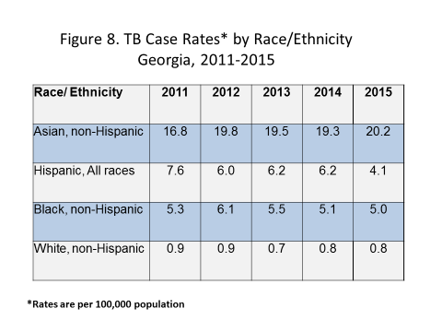

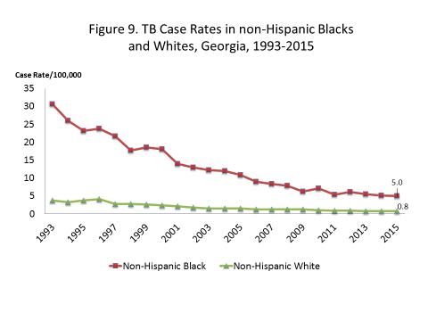

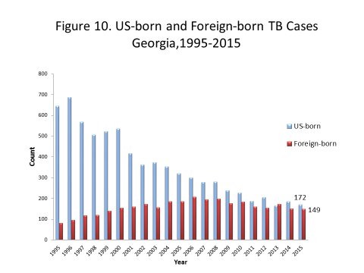

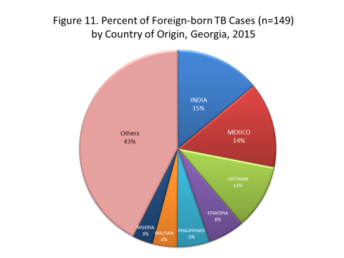

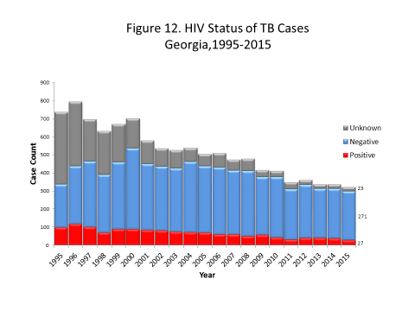
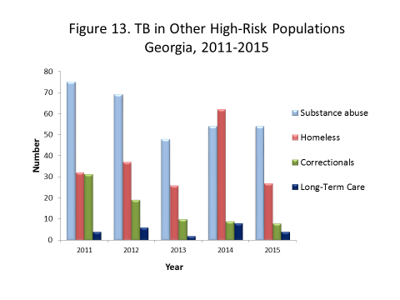

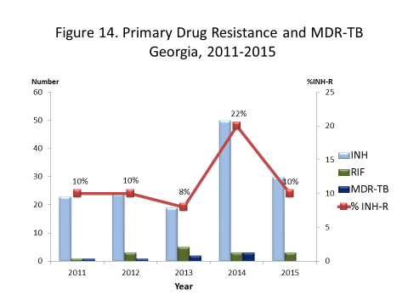

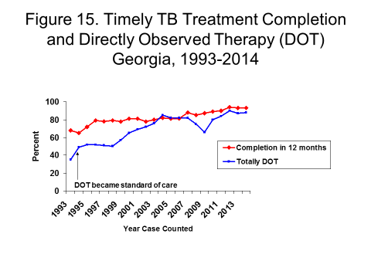
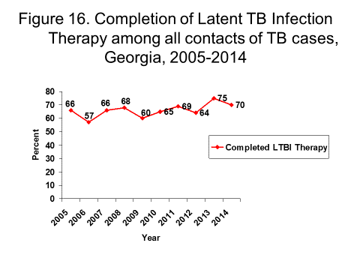

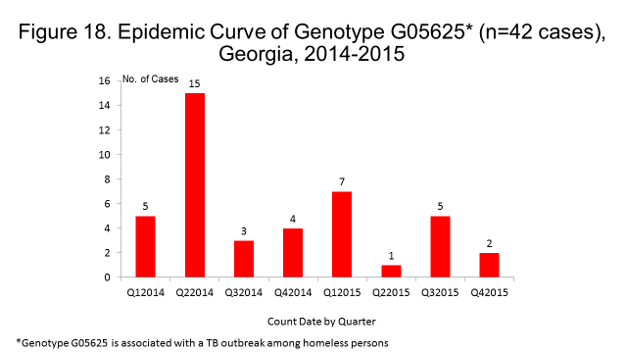

Tuberculosis Morbidity Trends by Health District Georgia, 1995-2015

