STANDARD APRN PROTOCOL FOR CONTRACEPTIVE IMPLANT INSERTION

NOTE: All clinicians performing insertions and/or removals of the contraceptive implant must complete the manufacturer’s (Merck) Clinical Training Program, a required comprehensive hands-on workshop. Only clinicians who complete the program will be able to order the product. You must be an advanced practice clinician or a physician in order to attend the required training. For those who completed training for Implanon, a web-based training can be completed for certification in Nexplanon placement. For those who have never been certified to place the contraceptive implant, in-person training is required. The training is free and can be arranged by calling 1-877-467-5266.

DEFINITION Nexplanon® is a small, thin, implantable hormonal contraceptive that is effective for up at least three years. The product has FDA approval for three years, but evidence indicates that the contraceptive effect is present for four years and longer. The subdermal contraceptive implant is an etonogestrel-impregnated 4cm plastic rod. It is placed under the skin of the upper arm. It does not contain estrogen. It prevents pregnancy primarily by inhibiting ovulation. Other contraceptive effects include thickening cervical mucus and thinning the endometrial lining. Nexplanon® is identical to its predecessor, Implanon®, except that it is radio-opaque and the inserter has been changed.

SUBJECTIVE 1. Desires an implant for long-term contraception.

    - Has detailed health history (includes menstrual, sexual, contraception, personal health and family history) that does not reveal a condition representing an unacceptable health risk according to the product prescribing information and to the CDC Medical Eligibility Criteria for Contraceptive Use.

3. If breastfeeding, she may initiate immediately. However, there is minimal likelihood of ovulating before one month postpartum in a woman who is breastfeeding.

4. Refer to CDC Medical Eligibility Criteria for Contraceptive Use for medical conditions that represent an unacceptable health risk for using the contraceptive implant. Medical conditions include:

- Lupus with positive (or unknown) antiphospholipid antibodies
- Breast cancer
- Cirrhosis – severe (decompensated)
- Liver Tumors – benign hepatocellular adenoma; malignant (hepatoma)
- Unexplained vaginal bleeding, suspicious for serious
underlying condition, before evaluation.

5. Refer to CDC Medical Eligibility Criteria for Contraceptive Use for medical conditions that represent an unacceptable health risk if they develop while using the contraceptive implant. Women with these conditions may initiate the implant. However, if women who did not have these conditions at the time of initiation develop these conditions after using the implant, the implant should not be continued. Medical conditions include:

- Ischemic heart disease
- Stroke

6. May report estrogen-excess side effects while taking
combined hormonal contraceptives, such as headaches, breast tenderness, weight gain, nausea and thus prefer a method that does not contain estrogen.

OBJECTIVE 1. Physical examination and laboratory tests as indicated. See
protocol for Preventive Care and Health Screening.

2. Timing of insertion of implant; see Initiation of Contraceptives Protocol.

ASSESSMENT Patient has no condition representing an unacceptable risk if using the contraceptive implant. No allergy to any component of the implant.

PLAN DIAGNOSTIC STUDIES

Pregnancy test if indicated to rule out pregnancy.

THERAPEUTIC

- Initiation

- If a provider can be reasonably certain that a woman is not pregnant, implant may be initiated that day with back up x 7 days.

- In situations where a provider cannot be reasonably certain that a woman is not pregnant the benefits of initiating the implant outweigh the risks and contraception can be initiated immediately.
- Starting the implant the day of the clinic visit can be easier for patients and can increase access Hormonal contraception will not prevent a pregnancy from sex that has already occurred.
- Most studies have shown no increased risk for adverse outcomes (congenital anomalies, neonatal or infant death) in infants exposed to contraception.
- The likelihood of pregnancy in previous studies of immediate initiation in situations like these was 3%.
- If patient wants to have implant inserted that day, insert implant. Encourage condoms or abstinence for 7 days. Repeat UCG in 14-28 days (this can be done by home pregnancy test if the patient desires).
- If patient declines initiation of the implant on that day of clinic visit, have her return on the first day of her next menstrual cycle for placement.
- If she has had unprotected sex in the last 120 hours, offer EC (ECPs or Paragard IUD). See Emergency Contraceptive Pills Protocol.

- Switching from other methods

- For patients with an IUD, it may be reasonable to insert the implant when the appointment for IUD removal is made.

- When switching from a hormonal method that works primarily by inhibiting ovulation, insert the implant immediately after stopping the other method with no breaks. If she has been using a contraceptive injection, the implant may be initiated any time within the window of contraceptive coverage. Back up x 7 days.

PHARMACOLOGIC

NOTE: Hazardous agent; use appropriate precautions for handling and disposal which can be found at: https://www.cdc.gov/niosh/docs/2016-161/default.html

- Local anesthesia with 3 mL of 1% lidocaine (should be injected under the skin and along the insertion track).

- Insert the contraceptive implant per manufacturer’s directions. Before insertion, the patient must read and sign the program’s method specific consent form.

- The implant should be palpated by both the clinician and patient before patient goes home to ensure proper placement.

- The provider should fill out the Contraceptive Implant Placement procedure note as indicated.

NON-PHARMACOLOGIC MEASURES

- Take precautions to avert a vasovagal reaction (syncope/ fainting). Allow the patient to lie still several minutes after insertion. Ask about pain or feeling faint. If the patient says she feels like she can sit up, have her sit up slowly while being supported. If no problems in 1-2 minutes, allow her to stand.

- Treat signs of vasovagal reaction (pallor/cyanosis, pinched-face look, dilated pupils, weak and rapid pulse, rapid shallow breathing, hypotension) according to the Emergency Guidelines, Policies and Procedures Nurse Protocol.

- Ice to insertion area for discomfort.

PATIENT EDUCATION/COUNSELING

- Counsel patient according to seven basic elements of informed consent (BRAIDED – Benefits Risks Alternatives Inquiries Decision Explanation Documentation).

- The User Card from the product package should be filled out and given to the patient after the contraceptive implant insertion so she will have a record of the location of implant and when it should be removed.

- Review warning signs and symptoms of possible insertion site problems: redness, swelling, or purulent discharge at insertion site. Encourage patient to keep insertion site bandaged for the next 3-5 days.

- Counsel patient on common side effects: menstrual changes or bleeding irregularities (spotting, light bleeding, prolonged bleeding or no bleeding), emotional lability, weight gain, headache, acne, depression.

- Further counsel patient regarding unpredictable bleeding irregularities, so that she knows what to expect. Women who use the contraceptive implant are likely to have changes in their vaginal bleeding patterns, especially during the first three months of use, which are often unpredictable. These may include changes in bleeding frequency or duration, or amenorrhea. Amenorrhea and oligomenorrhea are common.

- Take over-the-counter ibuprofen or acetaminophen and/or apply ice to insertion area for discomfort.
- If inserted more than 5 days from LMP and patient not currently on hormonal contraception, recommend back-up or abstinence for 7 days.

- Provide counseling on preconception health counseling and future fertility. (Refer to Preconception Health Toolkit).
http://www.fpm.emory.edu/preventive/research/projects/

- Use condoms to reduce the risk of STD, including HIV.

- Counsel patient to discuss all medications and herbal supplements with clinician because they can alter the metabolism of hormonal contraception and cause side effects, and/or decrease effectiveness.

- The contraceptive implant is approved for use for 3 years. However, clinical data demonstrates its effectiveness for 5 years, and maybe longer. This information can be used when counseling women at the time of initiation as well as at the end of the FDA approval window. If the patient is satisfied with the method at the end of the FDA approval window and would like to continue using it, evidence indicates that it still provides contraception as noted above. If she would like to have it removed, this should be honored.

FOLLOW-UP

- Return as scheduled for evaluation or contact clinic if side effects or danger signs develop. See table below, Routine follow-up after contraceptive initiation.

- Outside of clinic hours, seek physician or emergency care if warning signs develop.

3. Treatment of side effects: None of the following has been proven to be effective for treatment of bothersome bleeding while using the implant. Often continuation of use of the implant is the best treatment, but for some women the bleeding profile may not improve. If a woman is interested in continuing the implant and would like to try one of the following, it may be reasonable. If she desires removal, this request should be accommodated.

4. For bleeding irregularities see Nurse Protocol for Spotting and Breakthrough Bleeding while on Hormonal Contraception. Please see table below from the CDC’s Selected Practice Recommendations.

Table 1. Summary table of from the CDCs Selected Practice Recommendations for Contraceptive Use
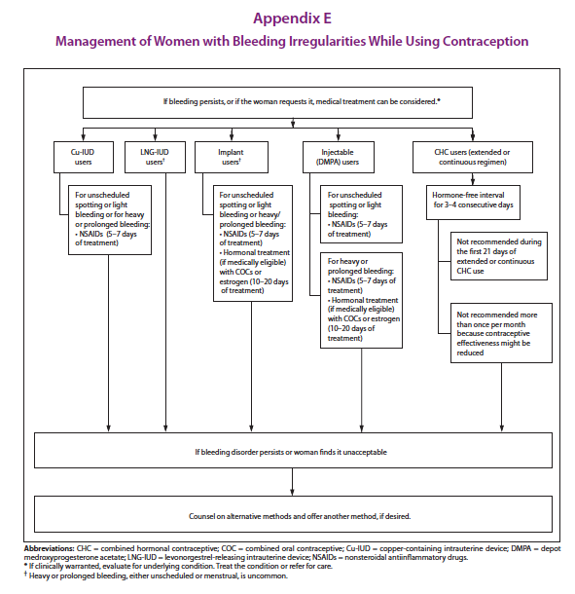

CONSULTATION/REFERRAL

- Difficult implant insertion or removal.
- Allergy to lidocaine.
- Suspected ectopic pregnancy.
- Other complications related to implant use.

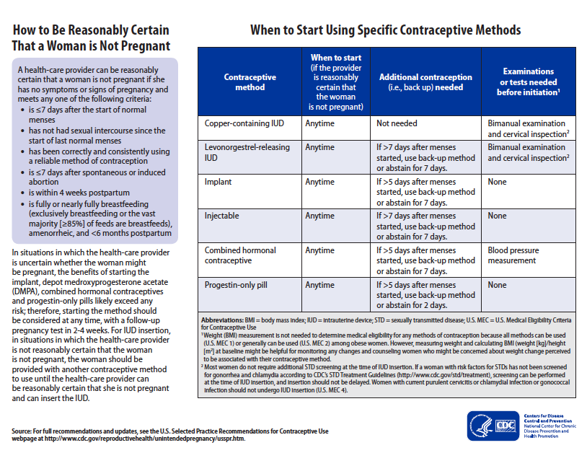

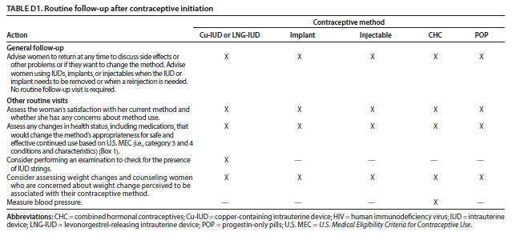

REFERENCES

1. Robert Hatcher et al., Contraceptive Technology, 20th ed., Ardent Media, Inc., New York, 2011. (Current)

2. Joellen Hawkins et al., Protocols for Nurse Practitioners in Gynecologic Settings, 11th ed., Springer Publishing Co., New York, 2015.

3. M. Zieman, R.A. Hatcher. Managing Contraception, 13th ed., Ardent Media Inc., New York, 2015.

4. CDC, U.S. Medical Eligibility Criteria for Contraceptive Use, 2016, MMWR 2016; 65: 3 http://www.cdc.gov/mmwr/volumes/65/rr/pdfs/rr6503.pdf

5. CDC, U.S. Selected Practice Recommendations for Contraceptive Use, 2016. MMWR 2016; 65:4 http://www.cdc.gov/mmwr/volumes/65/rr/pdfs/rr6504.pdf

6. Lexi-Comp, Inc., “Lexi-Comp Online”, Lexi-Comp, Inc. Hudson, Ohio, 2015, http://lexicomponline.com/crlsql/servelt/crlonline (April 28, 2015)

7. Wolters Kluwer; Lexicomp Online, 2017; http://online.lexi.com/lco/action/doc/retrieve/docid/patch_f/5245 >accessed June 4, 2017

8. US Department of Health and Human Services; Centers for Disease Control and Prevention; National Institute for Occupational Safety and Health. NIOSH list of antineoplastic and other hazardous drugs in healthcare settings, 2016. Available at https://www.cdc.gov/niosh/docs/2016-161/default.html Updated September 2016. Accessed November 8, 2016.

9. Ali, Moazzam et al. Extended Use up to Five Years of the Etenogestrel-releasing Subdermal Contraceptive Implant: Comparison to Levonorgestrel-releasing subdermal Implant. Human Reproduction: 31 (11), pp 2491-2498. September 26, 2016. https://academic.oup.com/humrep/article-pdf/31/11/2491/6629131/dew222.pdf

10. McNicholas C, Swor E, Wan L, et al. Prolonged use of the etonogestrel implant and levonorgestrel intrauterine device: 2 years beyond Food and Drug Administration - approved duration. Am J Obstet Gynecol 2017; 216:586.e1-6. http://dx.doi.org/10.1016/j.ajog.2017.01.036

