STANDARD NURSE PROTOCOL FOR COPPER
IUD-RELATED MENORRHAGIA

DEFINITION Menorrhagia refers to menstrual periods that occur at regular intervals but are marked by prolonged bleeding (greater than 7 days) or excessive blood loss (greater than 80 mL). IUD-related menorrhagia is prolonged or excessive bleeding with an IUD in place.

ETIOLOGY Presence of IUD in utero. Bleeding problems constitute one of the more common IUD complications. Women using the copper-releasing IUD (Copper T380A) usually have heavier menses. Excessive bleeding with the Copper T380A can be treated with NSAIDs. Since local prostaglandin production is involved with excessive bleeding, any prostaglandin synthetase inhibitor should help. Starting in advance of menses does not give better results than starting with the onset of flow. If hemoglobin levels drop, oral iron supplementation can be started. Excessive menstrual bleeding may be an indication for removal of the IUD. The levonorgestrel IUD is associated with decreased menstrual bleeding.

Other causes to consider may be: PID, partial expulsion of the IUD, dysfunctional uterine bleeding as a result of an endocrine imbalance, cancer of the cervix or endometrium, cervical or uterine polyps, abnormal perimenopausal bleeding, fibroids, and pregnancy.

SUBJECTIVE 1. Patient provides a detailed health history (includes menstrual, sexual, contraception, personal health and family history).

2. Patient reports prolonged or excessive menstrual bleeding and gives history of current IUD.

- Patient may have a recent history which includes the following:

- dizziness, weakness or tiredness

- pale skin color

OBJECTIVE 1. External exam usually within normal limits.

2. Internal exam may be within normal limits; may note partially-expelled IUD or feel IUD in the cervical canal.

3. Bimanual exam may be within normal limits. Cervical motion tenderness or pain in uterus and adnexal areas is more characteristic of PID.

ASSESSMENT IUD-related menorrhagia.

PLAN DIAGNOSTIC STUDIES

1. Hematocrit or hemoglobin.

2. Urine pregnancy test.

3. Gonorrhea and chlamydia tests; vaginal wet mounts, if indicated.

THERAPEUTIC

PHARMACOLOGIC

- If hemoglobin below normal, treat according to Nurse Protocol for Iron-Deficiency Anemia.

- Prostaglandin inhibitors/NSAIDs as needed to help reduce menstrual blood loss and for relief of pain, if not allergic. Begin at the onset of menses (or if the patient also has dysmenorrhea begin 24-48 hours prior to the onset) and continue for 3-4 days.

  - Ibuprofen 400 mg PO every 4 hours or 800mg three times daily as needed for pain or to help relieve menstrual blood loss. (Maximum dose 2.4 gm/day).

OR

  - Naproxen 500 mg PO for one dose, then 250 mg PO every 6-8 hours as needed for pain or to help relieve menstrual blood loss. (Maximum dose 1250mg/day)

OR

  - Over-the-counter-strength products (e.g., Advil, Nuprin, Aleve, Motrin IB, coated aspirin, or acetaminophen) per package directions as needed.
Table 1. Management of Women with Bleeding Irregularities, from the CDC’s US Selected Practice Recommendations
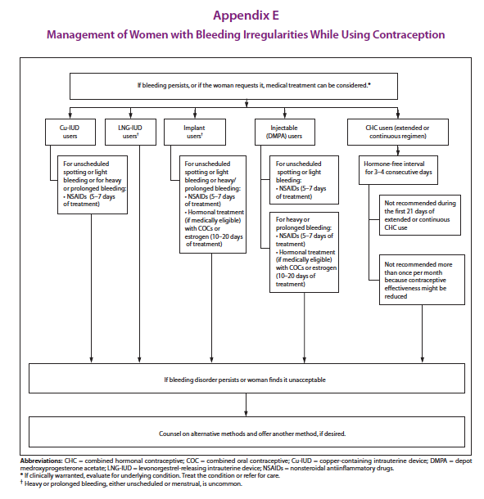

NON-PHARMACOLOGIC MEASURES

1. Remove the IUD (by APRN or physician) for the following:

- a. Partial expulsion.

b. Excessive menstrual blood loss.

c. Patient’s request for removal of IUD for any reason.

2. Consult with APRN or physician to discuss possible need for removal if any of the following:

a. hemoglobin has dropped 2 gm/dL or more from previous reading.

b. hemoglobin is less than 9 gm/dL.

c. hematocrit has dropped 6% or more over 4-6 weeks.

d. hematocrit is less than 27%.

3. If IUD is removed, may initiate alternate contraceptive method. Hormonal contraceptives (combined oral pills, transdermal contraceptive patch, Nuvaring, DMPA) may decrease bleeding and blood loss. Also, the Levonorgestrel IUD significantly improves menorrhagia. Refer to CDC Medical Eligibility Criteria for Contraceptive Use for medical conditions that represent an unacceptable health risk for the selected contraceptive method.

PATIENT EDUCATION/COUNSELING

- Counsel patient on the importance of iron rich foods in the daily diet of menstruating women.

- Discuss signs of possible pelvic infection and excessive bleeding.

FOLLOW-UP

Return in 4-6 weeks for evaluation of bleeding and hematocrit/ hemoglobin.

CONSULTATION/REFERRAL

- Immediately refer patient to physician if suspect ectopic pregnancy or PID that has not improved with 2-3 days of antibiotics. See Nurse STD Nurse Protocol.
https://dph.georgia.gov/sites/dph.georgia.gov/files/related_files/site_page/7.0%20STD%20Nurse%20Protocol%20-%2011-18-15.pdf

- Refer patient to physician if menorrhagia continues for 1-2 menstrual periods after pharmacologic measures started.

- Refer patient to APRN or physician if no improvement in anemia after 4 weeks of iron supplemental therapy.

- Refer to APRN or physician for removal.

REFERENCES

1. Robert Hatcher et al., Contraceptive Technology, 20th ed., Ardent Media, Inc., New York, 2011. (Current)
2. Joellen Hawkins et al., Protocols for Nurse Practitioners in Gynecologic Settings, 11th ed., Springer Publishing Co., New York, 2015.
3. M. Zieman, R.A. Hatcher. Managing Contraception, 13th ed., Ardent Media Inc., New York, 2015
4. CDC, U.S. Medical Eligibility Criteria for Contraceptive Use, 2016, MMWR 2016; 65: 3 http://www.cdc.gov/mmwr/volumes/65/rr/pdfs/rr6503.pdf
5. CDC, U.S. Selected Practice Recommendations for Contraceptive Use, 2016. MMWR 2016; 65:4 http://www.cdc.gov/mmwr/volumes/65/rr/pdfs/rr6504.pdf

